4/7/2019

Sched

Chris Banks, Cynthia Cheng, Thomas Craig, Nicholas Lee

Table of Contents

**Inception 1**

**1.0 Team Charter 1**

**1.1 Team Members 1**

**1.2 Member Roles 1**

**1.3 Expectations 1**

**1.4 Consequences 1**

**1.5 Agreement 1**

**2.0 Project Charter 1**

**2.1 Business Purpose: 1**

**2.2 Project Roles/Responsibilities: 1**

**2.3 Event Table: 1**

**2.4 Features List: 1**

**2.5 System Objectives: 1**

**2.6 Project Critical Success Factors: 1**

**2.7 Preliminary Technical Architecture: 1**

**3.0 Project Plan 1**

**4.0 Standards Document 1**

**4.1 Header Comments 1**

**4.2 Identifier Formatting 1**

**4.3 Methods 1**

**4.4 Exception Handling 1**

**5.0 Meeting Agenda / Minutes 1**

**2019/01/10 1**

**2019/01/14 1**

**2019/01/16 1**

**2019/01/18 1**

**2019/01/21 1**

**2019/01/23 1**

**6.0 Team Member Status Reports 1**

**Chris Banks 1**

**Thomas Craig 1**

**Nicholas Lee 1**

Cynthia Cheng 1

**7.0 Team Status Report** 1

Date: 1

Team Meetings and Activities 1

**8.0 Client Letter** 1

**9.0 Client Sign-Off** 1

**Iteration 1: Analysis 1**

**10.0 Use Case Diagrams** 1

**11.0 Use Case Descriptions** 1

11.1 View Dashboard UC#01 1

11.2 Add a Work Order UC#02 1

11.3 View a Work Order UC#03 1

11.4 Update a Work Order UC#04 1

11.5 Cancel a Work Order UC#05 1

11.6 Filter Work Order List UC#06 1

11.7 Search For a Work Order UC#07 1

11.8 Dispatch Schedule UC#15 1

11.9 View Recommended Technicians/Resources UC#20 1

11.10 Assign a Technician to a Work Order UC#21 1

11.11 Assign a Resource to a Work Order UC#22 1

**12.0 Analysis Level Class Diagram** 1

**13.0 System Sequence Diagrams** 1

13.1 View Dashboard UC#01 1

13.2 Add a Work Order UC#02 1

13.3 Update a Work Order UC#04 1

13.4 Cancel a Work Order UC#05 1

13.5 Filter Work Order List UC#06 1

13.6 Search for a Work Order UC#07 1

13.7 Dispatch Schedule UC#15 1

13.8 View Recommended Technicians/Resources UC#20 1

13.9 Assign a Technician to Work Order UC#21 1

13.10 Assign a Resource to Work Order UC#22 1

**14.0 State Chart Diagrams** 1

State Chart Diagram for Work Orders 1

**15.0 Meeting Agenda / Minutes** 1

2019/01/28 1

2019/01/30 1

2019/02/04 1

2019/02/06 1

2019/02/10 1

2019/02/11 1

2019/02/11 1

**16.0 Team Member Status Reports** 1

Chris Banks 1

Cynthia Cheng 1

Nicholas Lee 1

Thomas Craig 1

**17.0 Team Status Report** 1

Date: 1

Team Meetings and Activities 1

**18.0 Agile Backlog** 1

**19.0 Agile Release Summary** 1

**Iteration 1: Design 1**

**20.0 Design Class Diagram** 1

**21.0 System Sequence Diagrams** 1

21.1 View Dashboard UC#01 1

21.2 Add a Work Order UC#02 1

21.3 View a Work Order UC#03 1

21.4 Update a Work Order UC#04 1

21.5 Cancel a Work Order UC#05 1

21.6 Filter Work Order List UC#06 1

21.7 Search for a Work Order UC#07 1

21.8 Dispatch Schedule UC#15 1

21.9 View Recommended Technicians/Resources UC#20 1

21.10 Assign a Technician to a Work Order UC#21 1

21.11 Assign a Resource to a Work Order UC#22 1

**22.0 Navigation Diagram** 1

**23.0 Original Wireframes** 1

23.1 Dispatcher Dashboard 1

23.2 Search 1

23.3 Upper Filters 1

23.4 Lower Filters 1

23.5 Work Order Pane 1

**24.0 Prototype Screen Captures** 1

24.1 Dashboard without work order selected 1

24.2 Search Options 1

24.3 Work Order Selected 1

24.4 Recommendations – All Technicians 1

24.5 Recommendations – All Resources 1

**25.0 Entity Relation Diagram** 1

**26.0 Data Dictionary** 1

**Iteration 1: Construction 1**

**27.0 Screen Captures** 1

27.1 Dashboard 1

27.2 Filters and Search 1

27.3 Advanced Search 1

27.4 Select a Work Order in Work Order List 1

**28.0 Unit Tests** 1

**29.0 Agile Backlog** 1

**30.0 Client Sign-off** 1

**Iteration 2: Analysis 1**

**31.0 Use Case Diagram** 1

**32.0 Use Case Descriptions** 1

32.1 Schedule a Resource for Work Order UC#08 1

32.2 Schedule a Technician for Work Order UC#09 1

32.3 Cancel Work Order Assignment of Resource UC#10 1

32.4 Cancel Work Order Assignment of Technician UC#11 1

32.5 Work Order Timeslot is Updated UC#12 1

32.6 View a single date in Gantt Chart UC#13 1

32.7 View Multiple Dates in Gantt Chart UC#14 1

32.8 View Assigned Work Order Information UC#16 1

**33.0 Activity Diagrams** 1

33.1 Schedule Resource UC#08 1

33.2 Schedule Technician UC#09 1

33.3 Cancel Work Order Assignment of Resource UC#10 1

33.4 Cancel Work Order Assignment of Technician UC#11 1

33.5 Work Order Timeslot is updated UC#12 1

33.6 View Single Date in Gantt Chart UC#13 1

33.7 View Multiple Dates in Gantt Chart UC#14 1

33.8 View Assigned Work Order Information UC#15 1

**34.0 Analysis Class diagram** 1

**35.0 System Sequence Diagrams** 1

35.1 Schedule Resource for Work Order UC#08 1

35.2 Schedule Technician for Work Order (Gantt Chart) UC#09 1

35.3 Cancel Work Order Assignment of Resource (Gantt Chart) UC#10 1

35.4 Cancel Work Order Assignment of Technician (Gantt Chart) UC#11 1

35.5 Work Order Time Slot is Updated (Gantt Chart) UC#12 1

35.6 View a Single Date in Gantt Chart UC#13 1

35.7 View Multiple Dates In Gantt Chart UC#14 1

35.8 View Assigned Work Order Information in Gantt Chart UC#16 1

**36.0 State Chart Diagrams** 1

**37.0 Meeting Agenda / Minutes** 1

2019/02/19 1

2019/02/20 1

2019/02/25 1

Present 1

2019/03/04 1

2019/03/06 1

2019/03/08 1

**38.0 Team Member Status Reports** 1

Cynthia Cheng 1

Thomas Craig 1

Chris Banks 1

Nicholas Lee 1

**39.0 Team Status Report** 1

Date: 1

Team Meetings and Activities 1

**Iteration 2: Design 1**

**40.0 Design Class Diagram** 1

**41.0 System Sequence Diagrams** 1

41.1 Schedule Resource for Work Order (Gantt Chart) UC#08 1

41.2 Schedule Technician for Work Order (gantt Chart) UC#09 1

41.3 Cancel Work Order Assignment of Resource (Gantt) UC#10 1

41.4 Cancel Work Order Assignment of Technician (Gantt) UC#11 1

41.5 Work Order Timeslot is Updated (Gantt) UC#12 1

41.6 View a Single Date in Gantt Chart UC#13 1

41.7 View Multiple Dates in Gantt Chart UC#14 1

41.8 View Assigned Work Order Information in Gantt Chart UC#16 1

**42.0 Navigation Diagram** 1

**43.0 Prototype Screen Captures** 1

**44.0 Entity Relation Diagram** 1

**45.0 Data Dictionary** 1

**Iteration 2: Construction 1**

**46.0 Agile Release Summary** 1

**47.0 Agile Backlog** 1

**48.0 Client Sign Off** 1

**Iteration 3: Analysis 1**

**49.0 Use Case Diagram** 1

**50.0 Use Case Descriptions** 1

50.1 View Technician or Resource ETA UC#19 1

**51.0 Activity Diagrams** 1

51.1 View Technician or Resource ETA UC#19 1

**52.0 Analysis Class Diagram** 1

**53.0 System Sequence Diagram** 1

53.1 View Technician Or Resource ETA UC#19 1

**Iteration 3: Design 1**

**54.0 System Sequence Diagrams** 1

54.1 View Technician or Resource ETA UC#19 1

**55.0 Design Class Diagram** 1

**56.0 Navigation Diagram** 1

**57.0 Screen Captures** 1

Dashboard 1

Sidebar 1

Selected Work Order 1

**58.0 Entity Relation Diagram** 1

**59.0 Data Dictionary** 1

**60.0 Meeting Agenda / Minutes** 1

2019/03/11 1

2019/03/13 1

2019/03/18 1

2019/03/20 1

2019/03/25 1

**61.0 Team Member Status Reports** 1

Chris Banks 1

WEBPR 1

Cynthia Cheng 1

Thomas craig 1

Nicholas Lee 1

**62.0 Team Status Report** 1

Date: 1

Team Meetings and Activities 1

**Iteration 3: Construction 1**

**63.0 Client Sign-off** 1

**Transition 1**

**64.0 Test Plan / Results** 1

**65.0 Help System / User Doc** 1

**66.0 Deployment Guide** 1

**67.0 Web Search and Rationale Report** 1

**68.0 Final presentation slides** 1

**69.0 Team Member Status Reports** 1

**70.0 Team Status Report** 1

**71.0 Client Sign Off** 1

Inception

## **1.0 Team Charter**

### 1.1 Team Members

Cynthia Cheng [ccheng5421@conestogac.on.ca](mailto:ccheng5421@conestogac.on.ca)

Nicholas Lee [nlee6989@conestogac.on.ca](mailto:nlee6989@conestogac.on.ca)

Thomas Craig [tcraig1398@conestogac.on.ca](mailto:tcraig1398@conestogac.on.ca)

Chris Banks [cbanks4667@conestogac.on.ca](mailto:cbanks4667@conestogac.on.ca)

### 1.2 Member Roles

|  |  |
| --- | --- |
| Project Management | |
| Team leadership | Cynthia Cheng |
| Project planning | Thomas, Chris |
| Project record-keeping | Cynthia, Nicholas |
| Analysis, Design and Documentation | |
| Interacting with clients | Cynthia, Nicholas, Thomas, Chris |
| Diagramming and documenting client requirements | Cynthia, Nicholas, Thomas, Chris |
| Diagramming and documenting overall design | Cynthia, Nicholas, Thomas, Chris |
| Technical documentation | Cynthia, Nicholas, Thomas, Chris |
| Client documentation | Cynthia, Nicholas, Thomas, Chris |
| Web Development | |
| Creating web graphics | Cynthia, Nicholas, Thomas, Chris |
| Web site design | Cynthia, Nicholas, Thomas, Chris |
| Web page design | Cynthia, Nicholas, Thomas, Chris |
| Web programming | Cynthia, Nicholas, Thomas, Chris |
| Interactive testing | Cynthia, Nicholas, Thomas, Chris |
| Business Layer Development | |
| Class design | Cynthia, Nicholas, Thomas, Chris |
| Business programming | Cynthia, Nicholas, Thomas, Chris |
| Technical / lower-level programming | Cynthia, Nicholas, Thomas, Chris |
| Unit and integration testing | Cynthia, Nicholas, Thomas, Chris |
| Database Development | |
| Database design | Cynthia, Nicholas, Thomas, Chris |
| SQL/LINQ Devlopment | Cynthia, Nicholas, Thomas, Chris |
| Other | |
| Report development | N/A |
| Installer development | N/A |

### 1.3 Expectations

*Equal sharing of work.*

*Attending all meetings on Mondays and Wednesdays. If unable to attend, notify by team chat latest 8am day of meeting.*

*Creating deliverables on time (Wednesdays). If unable to meet expected timeframe, notify teammates via team chat to arrange back-up meeting for Thursday to discuss issues.*

*Any ideas, issues, etc. must be informed to group ASAP via team chat*

### 1.4 Consequences

*If a member misses a scheduled meeting (Monday and Wednesday) without giving advanced notice they must buy a pack of 20 timbits for the following meeting.*

*If a member is unable to complete their share of work and did not make alternative arrangements as per above, the member will 10% per missed deliverable.*

### 1.5 Agreement

Each team member *must* sign the charter. The Team Charter can be revised at any time during the project with the consent of *all* team members.

Cynthia Cheng __________________ Date:

Nicholas Lee __________________ Date:

Thomas Craig __________________ Date:

Chris Banks __________________ Date:

## **2.0 Project Charter**

### 2.1 Business Purpose:

*Create a scheduling web application for field services and improve automated scheduling process. Dispatchers will be able to schedule Technicians and Resources to fulfil Work Orders. Dispatchers will be recommended Technicians and Resources based on the Job requirements in the Work Order, availability, Resource requirements, and geographic proximity of preceding job site within a regional work area.*

### 2.2 Project Roles/Responsibilities:

***Circumference Team:***

*Product Owner and Project Management: Daniel Heidt and Ted Byers*

*Mentors: Daniel Heidt, Ted Byers, Diane MacMartin, Ian MacIntyre*

***Conestoga College SCHED Team:***

***\*****First name is lead, followed by support*

*Project Management: Cynthia Cheng, Nicholas Lee, Thomas Craig, Chris Banks*

*Work Orders: Nicholas Lee, Cynthia Cheng, Thomas Craig, Chris Banks*

*Booking Interface (Without Gantt Chart): Cynthia Cheng, Chris Banks, Thomas Craig, Nicholas Lee*

*Booking Interface (Gantt Chart): Thomas Craig, Chris Banks, Nicholas Lee, Cynthia Cheng*

*Automatic Scheduler: Cynthia Cheng, Christ Banks, Thomas Craig, Nicholas Lee*

*Map Interface: Chris Banks, Cynthia Cheng, Nicholas Lee, Thomas Craig*

### 2.3 Event Table:

|  |  |  |  |  |  |  |
| --- | --- | --- | --- | --- | --- | --- |
| Event | Trigger | Source | Use  Case # | Use Case | Response | Destination |
| *Dispatcher can view Dashboard* | *Dispatcher logs into Scheduler* | *Dispatcher* | *UC01* | *View Scheduler Dashboard* | *Scheduler Dashboard is displayed.*  *Contains the following:*  *Work Order List*  *Gantt Chart*  *Filtering Options* | *Dispatcher* |
| *Dispatcher wants to add a new Work Order* | *Add Work Order* | *Dispatcher* | *UC02* | *Add a Work Order* | *Work Order is added to be scheduled* | *Database* |
| *Dispatcher views a Work Order* | *Select Work Order* | *Dispatcher* | *UC03* | *View a Work Order* | *Work Order details can be viewed* | *Dispatcher* |
| *Dispatcher wants to update an existing Work Order* | *Update Work Order* | *Dispatcher* | *UC04* | *Update a Work Order* | *Work Order details are updated* | *Database* |
| *Dispatcher wants to cancel a Work Order* | *Cancel Work Order* | *Dispatcher* | *UC05* | *Cancel a Work Order* | *Work Order is cancelled* | *Database* |
| *Dispatcher wants to filter the Work Orders* | *Filter Work Order Panel* | *Dispatcher* | *UC06* | *Filter Work Order List* | *Work Orders can be filtered to display relevant Work Orders* | *Dispatcher* |
| *Dispatcher wants to search for a Work Order* | *Search* | *Dispatcher* | *UC07* | *Search for a Work Order* | *Work Order can find a specific Work Order* | *Dispatcher* |
| *Dispatcher wants to assign a Resource to a Work Order in Gantt Chart* | *Drag and drop Resource onto Gantt Chart* | *Dispatcher* | *UC08* | *Schedule Resource for Work Order* | *Resource has been scheduled into assigned status for a Work Order* | *Dispatcher* |
| *Dispatch wants to assign a Technician to a Work Order in Gantt Chart* | *Drag and drop Technician onto Gantt Chart* | *Dispatcher* | *UC09* | *Schedule Technician for Work Order* | *Technician has been scheduled into assigned for a Work Order* | *Dispatcher* |
| *Dispatcher wants to remove a Resource from a Work Order in Gantt Chart* | *Link beside Resource’s name* | *Dispatcher* | *UC10* | *Cancel Work Order assignment of Resource* | *Resource is no longer assigned to Work Order* | *Dispatcher* |
| *Dispatcher wants to remove a Technician from a Work Order in Gantt Chart* | *Link beside Technician’s name* | *Dispatcher* | *UC11* | *Cancel Work Order assignment of Technician* | *Technician is no longer assigned to Work Order* | *Dispatcher* |
| *Dispatcher wants to change Work Order’s scheduled time in Gantt Chart* | *Drags Work Order to different time slot* | *Dispatcher* | *UC12* | *Work Order time slot is updated* | *Work order is updated with new timeslot* | *Dispatcher* |
| *Dispatcher wants to view a single day in the Gantt Chart* | *Date option in Gantt Chart* | *Dispatcher* | *UC13* | *View a single date in Gantt Chart* | *Gantt chart is zoomed in to display selected date* | *Dispatcher* |
| *Dispatcher wants to view multiple days in the Gantt Chart* | *Date option in Gantt Chart* | *Dispatcher* | *UC14* | *View multiple dates in Gantt Chart* | *Gantt chart is zoomed out to display multiple days* | *Dispatcher* |
| *Dispatcher wants to complete dispatching schedule* | *Complete Dispatch Link* | *Dispatcher* | *UC15* | *Dispatch Schedule* | *Assigned Work Orders in Gantt Chart are Dispatched to Technicians and Resources* | *Dispatcher* |
| *Dispatcher wants to see information of assigned Work Orders in Gantt Chart* | *Hover over an assigned timeslot in Gantt Chart* | *Dispatcher* | *UC16* | *View Assigned Work Order Information* | *Condensed Work Order information is displayed* | *Dispatcher* |
| *Dispatcher uses automatic scheduler* | *Automatic Scheduler turned on* | *Dispatcher* | *UC17* | *Use Automatic Scheduling* | *Gantt Chart schedule is filled with automatic scheduler based on customized business rules* | *Dispatcher* |
| *Dispatcher wants to view Technician and Resource locations in comparison to Work Order location on a map* | *Map link* | *Dispatcher* | *UC18* | *View Location Mapping* | *A map identifying Technicians and Resources locations of preceding Work Order location to Work Order location being scheduled* | *Dispatcher* |
| *Dispatcher wants to know the estimated time of arrival of a Technician or Resource for a Work Order* | *Hover over Technician/ Resource* | *Dispatcher* | *UC19* | *View Technician or Resource ETA* | *Display estimated time of arrival of a Technician or Resource from preceding Work Order location to Work Order location being scheduled* | *Dispatcher* |

### 2.4 Features List:

*Booking interface (Not including Gantt Chart)*

* *Dispatchers are able to add, view, update, and delete Work Orders and their details*
* *Dispatchers are able to add notes to Work Orders*
* *Dispatchers are able to filter and search Work Orders*
* *Dispatchers are able to select, assign, and dispatch Work Orders*
* *Dispatchers are able to drag and drop Work Orders, Technicians, and Resources to be scheduled in a Gantt Chart*

*Booking Interface (Gantt Chart)*

* *Dispatchers can view a scheduled Work Order’s key customer information in Gantt Chart*
* *Dispatchers can view a single or multiple days schedule in the Gantt Chart*
* *Dispatchers can drag and drop Technicians and Resources in the Gantt Chart to schedule Work Orders*
* *Dispatchers are able to change Status of Work Order*

*Automatic Scheduler*

* *Dispatcher can enable Automatic Scheduler to recommend scheduling for a day / week according to customizable business rules*
* *Dispatcher can edit an automatically generated schedule before dispatching*
* *Dispatcher and Automatic Scheduler can’t override bookings made via portal*
* *Dispatcher is able to complete Dispatch functionality*
* *Dispatcher is able to Retract WO functionality*

*Map Interface*

* *Dispatcher can view location of Technicians and Resources*
* *Dispatcher can view a hot call Work Order Location and status of nearby Technicians at time of hot call*
* *Dispatcher can view the ETA for a Technician from the preceding Work Order to Work Order being scheduled*

### 2.5 System Objectives:

* *System should be available at all times except for scheduled maintenance periods.*
* *All transactions must provide less than 2 seconds response time*
* *System must be able to retain above response time when systems are upgraded/scales to for a larger database*
* *Web application must be easy to navigate and provide relevant content to users*

### 2.6 Project Critical Success Factors:

* *Deliverables completed as per project plan schedule*
* *Timely iteration feedback*
* *Ability to discuss with Client about any project questions, business requirements, and updates for the duration of the project*

### 2.7 Preliminary Technical Architecture:

* *.Net*
* *C#*
* *SQL Server*
* *ASP.Net*

## **3.0 Project Plan**

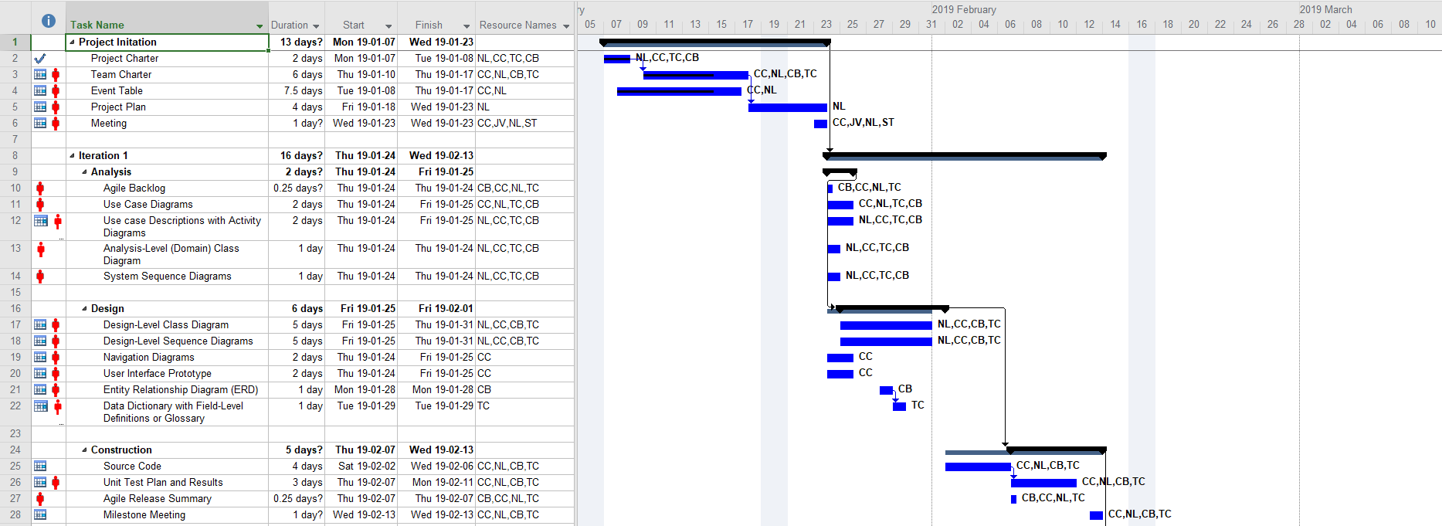

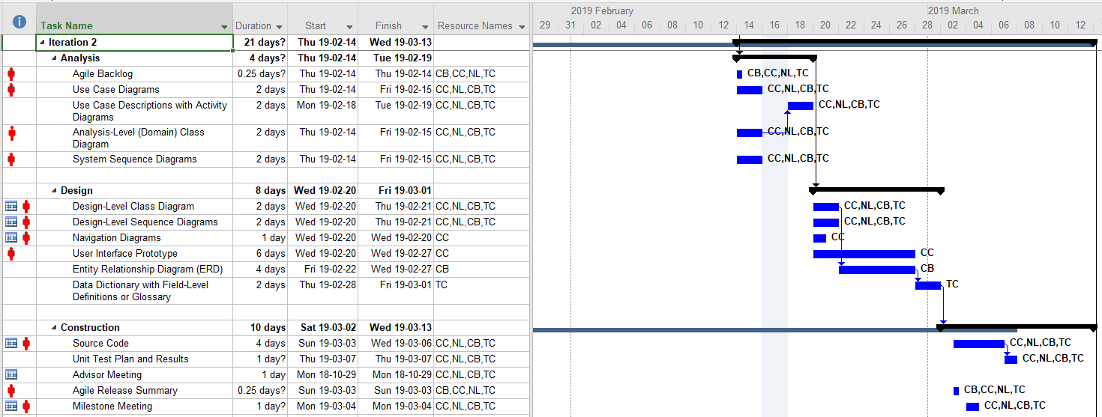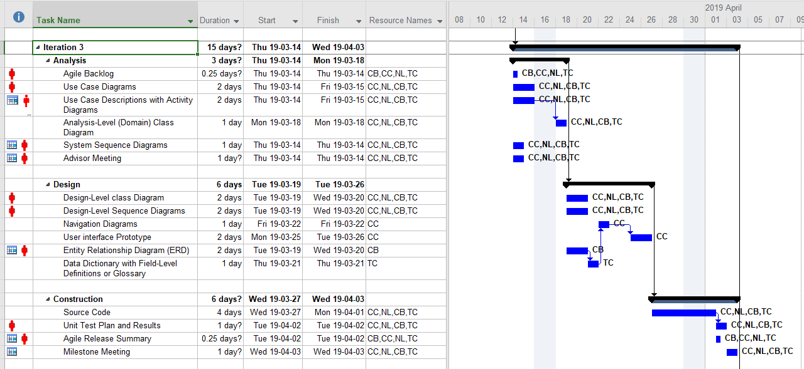

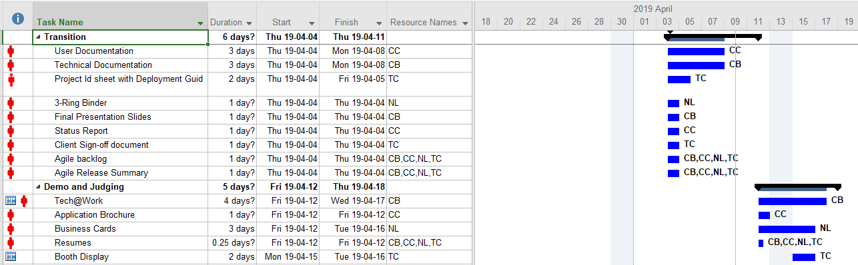

## **4.0 Standards Document**

### 4.1 Header Comments

The header comments should include:

* Class Description

### 4.2 Identifier Formatting

|  |  |  |
| --- | --- | --- |
| Element | Format | Example |
| Class | PascalCase | BankAccount |
| Interface | PascalCase | IEnumerable |
| Static Object | ALL UPPERCASE | DEPOSIT |
| Method Parameter | camelCase | userName |
| Variable | camelCase | firstName |
| Constant | ALL UPPERCASE | TAX_RATE |
| Namespace | PascalCase | Property.Basement |
| Property | PascalCase | GetUserName |
| Method | PascalCase | AddUser |
| Enumeration | PascalCase | MyConstant |
| Event | PascalCase | LaunchProgram |
| Database Table | snake_case | order |
| Database Column | snake_case | order_id |
| Database Key Words | ALL UPPERCASE | ON |

#### 4.2.1 Object Naming

The object names will be prefixed with the abbreviated name of the type of object. The objects themselves will be named with entire words with no abbreviations

Examples:

* TextBox – txtFirstName
* Label – lblFirstName
* Button – btnGenerate

#### 4.2.2 Variables/Constants

* All variables will be created on separate lines
* All variables will be initialized after they are created
* All variables should be accessed using properties outside of the class, not directly
* All constants will be declared globally (class scope)

Examples:

* string firstName = ””;
* int number = 0;

#### 4.2.3 Curly Braces

* All of the code between curly braces should be indented 1 tab space (including nested brackets)
* Closing curly braces should appear on a separate line

Example:

If (x = 0) {

//code here

}

#### 4.2.4 Spacing

* A blank line should appear before and after a control construct (if, for, while, etc)
* A blank space should appear after each comma in a comma-separated list
* A line of code should be split into several lines if it extends further than the code window
* A space should appear before and after operators such as > < =.

### 4.3 Methods

* All method parameters should be of a certain type, not generic like object
* Any methods that has multiple return paths should have a return statement associated with each
* A single method should fulfill a single task and should not be broad in its purpose
* Any major operations (i.e. DB Access) should not be handled within an event handler, and should be called in a separate method
* Documentation comments should appear above each method indicating its purpose, parameters and return value
* Implementation comments will be provided for explaining complex logic

### 4.4 Exception Handling

* A try-catch block should be looking for specific exceptions where known
* A try-catch block should always have a catch for general exceptions
* The catch block should not be left empty
* A try-catch block should not enclose the entire method code, only the part that will throw an exception

## **5.0 Meeting Agenda / Minutes**

### **2019/01/10**

#### Time:

09:15

#### Location:

**Doon Collaboration Room 3**

#### Attendance

|  |  |  |
| --- | --- | --- |
| **Present** | **Regrets** | **Status**  **Report?** |
| Nick Lee |  |  |
| Cynthia Cheng |  |  |
| Daniel Heidt |  |  |
| Ted Byers |  |  |
|  | **Team Status Report?** |  |

#### Agenda

|  |  |
| --- | --- |
| 1st Meeting – General Introductions | Complete |
| Review Initial Project Plan | Complete |

#### Deliverables

|  |  |
| --- | --- |
| Start looking into available Gantt libraries |  |
| Review SCHED requirements document |  |
| Circumference to provide examples of rough expected wireframes |  |

#### Action Items

|  |  |  |  |
| --- | --- | --- | --- |
| **What** | **Who** | **When** | **Complete?** |
| Look into available Gantt libraries | Cynthia Cheng, Nicholas Lee | In progress, required before Iteration 2 |  |
| Review SCHED requirements document | Cynthia Cheng, Nicholas Lee | 2019.01.14 |  |
| Examples of expected front end/wireframes | Daniel Heidt, Ted Byers | 2019.01.14 |  |

#### Minutes / Notes

|  |
| --- |
| General introduction to project and team members |
| Review Project Plan |
| Review expectations |

### **2019/01/14**

#### Time:

**12:30**

#### Location:

**Doon Work Room 3**

#### Attendance

|  |  |  |
| --- | --- | --- |
| **Present** | **Regrets** | **Status**  **Report?** |
| Nick Lee |  |  |
| Cynthia Cheng |  |  |
| Daniel Heidt |  |  |
| Ted Byers |  |  |
|  | **Team Status Report?** |  |

#### Agenda

|  |  |
| --- | --- |
| 2nd Meeting, Review any questions about SCHED requirements |  |
| Discuss Wireframe and Navigation of app interface |  |
| Discuss existing Database architecture |  |

#### Deliverables

|  |  |
| --- | --- |
| Start looking into available Gantt libraries | List created, in review |
| Review SCHED requirements document | Completed |
| Circumference to provide examples of rough expected wireframes | Completed |
| Review Database |  |
| Begin Wireframing |  |

#### Action Items

|  |  |  |  |
| --- | --- | --- | --- |
| **What** | **Who** | **When** | **Complete?** |
| Look into available Gantt libraries | Cynthia Cheng, Nicholas Lee | In progress, required before Iteration 2 |  |
| Review SCHED requirements document | Cynthia Cheng, Nicholas Lee | 2019.01.14 | Complete |
| Examples of expected front end/wireframes | Daniel Heidt, Ted Byers | 2019.01.14 | Complete |
| Review current database files/structure | Cynthia Cheng, Nicholas Lee | 2019.01.18 |  |
| Create Initial Wireframes | Cynthia Cheng, Nicholas Lee | 2019.01.18 |  |
|  |  |  |  |

#### Minutes / Notes

|  |
| --- |
| Reviewed SCHED requirements document |
| We were shared the incorrect team’s documents, this has been fixed |
| Discuss any questions from SCHED requirements |

### **2019/01/16**

#### Time:

**18:00**

#### Location:

**Doon Collaboration Room 3**

#### Attendance

|  |  |  |
| --- | --- | --- |
| **Present** | **Regrets** | **Status**  **Report?** |
| Nick Lee |  |  |
| Cynthia Cheng |  |  |
| Barbara Pridham |  |  |
|  |  |  |
|  | **Team Status Report?** |  |

#### Agenda

|  |  |
| --- | --- |
| 1st Facilitator meeting - Introduction | Complete |
| Discuss possibility of combining group with Thomas Craig and Chris Banks | Complete |
| Review current documentation | Complete |

#### Deliverables

|  |  |
| --- | --- |
| Complete Inception Phase Documents to be reviewed 2019.01.23 |  |

#### Action Items

|  |  |  |  |
| --- | --- | --- | --- |
| **What** | **Who** | **When** | **Complete?** |
| Inception Phase Documentation Review | Cynthia Cheng, Nicholas Lee | 2019.01.23 |  |
| Submit Inception Phase | Cynthia Cheng, Nicholas Lee | 2019.01.30 |  |

#### Minutes / Notes

|  |
| --- |
| General team introduction |
| As we were having difficulty finding a 3rd member, pitched the idea of adding Thomas Craig |
| And Chris Banks into our team as they had yet to get a capstone project |
| Reviewed location of documentation templates and what is required to complete inception phase |
| Agreed to have inception phase documents ready for next facilitator meeting for review before |
| Submitting for client sign off |
| Reviewed current documentation and client requirements |

### **2019/01/18**

#### Time:

**08:45**

#### Location:

**Remote meeting view Join.me**

#### Attendance

|  |  |  |
| --- | --- | --- |
| **Present** | **Regrets** | **Status**  **Report?** |
| Nick Lee |  |  |
| Cynthia Cheng |  |  |
| Daniel Heidt |  |  |
| Ted Byers |  |  |
|  | **Team Status Report?** |  |

#### Agenda

|  |  |
| --- | --- |
| Review initial wireframes | Complete |
| Discuss any database questions | Complete |
| Discuss required fields to be displayed and general interface interactions | Complete |
| Discuss any missed areas/flow that should be added to wireframe |  |

#### Deliverables

|  |  |
| --- | --- |
| Start looking into available Gantt libraries | List created, in review |
| Review Database | Complete |
| Begin Wireframing | Complete |

#### Action Items

|  |  |  |  |
| --- | --- | --- | --- |
| **What** | **Who** | **When** | **Complete?** |
| Look into available Gantt libraries | Cynthia Cheng, Nicholas Lee | In progress, required before Iteration 2 |  |
| Review current database files/structure | Cynthia Cheng, Nicholas Lee | 2019.01.18 | Complete |
| Create Initial Wireframes | Cynthia Cheng, Nicholas Lee | 2019.01.18 | Complete |
| Think of color coding for different statuses, logic for suggested/recommended | Cynthia Cheng, Nicholas Lee | 2019.01.21 |  |
| Review qualification logic requirements | Daniel Heidt, Ted Byers | 2019.01.21 |  |
| Define skills table requirements | Ted Byers | 2019.01.21 |  |

#### Minutes / Notes

|  |
| --- |
| Cynthia had issues with being able to display wireframe with join.me |
| This was resolved by sending a .png of the wireframes for Daniel to screenshare instead |
| Discussed how to split up the areas of the application and how they would interact (filterable, rearrangable, hovers, etc). |
| Confirmed Technicians and Resources share the same table |
| Hover logic by distance to job site differed to Iteration 3 as gamification may affect Gantt filters |
| Started discussing color coding of statuses to be more visible |
| Reviewed new skill/license/certifications and cost tables to be implemented |

### **2019/01/21**

#### Time:

**12:30**

#### Location:

**Doon Collaboration Room 3**

#### Attendance

|  |  |  |
| --- | --- | --- |
| **Present** | **Regrets** | **Status**  **Report?** |
| Nick Lee |  |  |
| Cynthia Cheng |  |  |
| Daniel Heidt |  |  |
| Ted Byers |  |  |
|  | **Team Status Report?** |  |

#### Agenda

|  |  |
| --- | --- |
| Discuss any missed areas/flow that should be added to wireframe | Complete |
| Discussed possibility of having new members join the team | Complete |
| Reviewed Ted’s initial skills requirements | Complete |
| Discussed how we should have Inception Documents for Circumference to review | Complete |
| Discussed more logic requirements | Complete |

#### Deliverables

|  |  |
| --- | --- |
| Inception Documents for Client Sign Off |  |
| Update Wireframes |  |

#### Action Items

|  |  |  |  |
| --- | --- | --- | --- |
| **What** | **Who** | **When** | **Complete?** |
| Look into available Gantt libraries | Cynthia Cheng, Nicholas Lee | In progress, required before Iteration 2 |  |
| Think of color coding for different statuses, logic for suggested/recommended | Cynthia Cheng, Nicholas Lee | 2019.01.21 | Complete |
| Review qualification logic requirements | Daniel Heidt, Ted Byers | 2019.01.21 | Complete |
| Define skills table requirements | Ted Byers | 2019.01.21 | Complete |
| Complete Inception Documentation | Cynthia Cheng, Nicholas Lee | 2019.01.28 |  |
| Provide existing example of filters available | Ted Byers | 2019.01.28 |  |
| Update Wireframe | Cynthia Cheng | 2019.01.28 |  |

#### Minutes / Notes

|  |
| --- |
| Reviewed new skills requirements and logic |
| Discussed logic requirements for technicians proximity, eligibility, rank score |
| Discussed how sorting will be set by default |
| Discussed what filters are available and what fields should be visible in WO pane vs Job details pane |
| Circumference requested updated wireframes, Cynthia to provide |
| Ted to provide an example of filterable fields to be added to search requirements |

### **2019/01/23**

#### Time:

**17:00**

#### Location:

**Doon Collaboration Room 3**

#### Attendance

|  |  |  |
| --- | --- | --- |
| **Present** | **Regrets** | **Status**  **Report?** |
| Nick Lee |  |  |
| Cynthia Cheng |  |  |
| Thomas Craig |  |  |
| Chris Banks |  |  |
| Barbara Pridham |  |  |
|  | **Team Status Report?** |  |

#### Agenda

|  |  |
| --- | --- |
| 2nd Facilitator Meeting, Introduction of new team members Thomas Craig and Chris Banks | Complete |
| Discuss possibility of combining group with Thomas Craig and Chris Banks | Complete |
| Review Inception Documents | Complete |
| Review any questions with new members | Complete |

#### Deliverables

|  |  |
| --- | --- |
| Complete Inception Phase Documents to be reviewed with Barbara 2019.01.23 | Complete |

#### Action Items

|  |  |  |  |
| --- | --- | --- | --- |
| **What** | **Who** | **When** | **Complete?** |
| Inception Phase Documentation Review | Cynthia Cheng, Nicholas Lee | 2019.01.23 | Complete |
| Submit Inception Phase | Cynthia Cheng, Nicholas Lee | 2019.01.30 |  |

#### Minutes / Notes

|  |
| --- |
| General team introduction of new members |
| Review of inception phase documents with Barabara, to be updated and sent to Circumference for client sign off |

## **6.0 Team Member Status Reports**

### **Chris Banks**

#### Date:

**2019/01/30**

#### Team Member Activities

|  |  |  |
| --- | --- | --- |
| **Category** | **Activity** | **Hours**  **(.25 increments)** |
|  |  |  |

#### Team Activty

|  |  |  |
| --- | --- | --- |
| **Location** | **Activity** | **Hours**  **(.25 increments)** |
| Doon Collaboration Room 3 | Facilitator Meeting | 1 |
| 2A206 | Coding Standards | 1.25 |
| **Issues/Obstacles/Dependencies/Problems** | | |
|  | | |

#### Categories:

|  |  |
| --- | --- |
| PM Project Management | WEBPR WEB PRogramming |
| IWC Interacting With Clients | ITEST Interactive TESTing |
| DCR Diagramming and Documenting Client Requirements | ENTPR ENTity class design and PRogramming |
| DOD Diagramming and Documenting Overall Design | ITEST Interactive TESTing |
| TDOC Technical DOCumentation | TPR Technical / lower-level PRogramming |
| CDOC Client DOCumentation | UTEST Unit and integration TESTing |
| GUID GUI Design | DBD DataBase Design |
| WINPR WINdows PRogramming | SQL SQL development |
| WSD Web Site Design | RPT Report Development |
| WPD Web Page Design | INST Installer development |

### **Thomas Craig**

#### Date:

**2019/01/30**

#### Team Member Activities

|  |  |  |
| --- | --- | --- |
| **Category** | **Activity** | **Hours**  **(.25 increments)** |
|  |  |  |

#### Team Activty

|  |  |  |
| --- | --- | --- |
| **Location** | **Activity** | **Hours**  **(.25 increments)** |
| Doon Collaboration Room 3 | Facilitator Meeting | 1 |
| 2A206 | Coding Standards | 1.25 |
| **Issues/Obstacles/Dependencies/Problems** | | |
|  | | |
|  | | |
|  | | |

#### Categories:

|  |  |
| --- | --- |
| PM Project Management | WEBPR WEB PRogramming |
| IWC Interacting With Clients | ITEST Interactive TESTing |
| DCR Diagramming and Documenting Client Requirements | ENTPR ENTity class design and PRogramming |
| DOD Diagramming and Documenting Overall Design | ITEST Interactive TESTing |
| TDOC Technical DOCumentation | TPR Technical / lower-level PRogramming |
| CDOC Client DOCumentation | UTEST Unit and integration TESTing |
| GUID GUI Design | DBD DataBase Design |
| WINPR WINdows PRogramming | SQL SQL development |
| WSD Web Site Design | RPT Report Development |
| WPD Web Page Design | INST Installer development |

### **Nicholas Lee**

#### Date:

**2018/01/23**

#### Team Member Activities

|  |  |  |
| --- | --- | --- |
| **Category** | **Activity** | **Hours**  **(.25 increments)** |
| PM | Use cases | 0.25 |
| PM | Project Plan | 0.50 |
|  |  |  |

#### Team Activty

|  |  |  |
| --- | --- | --- |
| **Location** | **Activity** | **Hours**  **(.25 increments)** |
| Collab | Meeting with client | 1.25 |
| collab | Meeting with client | 1.25 |
| collab | Facilitator Meeting | 1.0 |
| remote | Meeting with client | 1.25 |
| Collab | Meeting with client | 1.25 |
| Collab | Facilitator Meeting | 1.0 |
|  |  |  |
| **Issues/Obstacles/Dependencies/Problems** | | |
| Confusion about capstone team with initial list of groups posted on eConestoga  Difficulties finding a 3rd member, resolved by combining with another 2 person capstone group  Issues using join.me screenshare, bypassed by creating an image of content and having another member display it | | |

#### Categories:

|  |  |
| --- | --- |
| PM Project Management | WEBPR WEB PRogramming |
| IWC Interacting With Clients | ITEST Interactive TESTing |
| DCR Diagramming and Documenting Client Requirements | ENTPR ENTity class design and PRogramming |
| DOD Diagramming and Documenting Overall Design | ITEST Interactive TESTing |
| TDOC Technical DOCumentation | TPR Technical / lower-level PRogramming |
| CDOC Client DOCumentation | UTEST Unit and integration TESTing |
| GUID GUI Design | DBD DataBase Design |
| WINPR WINdows PRogramming | SQL SQL development |
| WSD Web Site Design | RPT Report Development |
| WPD Web Page Design | INST Installer development |

### **Cynthia Cheng**

#### Date:

**2019/01/30**

#### Team Member Activities

|  |  |  |
| --- | --- | --- |
| **Category** | **Activity** | **Hours**  **(.25 increments)** |
| PM, IWC | Reviewed and signed NDA for Circumference | .25 |
| PM | Set up locker for at school documentation and binder | .25 |
| PM | Reviewed Project Plan and SCHED Requirements | 3 |
| PM | Reviewed new SCHED Requirements for Skills/Certifications/Licenses | 1 |
| GUID | Initial Wireframes | 3 |
| GUID | Updated Wireframes – Incomplete | 4 |
| CDOC | Wrote Project Charter and Events Table | 3 |
|  |  |  |
|  |  |  |
|  |  |  |

#### Team Activty

|  |  |  |
| --- | --- | --- |
| **Location** | **Activity** | **Hours**  **(.25 increments)** |
| Doon Collaboration Room 3 | Client Meeting | 1.25 |
| Doon Work Room 3 | Client Meeting | 1.25 |
| Doon Collaboration Room 3 | Facilitator Meeting | 1 |
| Remote Meeting via Join.Me | Client Meeting | 1.25 |
| Doon Collaboration Room 3 | Client Meeting | 1.25 |
| Doon Collaboration Room 3 | Facilitator Meeting | 1 |
|  |  |  |
| **Issues/Obstacles/Dependencies/Problems** | | |
| Using Lunacy for Wireframes, issue with saving when using existing sketch resources taking more time to create and update wireframes | | |
| Issue with using Join.me screenshare. Tried to install application but would auto disappear/uninstall | | |
| Ill over weekend of Jan 25 to Jan 28 preventing work on updating wireframes | | |

#### Categories:

|  |  |
| --- | --- |
| PM Project Management | WEBPR WEB PRogramming |
| IWC Interacting With Clients | ITEST Interactive TESTing |
| DCR Diagramming and Documenting Client Requirements | ENTPR ENTity class design and PRogramming |
| DOD Diagramming and Documenting Overall Design | ITEST Interactive TESTing |
| TDOC Technical DOCumentation | TPR Technical / lower-level PRogramming |
| CDOC Client DOCumentation | UTEST Unit and integration TESTing |
| GUID GUI Design | DBD DataBase Design |
| WINPR WINdows PRogramming | SQL SQL development |
| WSD Web Site Design | RPT Report Development |
| WPD Web Page Design | INST Installer development |

## **7.0 Team Status Report**

### Date:

**2019.01.29**

### Team Meetings and Activities

|  |  |  |  |  |
| --- | --- | --- | --- | --- |
| **Location** | **Team Meeting / Team Activity** | **Present**  (list of initials) | **Date**  YYYY.MM.DD | **Duration**  (nearest .25 hr) |
| Doon Collaboration Room 3 | Client Meeting | NL, CC | 2019.01.10 | 1.25 |
| Doon Work Room 3 | Client Meeting | NL, CC | 2019.01.14 | 1.25 |
| Doon Collaboration Room 3 | Facilitator Meeting | NL, CC | 2019.01.16 | 1 |
| Remote Meeting via Join.Me | Client Meeting | Nl, CC | 2019.01.18 | 1.25 |
| Doon Collaboration Room 3 | Client Meeting | NL, CC | 2019.01.21 | 1.25 |
| Doon Collaboration Room 3 | Facilitator Meeting | NL, CC,CB,TC | 2019.01.23 | 1 |
| 2A206 | Coding Standards | CB,TC | 2019.01.23 | 1.25 |
| **Issues/Obstacles/Dependencies/Problems** | | | | |
| Confusion about capstone team with initial list of groups posted on eConestoga  Difficulties finding a 3rd member, resolved by combining with another 2 person capstone group  Issues using join.me screenshare, bypassed by creating an image of content and having another member display it | | | | |

## **8.0 Client Letter**



**Client Expectations: Student Projects 2019**

Dear Project Client:

I would like to thank you for serving as a client for our student projects. I hope that the experience will be as enjoyable and rewarding for you as it is for the students. I have written this letter to address some frequently asked questions that are often raised regarding the project. I hope it will help to clarify your role and expectations as well as minimize any misunderstandings that may occur.

|  |  |
| --- | --- |
| **Q:** | **What is the Systems Project?** |
| A: | The Systems Project is a course requirement of the CPA programs within the School of Engineering and Information Technology. The project is undertaken by a group of 2-3 students, mentored by a faculty advisor. Each student must work within a group to develop a working computer system before they are allowed to graduate. Each group must design and develop an original computer system that meets their client's requirements. |
| **Q:** | **What fees are charged?** |
| A: | No fee is charged for the work done as part of the Systems Project course requirement. |
| **Q:** | **What expectations should I have as a client?** |
| A: | You should expect to spend some time with the students over the course of the project in order to help them develop the specifications: you are the business expert. You should consider the completed project to be a prototype system. In order for the students to receive a passing grade, it is expected that the resulting system will manage its data correctly but, depending on the skill level of the group, it might not be as user friendly or as complete as you might wish. In addition, one of the responsibilities of the student group is to manage the scope of the project such that the application can be completed within the allotted school term. This may result in an application system that does not meet all of your needs. |
| **Q:** | **What are the project deliverables to the client?** |
| A: | You should get a fully functional copy of the system, including source code, database, executable code and documentation. This should allow you to maintain the system in the future even if the original students are no longer available. |
| **Q:** | **Who owns the application system that is developed by the students?** |
| A: | The college recognises that students may create intellectual property as a natural outcome of the educational process. Depending on the level of client involvement in the project, the client may feel that they also have an interest in the intellectual property. The college's primary role is to provide the educational environment and opportunities that support student learning. Students own the copyright to the materials they produce. In general, the college does not claim ownership of any intellectual properties created by students unless the student received compensation as an employee for the creation of the work or unless the creation of the work required extensive use of college resources. If you feel that there may be some |

issues with respect to the area of intellectual property or copyright, it is best to address this specifically in an agreement with the students before the project begins.

|  |  |
| --- | --- |
| **Q:** | **Can I expect to implement the system in my business environment?** |
| A: | We expect the students to grant a restricted license to the client, such that they can establish a copy of any required database and whatever number of copies of the system that would be required to access this single database over a network (assuming a multi-user system). If the client wants to make additional installations in additional offices or to include the system as part of a saleable product, a fair arrangement should be made with the student group for these additional licenses. |
| **Q:** | **What if I want to continue development of the system after the end of term?** |
| A: | Since this work will occur after the end of the course requirement period (i.e. in May or June), it is not covered under the Systems Project. Over the course of the project we hope that you will have established a good working relationship with one or more members of your student team. At this point, you may wish to continue the development on a feeforservice or other contractual basis with the original students or with your own staff. |

I hope this letter addresses some of the questions you may have had with respect to acting as a client for our students. If you have any further questions or concerns, please do not hesitate to call.

Pejman Salehi, PhD.

Chair, School of Engineering and Information Technology, Conestoga College ITAL Psalehi@conestogac.on.ca telephone: (519) 748-5220 x3251

## **9.0 Client Sign-Off**

I,**Daniel Heidt** , acknowledge that I have received all the stated deliverables and that they are at an acceptable quality to me.

Deliverables:

- Team Charter

- Project Charter with Event Table

- Project Plan

I also acknowledge receipt of the **Client Expectations letter** from the college.

_________ x     Signed  Date: _______30 January 2019_________________.



Iteration 1: Analysis

## **10.0 Use Case Diagrams**



|  |  |  |
| --- | --- | --- |
| Use Case # | **UC01** | |
| Use Case Name | **View Dashboard** | |
| Scenario | User wants to view dashboard | |
| Triggering Event | Dispatcher logs in | |
| Brief Description | Dispatcher views dashboard | |
| Actors | Dispatcher | |
| Related Use Cases |  | |
| Stakeholders | Dispatcher | |
| Pre-conditions | Dispatcher has an account | |
| Post-conditions | Dispatcher is logged in | |
| Flow of Events | **Actor** | **System** |
| 1 Dispatcher fills in login credentials and presses submit | 1.1 System Validates login information and redirects to dashboard |
| Exception  Conditions |  | 1.2 Login information is incorrect, dispatcher is presented an error message and returns to 1.1 |

## **11.0 Use Case Descriptions**

****Only do as much of this UC as necessary for testing purposes

### 11.1 View Dashboard UC#01

|  |  |  |
| --- | --- | --- |
| Use Case # | **UC02** | |
| Use Case Name | **Add a Work Order** | |
| Scenario | Dispatcher wants to add a work order | |
| Triggering Event | Dispatcher presses add work order button | |
| Brief Description | Dispatcher is able to add workorder | |
| Actors | Dispatcher | |
| Related Use Cases |  | |
| Stakeholders | Dispatcher | |
| Pre-conditions | Dispatcher has an account | |
| Post-conditions | Work order is added | |
| Flow of Events | **Actor** | **System** |
| 1 Dispatcher presses add work order button  2 Dispatcher fills out form | 1.1 Displays form for Dispatcher  2.2 Work order information is all valid, work order is added and success message is displayed |
| Exception  Conditions | 2.1 Work order information is not all valid, Dispatcher is presented an error message and returns to 2 |  |

### 11.2 Add a Work Order UC#02

|  |  |  |
| --- | --- | --- |
| Use Case # | **UC03** | |
| Use Case Name | **View a Work Order** | |
| Scenario | Dispatcher selects a work order to view details | |
| Triggering Event | Dispatcher clicks work order from list | |
| Brief Description | Dispatcher selects a work order to view more details | |
| Actors | Dispatcher | |
| Related Use Cases |  | |
| Stakeholders | Dispatcher | |
| Pre-conditions | Dispatcher is logged in | |
| Post-conditions |  | |
| Flow of Events | **Actor** | **System** |
| 1 Dispatcher clicks on work order | 1.1 Populates fields with information on specific work order |
| Exception  Conditions | 1. | 2. |

### 11.3 View a Work Order UC#03

|  |  |  |
| --- | --- | --- |
| Use Case # | **UC04** | |
| Use Case Name | **Update a Work Order** | |
| Scenario | Dispatcher wants to update work order | |
| Triggering Event | Dispatcher presses updated work order | |
| Brief Description | Dispatcher updates work order | |
| Actors | Dispatcher | |
| Related Use Cases | 02- Add work order, 05 cancel work order | |
| Stakeholders | Dispatcher | |
| Pre-conditions | Dispatcher is logged in, work order exists | |
| Post-conditions | Work order is updated | |
| Flow of Events | **Actor** | **System** |
| 1 Dispatcher Presses Update Work order  2 Dispatcher updates desired fields | 1.1 System populates fields  2.2 Information is valid, System updates work order |
| Exception  Conditions | 2.1 Information is not valid system returns error message and returns to 2 | 2. |

### 11.4 Update a Work Order UC#04

|  |  |  |
| --- | --- | --- |
| Use Case # | **UC05** | |
| Use Case Name | **Cancel a Work Order** | |
| Scenario | Dispatcher wants to cancel a work order | |
| Triggering Event | Dispatcher clicks cancel work order | |
| Brief Description | Dispatcher cancels a work order | |
| Actors | Dispatcher | |
| Related Use Cases | UC02- Add work order, UC04 update work order | |
| Stakeholders | Dispatcher | |
| Pre-conditions | Dispatcher is logged in, work order exists | |
| Post-conditions | Work order is canceled | |
| Flow of Events | **Actor** | **System** |
| 1 Dispatcher clicks Cancel Work order button  2 Dispatcher presses cancel work order | 1.1 System asks for confirmation  2.1 System display work order cancellation successful message |
| Alternate flow | 3 Dispatcher presses no | 3.1 Returns work order cancellation unsuccessful message |
| Exception  Conditions | 1. | 2. |

### 11.5 Cancel a Work Order UC#05

### 11.6 Filter Work Order List UC#06

|  |  |  |
| --- | --- | --- |
| Use Case # | **UC06** | |
| Use Case Name | **Filter work order list** | |
| Scenario | Dispatcher wants to filter the list of work orders | |
| Triggering Event | Dispatcher clicks submit on filter work order form/panel | |
| Brief Description | Dispatcher filters work order | |
| Actors | Dispatcher | |
| Related Use Cases | UC03- view work order, UC07-search for a work order | |
| Stakeholders | Dispatcher | |
| Pre-conditions | Dispatcher is logged in | |
| Post-conditions |  | |
| Flow of Events | **Actor** | **System** |
| 1 Dispatcher clicks filter work order button  2 Dispatcher submits filter criteria | 1.1 System displays filter panel  2.1 system displays results |
| Exception  Conditions | 1. | 2. |

### 11.7 Search For a Work Order UC#07

|  |  |  |
| --- | --- | --- |
| Use Case # | **UC07** | |
| Use Case Name | **Search for a Work Order** | |
| Scenario | Dispatcher searches work order based on ID | |
| Triggering Event | Dispatcher presses submit on search work order button | |
| Brief Description | Searches for a specific work order | |
| Actors | Dispatcher | |
| Related Use Cases | 06-filter work order list | |
| Stakeholders |  | |
| Pre-conditions | Dispatcher is logged in | |
| Post-conditions |  | |
| Flow of Events | **Actor** | **System** |
| 1 Dispatcher fills in work order search form | 1.1 Displays filtered work order list |
| Exception  Conditions | 1. | 2. |

### 11.8 Dispatch Schedule UC#15

|  |  |  |
| --- | --- | --- |
| Use Case # | **15** | |
| Use Case Name | **Dispatch Schedule** | |
| Scenario | Dispatcher Presses Book button | |
| Triggering Event | Dispatcher clicks button or link to dispatch scheduled work | |
| Brief Description | Dispatcher wants to dispatch currently booked work orders | |
| Actors | Dispatcher | |
| Related Use Cases | 21 – Assign Technician to Work Order, 22 – Assign Resource to Work Order | |
| Stakeholders | Dispatcher | |
| Pre-conditions | Technicians and resources exist in database.  Selected work order exists  Dispatcher is logged in  Dispatcher has scheduled work orders but hasn’t dispatched them | |
| Post-conditions |  | |
| Flow of Events | **Actor** | **System** |
| 1 Dispatcher clicks dispatch button or link  2. Confirms Dispatch request | 1.2 Asks for confirmation  2.1 Displays success message |
| Alternate | 3 Cancels Dispatch request | 3.1 Displays Dispatch Unsuccessful message |
| Exception  Conditions | 1.1 Errors in scheduling Message |  |

### 11.9 View Recommended Technicians/Resources UC#20

|  |  |  |
| --- | --- | --- |
| Use Case # | **UC20** | |
| Use Case Name | **View Recommended Technicians/Resources** | |
| Scenario | Dispatcher wants to see the recommended technicians and resources | |
| Triggering Event | Dispatcher clicks work order from list | |
| Brief Description | Dispatcher selects a work order and sees the recommended technicians and resources | |
| Actors | Dispatcher | |
| Related Use Cases | 03-view work order | |
| Stakeholders | Dispatcher | |
| Pre-conditions | Technicians and resources exist in database. Selected work order exists  Dispatcher is logged int | |
| Post-conditions |  | |
| Flow of Events | **Actor** | **System** |
| 1 Dispatcher clicks on work order | 1.1 System Displays work order and suggested resources and technicians for work order |
| Exception  Conditions | 1. | 2. |

### 11.10 Assign a Technician to a Work Order UC#21

|  |  |  |
| --- | --- | --- |
| Use Case # | **UC21** | |
| Use Case Name | **Assign a technician to a work order** | |
| Scenario | A dispatcher wants to assign a technician to a work order | |
| Triggering Event | Dispatcher | |
| Brief Description | Dispatcher assigns technician/resource to a work order | |
| Actors | Dispatcher | |
| Related Use Cases | 22 assign resource to work order, | |
| Stakeholders | Dispatcher | |
| Pre-conditions | Dispatcher is logged in, work order exists | |
| Post-conditions |  | |
| Flow of Events | **Actor** | **System** |
| 1 Assigns a work order to a technician and a time | 1.2 Returns a success message |
| Alternate Flow | Returns Error message |  |
| Exception  Conditions | 1. | 2. |

### 11.11 Assign a Resource to a Work Order UC#22

|  |  |  |
| --- | --- | --- |
| Use Case # | **UC22** | |
| Use Case Name | **Assign a resource to a work order** | |
| Scenario | A dispatcher wants to assign a resource to a work order | |
| Triggering Event | Dispatcher | |
| Brief Description | Dispatcher assigns resource to a work order | |
| Actors | Dispatcher | |
| Related Use Cases | 21 assign technician to work order, | |
| Stakeholders | Dispatcher | |
| Pre-conditions | Dispatcher is logged in, work order exists | |
| Post-conditions |  | |
| Flow of Events | **Actor** | **System** |
| 1 Assigns a work order to a resource and a time | 1.2 Returns success message |
| Exception  Conditions | 1.1 Returns error message | 2. |

*This use case will only be completed enough for testing purposes as discussed with client

## **12.0 Analysis Level Class Diagram**

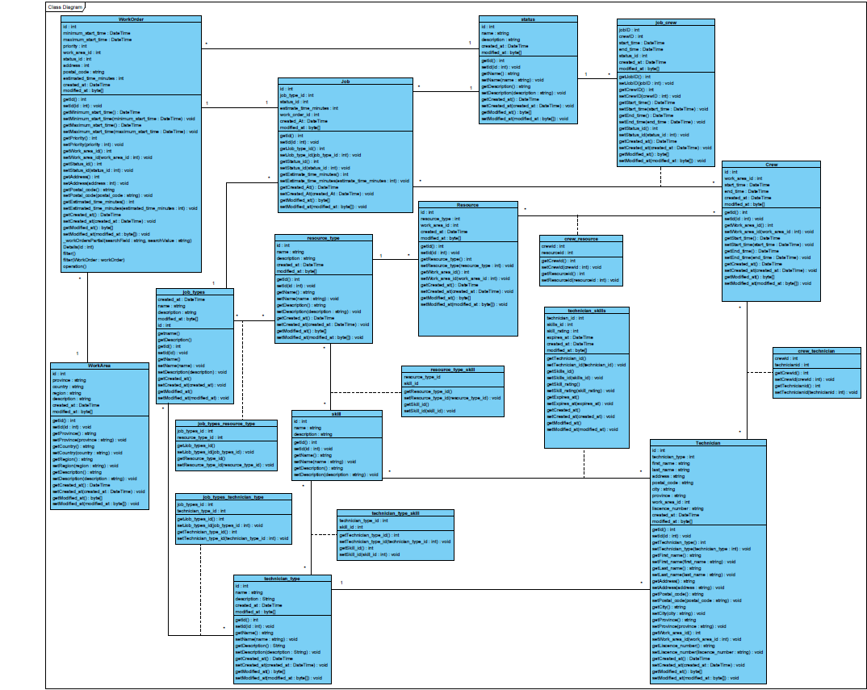

## **13.0 System Sequence Diagrams**

### 13.1 View Dashboard UC#01

**sd**

UC01 - View Scheduler Dashboard

**alt**

[

Login failed

]

[

Login successful

]

Dispatcher

System

Returns "Incorrect Credentials" message

1.2:

1.1:

Scheduler Dashboard is displayed

Logs into Scheduler

1:

### 13.2 Add a Work Order UC#02

**sd**

UC02 - Add a Work Order

**loop**

]

While Work Order details improper

[

**alt**

]

Work Order details proper

[

Work Order details improper

[

]

Dispatcher

System

2.1:

Returns Work Order Details page with incorrect fields highlighted

2.2:

Returns "Work Order Added Successfully" message

2:

Fills in Work Order details

1.1:

Returns blank Work Order Details page

1:

Clicks "Add Work Order" button

### 13.3 Update a Work Order UC#04

**sd**

UC04 - Update a Work Order

**loop**

[

]

While Work Order details improper

**alt**

]

Work Order details improper

[

[

Work Order details proper

]

Dispatcher

System

2.1:

Returns Work Order Details page with incorrect fields highlighted

Returns "Work Order Updated Successfully" message

2.2:

1.1:

Returns Work Order Details page with populated fields

2:

Updates Work Order details

Clicks "Update Work Order" button

1:

### 13.4 Cancel a Work Order UC#05

**sd**

UC05 - Cancel a Work Order

**alt**

]

[

Cancellation canceled

Cancellation confirmed

]

[

Dispatcher

System

3:

Cancels Work Order cancellation

2:

Confirms Work Order cancellation

Returns "Work Order Cancellation Unsuccessful" message

3.1:

2.1:

Returns "Work Order Cancellation Successful" message

Asks for confirmation

1.1:

1:

Clicks "Cancel Work Order" button

### 13.5 Filter Work Order List UC#06

**sd**

UC06 - Filter Work Order List

Dispatcher

System

Returns filtered Work Order list

2.1:

2:

Fills in filters

Returns Work Order filters panel

1.1:

1:

Clicks "Filter Work Orders" button

### 13.6 Search for a Work Order UC#07

**sd**

UC07 - Search for a Work Order

Dispatcher

System

1.1:

Returns filtered Work Order list

1:

Fills in "Search" field and Clicks "Search" button

### 13.7 Dispatch Schedule UC#15

**sd**

UC15 - Dispatch Schedule

]

Dispatch canceled

[

[

Dispatch confirmed

]

**alt**

Errors in scheduling

[

]

Scheduling okay

]

[

**alt**

System

Dispatcher

1.1:

Returns "Errors in Scheduling" message

Returns "Dispatch Unsuccessful" message

3.1:

2.1:

Returns "Dispatch Successful" message

1.2:

Asks for confirmation

3:

Cancels Dispatch request

Confirms Dispatch request

2:

1:

Clicks "Dispatch" button

### 13.8 View Recommended Technicians/Resources UC#20

### 13.9 Assign a Technician to Work Order UC#21

**sd**

UC20 - View Recommended Technicians/Resources

Dispatcher

System

1.1:

Returns recommended Technicians and Resources list

1:

Clicks on a Work Order

**sd**

UC21 - Assign a Technician to Work Order

**alt**

[

Assignment successful

]

[

Scheduling conflict

]

Dispatcher

System

1.1:

Returns "Technician Assignment Unsuccessful" message

Returns "Technician Assignment Successful" message

1.2:

Assigns a Work Order to a Technician and time

1:

### 13.10 Assign a Resource to Work Order UC#22

**sd**

UC22 - Assign a Resource to Work Order

**alt**

[

Scheduling conflict

]

[

Assignment successful

]

Dispatcher

System

1.1:

Returns "Resource Assignment Unsuccessful" message

Returns "Resource Assignment Successful" message

1.2:

Assigns a Work Order to a Resource and time

1:

## **14.0 State Chart Diagrams**

### State Chart Diagram for Work Orders

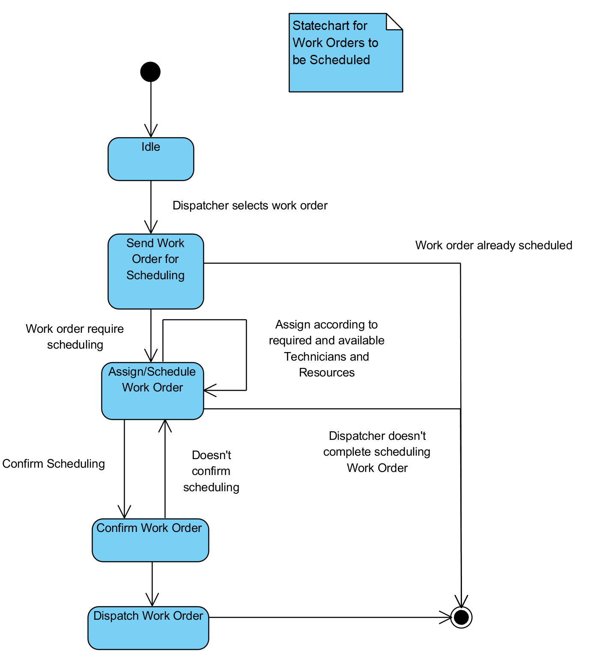

## **15.0 Meeting Agenda / Minutes**

### **2019/01/28**

#### Time:

**12:30**

#### Location:

**Doon Collaboration Room 3**

#### Attendance

|  |  |  |
| --- | --- | --- |
| **Present** | **Regrets** | **Status**  **Report?** |
| Nick Lee |  |  |
| Cynthia Cheng |  |  |
| Thomas Craig |  |  |
| Chris Banks |  |  |
| Daniel Heidt |  |  |
| Ted Byers |  |  |
|  | **Team Status Report?** |  |

#### Agenda

|  |  |
| --- | --- |
| Provide Inception Phase for Client Sign off | Complete |
| Provide updated wireframes | Delayed |
| Discuss Gantt functionality | Complete |

#### Deliverables

|  |  |
| --- | --- |
| Inception Documents for Client Sign Off | Complete |
| Update Wireframes | Delayed |

#### Action Items

|  |  |  |  |
| --- | --- | --- | --- |
| **What** | **Who** | **When** | **Complete?** |
| Look into available Gantt libraries | Cynthia Cheng, Nicholas Lee, Thomas Craig, Chris Banks | 2019.02.04 |  |
| Complete Inception Documentation | Cynthia Cheng, Nicholas Lee, Thomas Craig, Chris Banks | 2019.01.28 | Complete |
| Provide existing example of filters available | Ted Byers | 2019.01.28 | Complete |
| Update Wireframe | Cynthia Cheng | 2019.01.31 |  |
| Client Sign Off | Daniel Heidt | 2019.01.30 |  |

#### Minutes / Notes

|  |
| --- |
| Cynthia was unable to complete update to wireframe images due to illness, to provide by email shortly |
| Discussed Gantt Chart functionality |
| * Dispatcher will be able to right click in Gantt chart |
| * Dispatcher will need to be able to multi-select and batch-dispatch |
| * This will allow a few WOs not to be dispatched if desired – color code of bar and WO row will |
| Change accordingly |
| Will discuss Gantt chart and review libraries next meeting |
| Discussed travel time feature |
| * Will use postal code/zip code reference |
| * Will require calculations to determine how fast the system will assume technicians will travel on |
| average |

### **2019/01/30**

#### Time:

**17:00**

#### Location:

**Doon Collaboration Room 4**

#### Attendance

|  |  |  |
| --- | --- | --- |
| **Present** | **Regrets** | **Status**  **Report?** |
| Nick Lee |  |  |
| Cynthia Cheng |  |  |
| Thomas Craig |  |  |
| Chris Banks |  |  |
| Barbara Pridham |  |  |
|  | **Team Status Report?** |  |

#### Agenda

|  |  |
| --- | --- |
| Hand in Inception Phase | Complete |
| Discuss what to do moving forward | Complete |

#### Deliverables

|  |  |
| --- | --- |
| Hand in Inception phase and sign off | Complete |

#### Action Items

|  |  |  |  |
| --- | --- | --- | --- |
| **What** | **Who** | **When** | **Complete?** |
| Submit Inception Phase | Cynthia Cheng, Nicholas Lee, Thomas Craig, Chris Banks | 2019.01.30 | Complete |

#### Minutes / Notes

|  |
| --- |
| Hand in Inception Phase to Barbara |
| Review Inception Phase submission and discuss moving into iteration 1 |

### **2019/02/04**

#### Time:

**12:30**

#### Location:

**Doon Work Room 2**

#### Attendance

|  |  |  |
| --- | --- | --- |
| **Present** | **Regrets** | **Status**  **Report?** |
| Nick Lee |  |  |
| Cynthia Cheng |  |  |
| Thomas Craig |  |  |
| Chris Banks |  |  |
| Daniel Heidt |  |  |
| Ted Byers |  |  |
|  | **Team Status Report?** |  |

#### Agenda

|  |  |
| --- | --- |
| Review Updated Wireframe | Complete |
| Discuss Gantt Libraries | Complete |
| Discuss UI updates | Complete |

#### Deliverables

|  |  |
| --- | --- |
| Update Wireframes | Complete |
| Provide narrowed list of Gantt libraries |  |

Action Items

|  |  |  |  |
| --- | --- | --- | --- |
| **What** | **Who** | **When** | **Complete?** |
| Look into available Gantt libraries | Cynthia Cheng, Nicholas Lee, Thomas Craig, Chris Banks | 2019.02.04 | Complete |
| Update Wireframe | Cynthia Cheng | 2019.01.31 | Complete |
| Client Sign Off | Daniel Heidt | 2019.01.30 | Complete |
| Narrow list of Gantt libraries | Cynthia Cheng Nicholas Lee, Thomas Craig, Chris Banks | 2019.02.07 |  |
| Finalize availability and SCHED statuses, update requirements document | Daniel Heidt, Ted Byers | 2019.02.11 |  |

#### Minutes / Notes

|  |
| --- |
| Reviewed wireframe update |
| Reviewed list of gantt libraries and more library requirements |
| * Must be printable |
| * Non-availability will be displayed in black bars, WOs should be able to be dragged into the gaps |
| Between existing non-available bars |
| * Drag and drop capable |
| * Must display sperate technician and resource rows |

### **2019/02/06**

#### Time:

**17:00**

#### Location:

**Doon Collaboration Room 4**

#### Attendance

|  |  |  |
| --- | --- | --- |
| **Present** | **Regrets** | **Status**  **Report?** |
| Nick Lee |  |  |
| Cynthia Cheng |  |  |
| Thomas Craig |  |  |
| Chris Banks |  |  |
| Barbara Pridham |  |  |
|  | **Team Status Report?** |  |

#### Agenda

|  |  |
| --- | --- |
| Review Analysis Documentation | Complete |

#### Deliverables

|  |  |
| --- | --- |
| Review Analysis Documentation | Complete |
| Review Design Documentation |  |

#### Action Items

|  |  |  |  |
| --- | --- | --- | --- |
| **What** | **Who** | **When** | **Complete?** |
| Review Design Documentation | Cynthia Cheng, Nicholas Lee, Thomas Craig, Chris Banks | 2019.02.13 |  |

#### Minutes / Notes

|  |
| --- |
| Review Analysis documentation for Iteration 1 |
| Discuss changing meeting time for following week/have a remote meeting Tuesday |

### **2019/02/10**

#### Time:

**2:00**

#### Location:

**Remote - Discord**

#### Attendance

|  |  |  |
| --- | --- | --- |
| **Present** | **Regrets** | **Status**  **Report?** |
| Nick Lee |  |  |
| Cynthia Cheng |  |  |
| Thomas Craig |  |  |
| Chris Banks |  |  |
|  | **Team Status Report?** |  |

#### Agenda

|  |  |
| --- | --- |
| Review status on design documentation | Complete |
| Complete agile backlog | Complete |
| Discuss Construction phase | Complete |

#### Deliverables

|  |  |
| --- | --- |
| Design documentation | Complete |
| Agile Backlog | Complete |

#### Action Items

|  |  |  |  |
| --- | --- | --- | --- |
| **What** | **Who** | **When** | **Complete?** |

#### Minutes / Notes

|  |
| --- |
| Reviewed status of design documentation |
| Completed agile backlog |
| Discussed moving into Construction phase |

### **2019/02/11**

#### Time:

**12:30**

#### Location:

**Teach Me Tech Lab 501-1**

#### Attendance

|  |  |  |
| --- | --- | --- |
| **Present** | **Regrets** | **Status**  **Report?** |
| Nick Lee |  |  |
| Cynthia Cheng |  |  |
| Thomas Craig |  |  |
| Chris Banks |  |  |
| Daniel Heidt |  |  |
| Ted Byers |  |  |
|  | **Team Status Report?** |  |

#### Agenda

|  |  |
| --- | --- |
| Review narrows Gantt Library list and decide on library | Complete |
| Discuss flow for dispatching conflicts |  |
| Review Iteration 1 ERD |  |

#### Deliverables

|  |  |
| --- | --- |
| Provide narrowed list of Gantt libraries | Complete |
| Provide ERD for Circumference to Review |  |

#### Action Items

|  |  |  |  |
| --- | --- | --- | --- |
| **What** | **Who** | **When** | **Complete?** |
| Narrow list of Gantt libraries | Cynthia Cheng Nicholas Lee, Thomas Craig, Chris Banks | 2019.02.07 | Complete |
| Finalize availability and SCHED statuses, update requirements document | Daniel Heidt, Ted Byers | 2019.02.11 | Complete |
| Provide Circumference ERD to review | Chris Banks | 2019.02.11 |  |

#### Minutes / Notes

|  |
| --- |
| Reviewed narrowed down list of Gantt libraries – decided on JSGantt |
| Discussed flow for dispatching conflicts |
| Was to review ERD however ran out of time, Chris to email ERD to Circumference to review |

### **2019/02/11**

#### Time:

**17:00**

#### Location:

**Remote - Google Hangouts**

#### Attendance

|  |  |  |
| --- | --- | --- |
| **Present** | **Regrets** | **Status**  **Report?** |
| Nick Lee |  |  |
| Cynthia Cheng |  |  |
| Thomas Craig |  |  |
| Chris Banks |  |  |
| Barbara Pridham |  |  |
|  | **Team Status Report?** |  |

#### Agenda

|  |  |
| --- | --- |
| Review Design Documentation | Complete |
| Discuss Construction phase and deadlines | Complete |

#### Deliverables

|  |  |
| --- | --- |
| Review Design Documentation | Complete |
| Complete Iteration 1 for Tuesday 19 |  |

#### Action Items

|  |  |  |  |
| --- | --- | --- | --- |
| **What** | **Who** | **When** | **Complete?** |
| Review Design Documentation | Cynthia Cheng, Nicholas Lee, Thomas Craig, Chris Banks | 2019.02.11 | Complete |

#### Minutes / Notes

|  |
| --- |
| Review Design documentation |
| * Had some delays with remote meeting as immediately after a class and not all files were |
| Able to be viewed on initial computer we were remotely screensharing - resolved |
| * Discussed Iteration 1 wrap up and client sign off requirement |

## **16.0 Team Member Status Reports**

### **Chris Banks**

#### Date:

**2019.02.19**

#### Team Member Activities

|  |  |  |
| --- | --- | --- |
| **Category** | **Activity** | **Hours**  **(.25 increments)** |
| DCR | Analysis Level Class Diagram | 3 |
| DBD | Entity Relation Diagram | 4 |
| WEBPR | UI Web Programming | 35 |

#### Team Activty

|  |  |  |
| --- | --- | --- |
| **Location** | **Activity** | **Hours**  **(.25 increments)** |
| Remote via join.me | Client Meeting | 1.25 |
| Doon Collaboration Room 4 | Facilitator Meeting | 1 |
| Remote via Join.me | Client Meeting | 1.25 |
| Doon Collaboration Room 4 | Facilitator Meeting | 1 |
| Remote via Discord | Team Meeting to complete Agile Backlog | 2 |
| Remote via Join.me | Client Meeting | 1.25 |
| Remote Via Discord | Team Activity – Solution and Database setup | 3 |
| **Issues/Obstacles/Dependencies/Problems** | | |
|  | | |
|  | | |
|  | | |

#### Categories:

|  |  |
| --- | --- |
| PM Project Management | WEBPR WEB PRogramming |
| IWC Interacting With Clients | ITEST Interactive TESTing |
| DCR Diagramming and Documenting Client Requirements | ENTPR ENTity class design and PRogramming |
| DOD Diagramming and Documenting Overall Design | ITEST Interactive TESTing |
| TDOC Technical DOCumentation | TPR Technical / lower-level PRogramming |
| CDOC Client DOCumentation | UTEST Unit and integration TESTing |
| GUID GUI Design | DBD DataBase Design |
| WINPR WINdows PRogramming | SQL SQL development |
| WSD Web Site Design | RPT Report Development |
| WPD Web Page Design | INST Installer development |

### **Cynthia Cheng**

#### Date:

**2019.02.19**

#### Team Member Activities

|  |  |  |
| --- | --- | --- |
| **Category** | **Activity** | **Hours**  **(.25 increments)** |
| DCR, DOD, GUID | Navigation Diagram, Updated Lunacy Wireframes, and created Statechart Diagram | 5.5 |
| DCR, DOD, GUID | Updated Lunacy Wireframes | 1 |
| GUID | Created prototype with JustInMind Prototyper | 3 |
| GUID | Updated prototype (Missed search functionality) | 1 |
| PM | Organized all Iteration 1 files for submission to Circumference, updated any missing diagrams/descriptions | 2 |
| PM | Updated Iteration 1 files for submission to Barbara | 1 |

#### Team Activty

|  |  |  |
| --- | --- | --- |
| **Location** | **Activity** | **Hours**  **(.25 increments)** |
| Remote via Discord | Team Meeting to complete Agile Backlog | 2 |
| Remote via Discord | Team Activity – Construction | 7 |
| Remote via Discord | Team Activity – Construction | 8 |
| Remote via Discord | Team Activity – Construction | 6 |
| **Issues/Obstacles/Dependencies/Problems** | | |
| Using Lunacy for Wireframes, issue with saving when using existing sketch resources taking more time to create and update wireframes -> required recreating all field information every change to GUI | | |
|  | | |
|  | | |

#### Categories:

|  |  |
| --- | --- |
| PM Project Management | WEBPR WEB PRogramming |
| IWC Interacting With Clients | ITEST Interactive TESTing |
| DCR Diagramming and Documenting Client Requirements | ENTPR ENTity class design and PRogramming |
| DOD Diagramming and Documenting Overall Design | ITEST Interactive TESTing |
| TDOC Technical DOCumentation | TPR Technical / lower-level PRogramming |
| CDOC Client DOCumentation | UTEST Unit and integration TESTing |
| GUID GUI Design | DBD DataBase Design |
| WINPR WINdows PRogramming | SQL SQL development |
| WSD Web Site Design | RPT Report Development |
| WPD Web Page Design | INST Installer development |

### **Nicholas Lee**

#### Date:

**2019.02.16**

#### Team Member Activities

|  |  |  |
| --- | --- | --- |
| **Category** | **Activity** | **Hours**  **(.25 increments)** |
| DOD | Use case descriptions activity diagram | 0.5 |
| DOD | Design Class Diagram | 2 |
| WEBPR | Programming Work Order Crud | 4 |
| WEBPR | Programming Work order crud | 4 |
| WEBPR | Programming assign technician/resource and Book work order | 7 |
| WEBPR | Basic front end/bug fixes | 4 |
| UTEST | Tests/bug fixes | 5 |

#### Team Activty

|  |  |  |
| --- | --- | --- |
| **Location** | **Activity** | **Hours**  **(.25 increments)** |
| Doon collab room 3 | Client Meeting | 1.25 |
| Doon collab room 4 | Facilitator meeting | 1 |
| Doon Work room 2 | Client meeting | 1.25 |
| Doon collab room 4 | Facilitator meeting | 1 |
| Remote via discord | Team meeting to complete Agile Backlog | 2 |
| Teach me tech lab 501 | Client meeting | 1.25 |
| Remote via google hangouts | Facilitator Meeting | 1 |
| Remote via discord | Team Activity – Solution and database setup | 3 |
| Remote via discord | Team Activity - Construction | 7 |
| Remote via discord | Team Activity – Construction | 8 |
| Remote via discord | Team Activity - Construction | 6 |
| **Issues/Obstacles/Dependencies/Problems** | | |
| Front end was more difficult than expected due to multiple models being on a single view | | |
| Difficulties with getting unit tests running | | |
|  | | |

#### Categories:

|  |  |
| --- | --- |
| PM Project Management | WEBPR WEB PRogramming |
| IWC Interacting With Clients | ITEST Interactive TESTing |
| DCR Diagramming and Documenting Client Requirements | ENTPR ENTity class design and PRogramming |
| DOD Diagramming and Documenting Overall Design | ITEST Interactive TESTing |
| TDOC Technical DOCumentation | TPR Technical / lower-level PRogramming |
| CDOC Client DOCumentation | UTEST Unit and integration TESTing |
| GUID GUI Design | DBD DataBase Design |
| WINPR WINdows PRogramming | SQL SQL development |
| WSD Web Site Design | RPT Report Development |
| WPD Web Page Design | INST Installer development |

### **Thomas Craig**

#### Date:

**2019.02.16**

#### Team Member Activities

|  |  |  |
| --- | --- | --- |
| **Category** | **Activity** | **Hours**  **(.25 increments)** |
| DCR | Analysis Level System Sequence Diagrams | 3 |
| DOD | Design Level System Sequence Diagrams | 5 |
| WEBPR | Coding Filter Front end | 2.5 |

#### Team Activty

|  |  |  |
| --- | --- | --- |
| **Location** | **Activity** | **Hours**  **(.25 increments)** |
| Doon Collaboration Room 3 | Client Meeting | 1.25 |
| Doon Collaboration Room 4 | Facilitator Meeting | 1 |
| Doon Work Room 2 | Client Meeting | 1.25 |
| Doon Collaboration Room 4 | Facilitator Meeting | 1 |
| Remote via Discord | Team Meeting to complete Agile Backlog | 2 |
| Tech Me Tech Lab 501-1 | Client Meeting | 1.25 |
| Remote via Google Hangouts | Facilitator Meeting | 1 |
| Remote via Discord | Team Activity – Construction | 7 |
| Remote via Discord | Team Activity – Construction | 8 |
| Remotes via Discord | Team Activity – Construction | 6 |
| **Issues/Obstacles/Dependencies/Problems** | | |
|  | | |
|  | | |
|  | | |

#### Categories:

|  |  |
| --- | --- |
| PM Project Management | WEBPR WEB PRogramming |
| IWC Interacting With Clients | ITEST Interactive TESTing |
| DCR Diagramming and Documenting Client Requirements | ENTPR ENTity class design and PRogramming |
| DOD Diagramming and Documenting Overall Design | ITEST Interactive TESTing |
| TDOC Technical DOCumentation | TPR Technical / lower-level PRogramming |
| CDOC Client DOCumentation | UTEST Unit and integration TESTing |
| GUID GUI Design | DBD DataBase Design |
| WINPR WINdows PRogramming | SQL SQL development |
| WSD Web Site Design | RPT Report Development |
| WPD Web Page Design | INST Installer development |

## **17.0 Team Status Report**

### Date:

**2019.02.19**

### Team Meetings and Activities

|  |  |  |  |  |
| --- | --- | --- | --- | --- |
| **Location** | **Team Meeting / Team Activity** | **Present**  (list of initials) | **Date**  YYYY.MM.DD | **Duration**  (nearest .25 hr) |
| Doon Collaboration Room 3 | Client Meeting | NL, CC, TC, CB | 2019.01.28 | 1.25 |
| Doon Collaboration Room 4 | Facilitator Meeting | NL, CC, TC, CB | 2019.01.30 | 1 |
| Doon Work Room 2 | Client Meeting | NL, CC, TC, CB | 2019.02.04 | 1.25 |
| Doon Collaboration Room 4 | Facilitator Meeting | NL, CC, TC, CB | 2019.02.06 | 1 |
| Remote via Discord | Team Meeting to complete Agile Backlog | NL, CC, TC, CB | 2019.02.10 | 2 |
| Tech Me Tech Lab 501-1 | Client Meeting | NL, CC, TC, CB | 2019.02.11 | 1.25 |
| Remote via Google Hangouts | Facilitator Meeting | NL, CC, TC | 2019.02.11 | 1 |
| Remote via Discord | Team Activity – Solution and Database setup | NL, CB | 2019.02.12 | 3 |
| Remote via Discord | Team Activity – Construction | NL, CC, TC | 2019.02.13 | 7 |
| Remote via Discord | Team Activity – Construction | NL, CC, TC | 2019.02.15 | 8 |
| Remotes via Discord | Team Activity – Construction | NL, CC, TC | 2019.02.16 | 6 |
| **Issues/Obstacles/Dependencies/Problems** | | | | |
|  | | | | |

## **18.0 Agile Backlog**

## **19.0 Agile Release Summary**



Iteration 1: Design

## **20.0 Design Class Diagram**

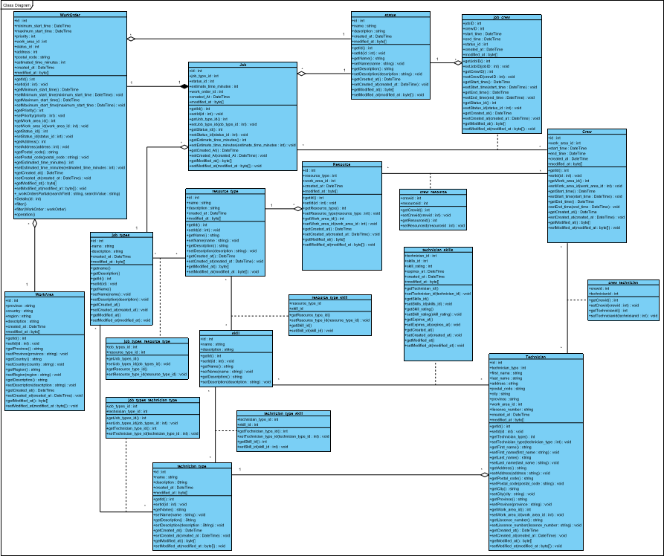

## **21.0 System Sequence Diagrams**

### 21.1 View Dashboard UC#01

**sd**

UC01 - View Scheduler Dashboard

**alt**

]

Login failed

[

Login successful

[

]

Dispatcher

<<

control

>>

User Management Controller

<<

system

>>

Database

1.3:

Credentials are invalid

1.2:

Credentials are valid

1.1:

Verifies Credentials

1.3.1:

Returns "Incorrect Credentials" message

1.3:

Scheduler Dashboard is displayed

1:

Logs into Scheduler

### 21.2 Add a Work Order UC#02

### 21.3 View a Work Order UC#03

**sd**

UC03 - View a Work Order

Dispatcher

>>

control

<<

Work Order Controller

>>

entity

<<

Jobs List

>>

system

<<

Database

>>

entity

<<

Work Order

1.4:

Work Order details

Retrieve Work Order details

1.3:

1.8:

Jobs List for Work Order

1.7:

Retrieve Jobs List for Work Order

1.6:

Jobs List

1.5:

Create Jobs List

Work Order

1.2:

1.1:

Create Work Order

1.9:

The Work Order's details are returned

Clicks on a Work Order

1:

### 21.4 Update a Work Order UC#04

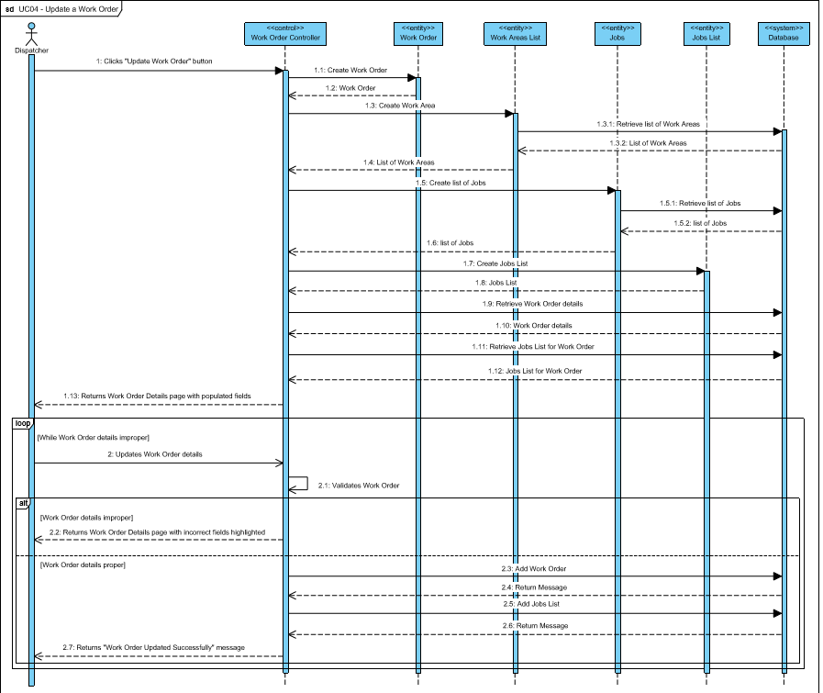

### 21.5 Cancel a Work Order UC#05

**sd**

UC05 - Cancel a Work Order

**alt**

]

[

Cancellation canceled

]

Cancellation confirmed

[

Dispatcher

>>

<<

control

Work Order Controller

>>

entity

<<

Work Order

system

>>

<<

Database

Return Message

2.6:

2.5:

Cancel Work Order

Work Order details

2.4:

Retrieve Work Order details

2.3:

2.2:

Work Order

Create Work Order

2.1:

3:

Cancels Work Order cancellation

Confirms Work Order cancellation

2:

3.1:

Returns "Work Order Cancellation Unsuccessful" message

2.7:

Returns "Work Order Cancellation Successful" message

Asks for confirmation

1.1:

Clicks "Cancel Work Order" button

1:

### 21.6 Filter Work Order List UC#06

**sd**

UC06 - Filter Work Order List

Dispatcher

<<

control

>>

Work Order Controller

<<

>>

entity

Work Order Filter

<<

system

>>

Database

1.2:

Work Order Filter

1.1:

Create Work Order Filter

2.2:

Returns Work Order list

2.1:

Retrieve Work Orders that fulfill filter requirements

2.3:

Returns filtered Work Order list

2:

Fills in filters

1.3:

Returns Work Order filters panel

1:

Clicks "Filter Work Orders" button

### 21.7 Search for a Work Order UC#07

**sd**

UC07 - Search for a Work Order

Dispatcher

<<

control

>>

Work Order Controller

<<

system

>>

Database

1.2:

Returns filtered Work Order list

1.1:

Retrieve Work Orders that match search criteria

1.3:

Returns filtered Work Order list

1:

Fills in "Search" field and Clicks "Search" button

### 21.8 Dispatch Schedule UC#15

**sd**

UC15 - Dispatch Schedule

**alt**

[

Scheduling okay

]

**alt**

]

[

Dispatch canceled

[

Dispatch confirmed

]

[

]

Errors in scheduling

Dispatcher

>>

<<

control

Schedule Controller

<<

>>

system

Database

entity

<<

>>

Schedule

Return Message

2.2:

Update Schedules

2.1:

1.5:

Returns "No errors in Scheduling" message

1.4:

Returns "Errors in Scheduling" message

Check schedules for conflicts

1.3:

Schedule

1.2:

Create Schedule

1.1:

1.5:

Returns "Errors in Scheduling" message

3.1:

Returns "Dispatch Unsuccessful" message

2.3:

Returns "Dispatch Successful" message

Asks for confirmation

1.5.1:

3:

Cancels Dispatch request

Confirms Dispatch request

2:

Clicks "Dispatch" button

1:

### 21.9 View Recommended Technicians/Resources UC#20

**sd**

UC20 - View Recommended Technicians/Resources

Dispatcher

>>

control

<<

Schedule Controller

<<

>>

entity

Resources List

>>

system

<<

Database

>>

entity

<<

Job

1.9:

Returns recommended Technicians and Resources list

1.8:

List of Resources

1.4:

Job details

1.3:

Retrieve Job details

Job

1.2:

1.7:

Retrieve list of Resources that meet Work Order Criteria

1.6:

Resources List

1.5:

Create Resources List

Create Job

1.1:

1:

Clicks on a Work Order

### 21.10 Assign a Technician to a Work Order UC#21

**sd**

UC21 - Assign a Technician to Work Order

**alt**

]

Assignment successful

[

]

Scheduling conflict

[

Dispatcher

<<

>>

control

Schedule Controller

>>

entity

<<

Crew

>>

system

<<

Database

<<

entity

>>

Job

>>

entity

<<

Technician

Return Message

1.13.6:

Add Crew

1.13.5:

1.13.4:

Return Message

Add scheduled time to Crew

1.13.3:

Return Message

1.13.2:

Adds Technician to Crew

1.13.1:

1.13:

Returns "Technician has no conflicts" message

1.12:

Returns "Technician has conflict" message

1.11:

Check Technician schedule for conflicts

Job details

1.8:

Retrieve Job details

1.7:

1.6:

Job

1.5:

Create Job

1.10:

Crew

1.9:

Create Crew

Technician Details

1.4:

Retrieve Technician Details

1.3:

Technician

1.2:

Create Technician

1.1:

1.13:

Returns "Technician Assignment Unsuccessful" message

1.13.7:

Returns "Technician Assignment Successful" message

Assigns a Work Order to a Technician and time

1:

### 21.11 Assign a Resource to a Work Order UC#22

**sd**

UC22 - Assign a Resource to Work Order

**alt**

]

Scheduling conflict

[

[

Assignment successful

]

entity

<<

>>

Resource

<<

entity

>>

Job

>>

system

<<

Database

>>

entity

<<

Crew

<<

>>

control

Schedule Controller

Dispatcher

1.2:

Resource

1.1:

Create Resource

1.6:

Job

1.5:

Create Job

Return Message

1.13.6:

Returns "Resource has no conflicts" message

1.13:

1.12:

Returns "Resource has conflict" message

1.8:

Job details

1.4:

Resource Details

1.13.5:

Add Crew

1.11:

Check Resource schedule for conflicts

Retrieve Job details

1.7:

1.3:

Retrieve Resource Details

1.13.4:

Return Message

1.13.2:

Return Message

1.10:

Crew

1.13.3:

Add scheduled time to Crew

1.13.1:

Adds Resource to Crew

1.9:

Create Crew

Returns "Resource Assignment Unsuccessful" message

1.13:

1.13.7:

Returns "Resource Assignment Successful" message

Assigns a Work Order to a Resource and time

1:

## **22.0 Navigation Diagram**

## **23.0 Original Wireframes**

### 23.1 Dispatcher Dashboard

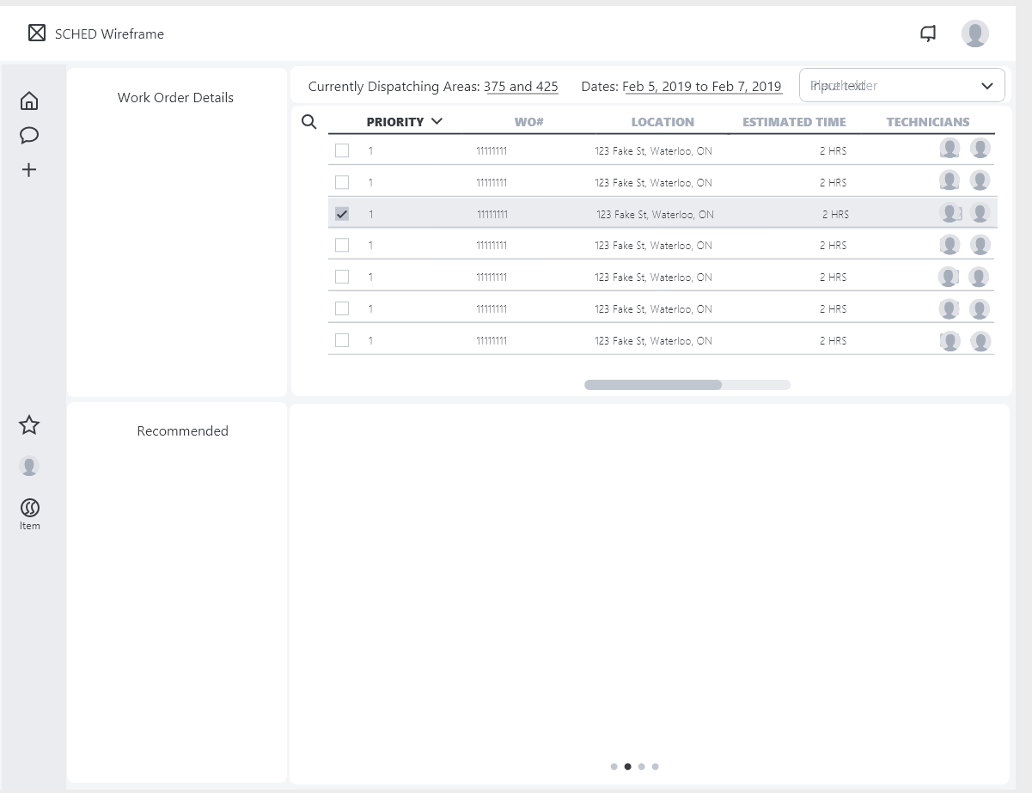

### 23.2 Search

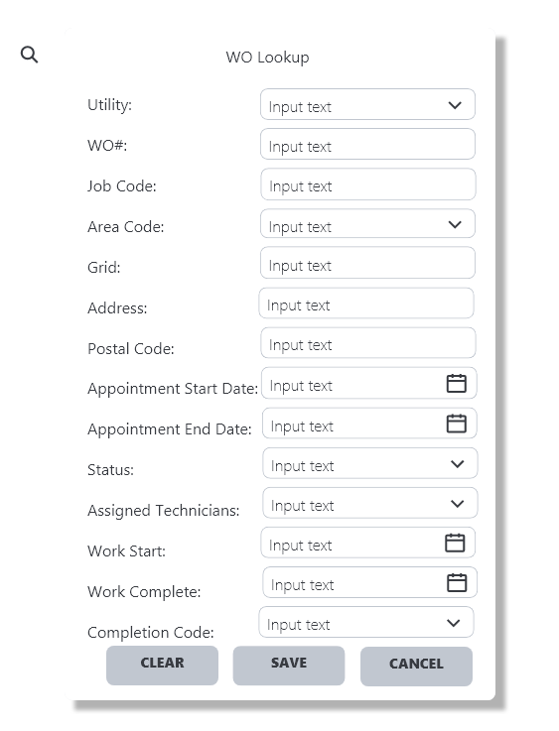

### 23.3 Upper Filters

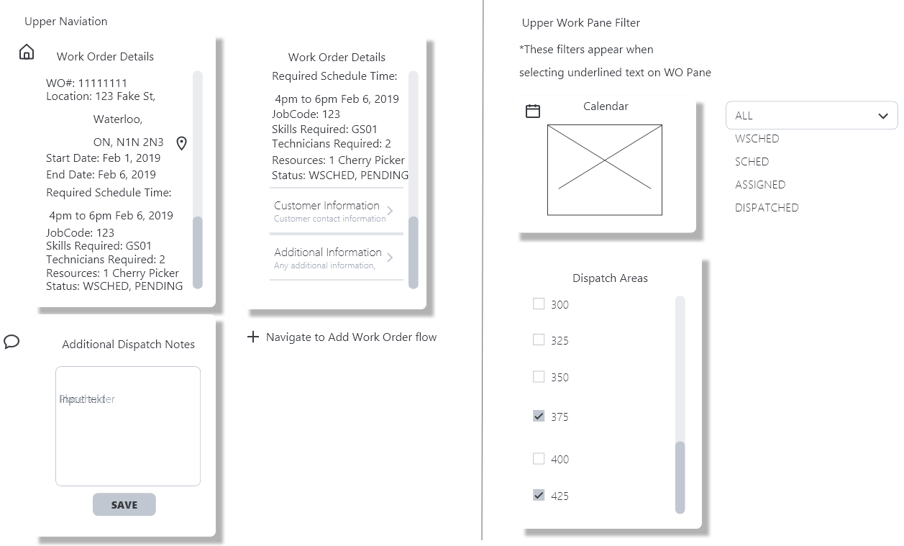

### 23.4 Lower Filters

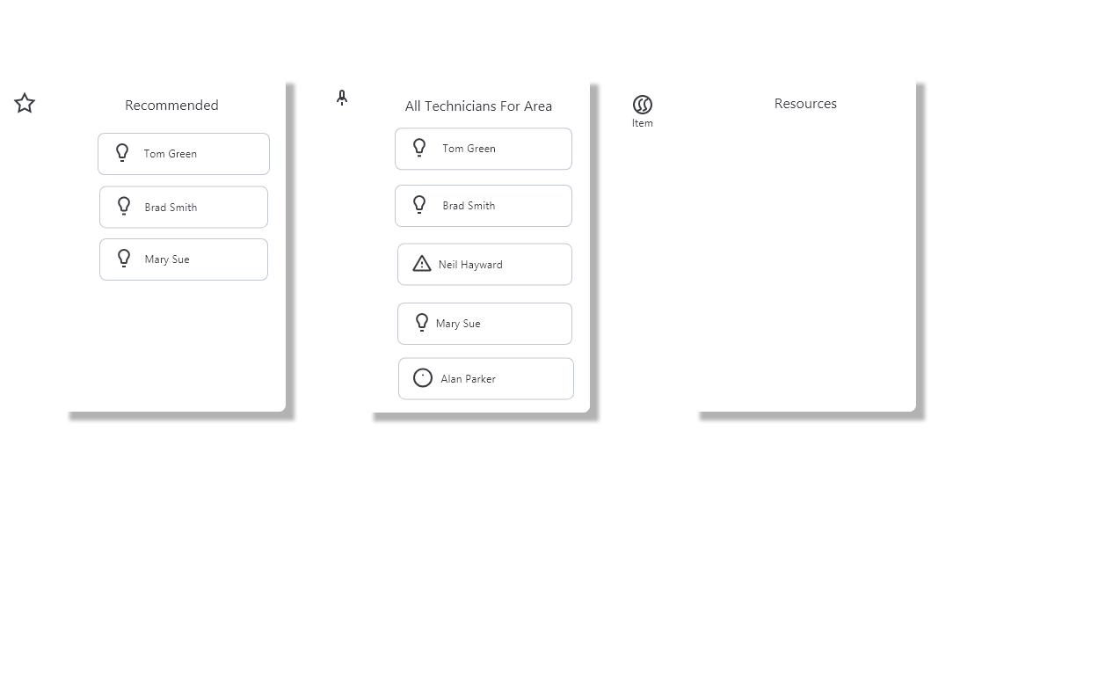

### 23.5 Work Order Pane

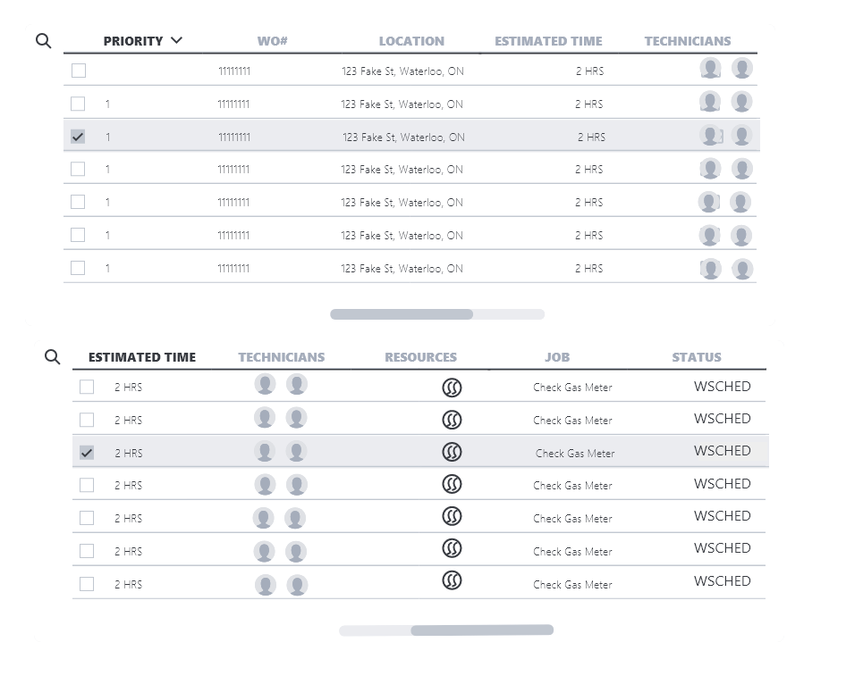

## **24.0 Prototype Screen Captures**

### 24.1 Dashboard without work order selected

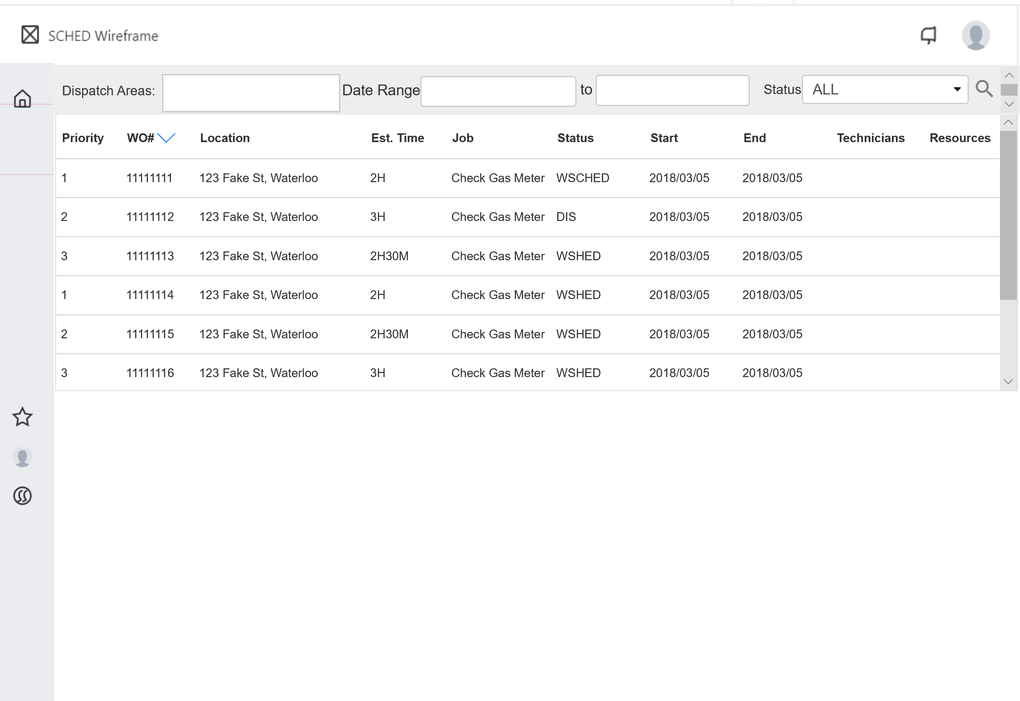

### 24.2 Search Options

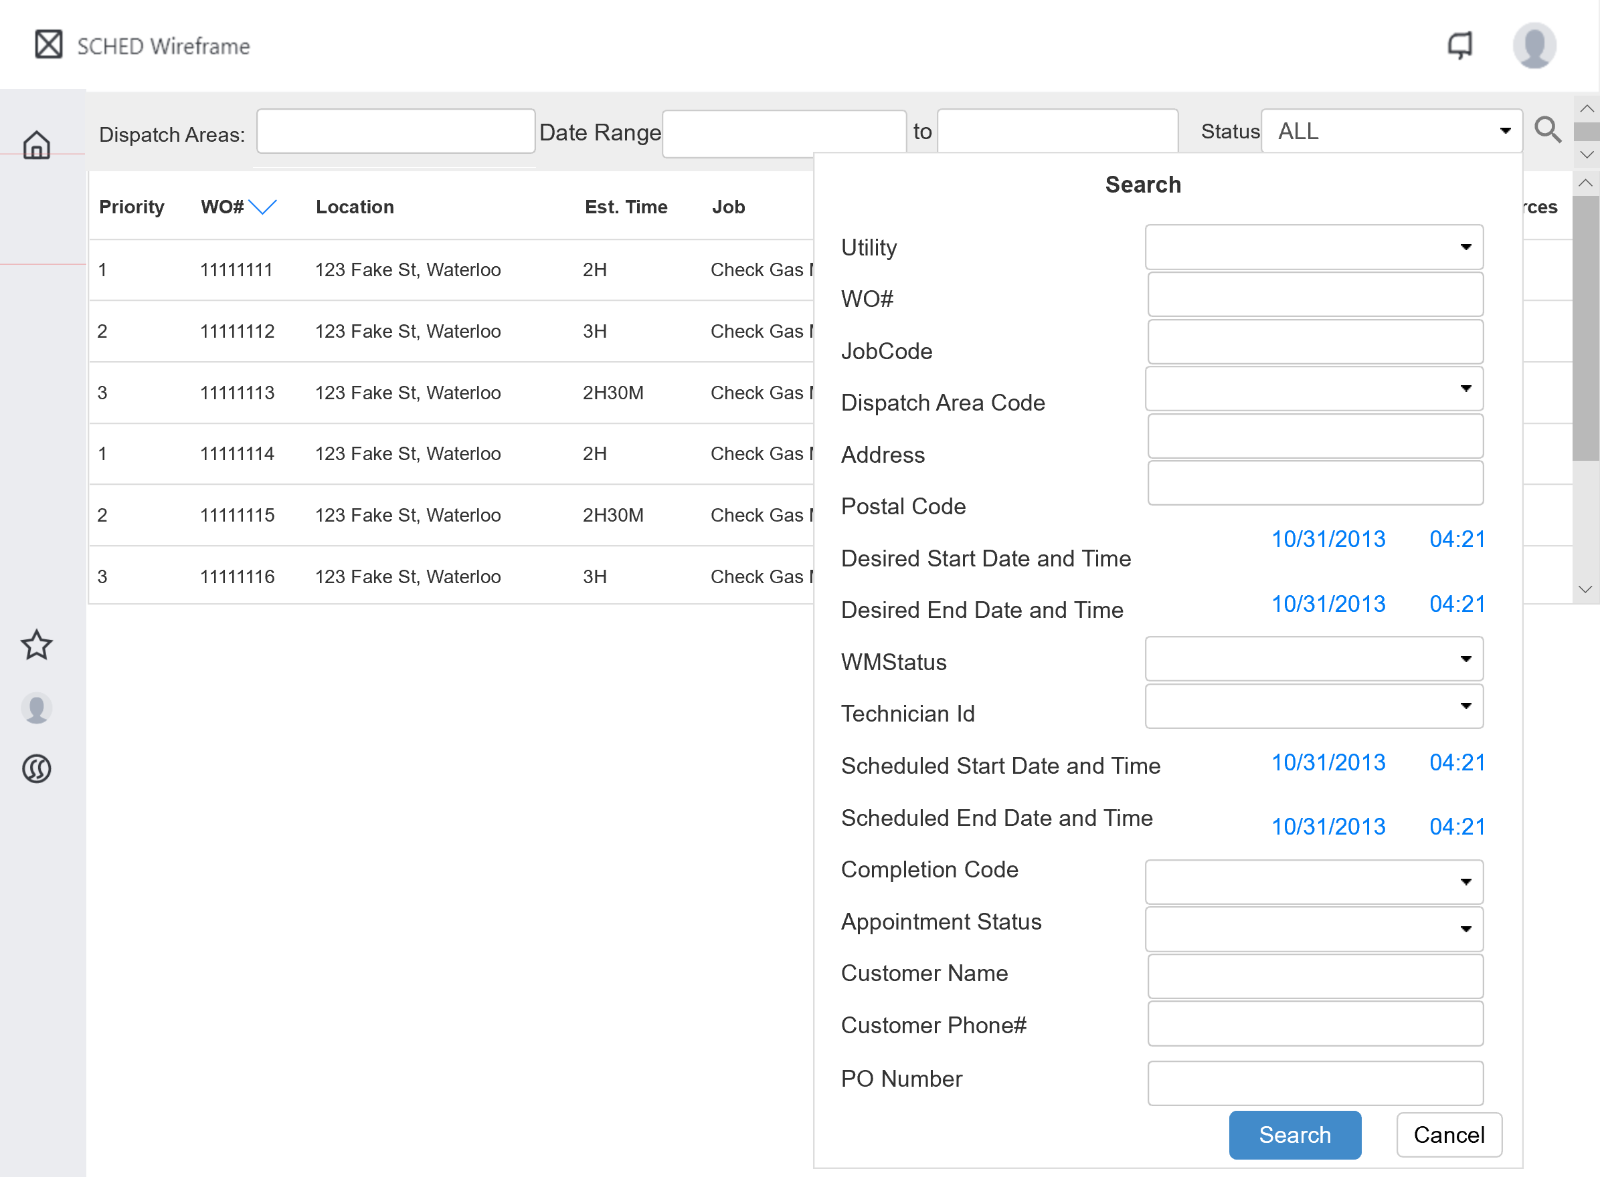

### 24.3 Work Order Selected

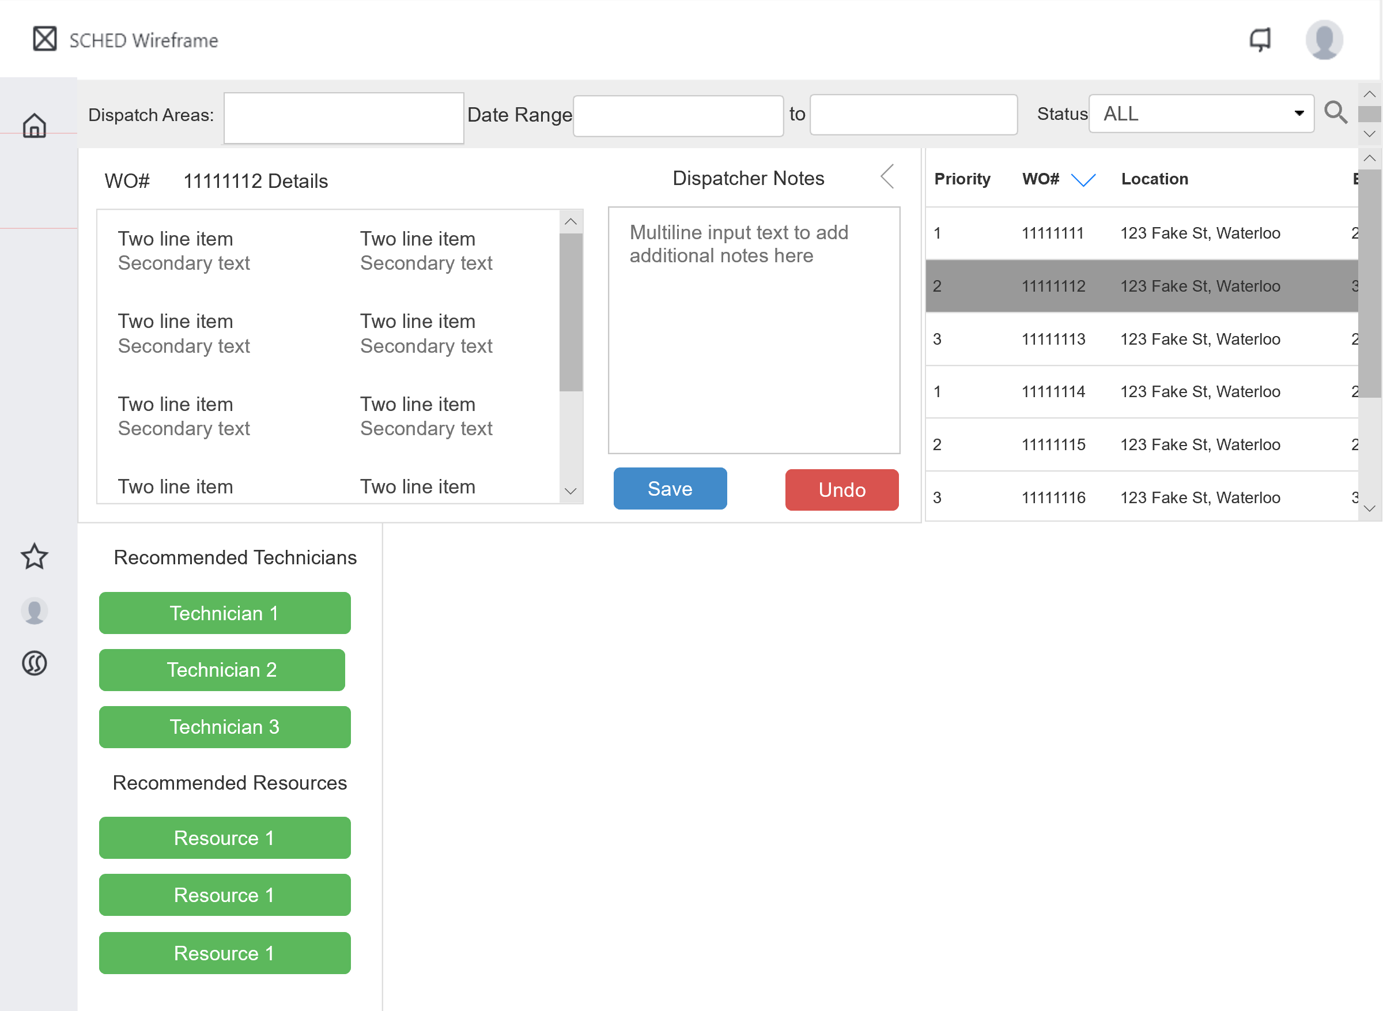

### 24.4 Recommendations – All Technicians

24.5 Recommendations – All Resources  
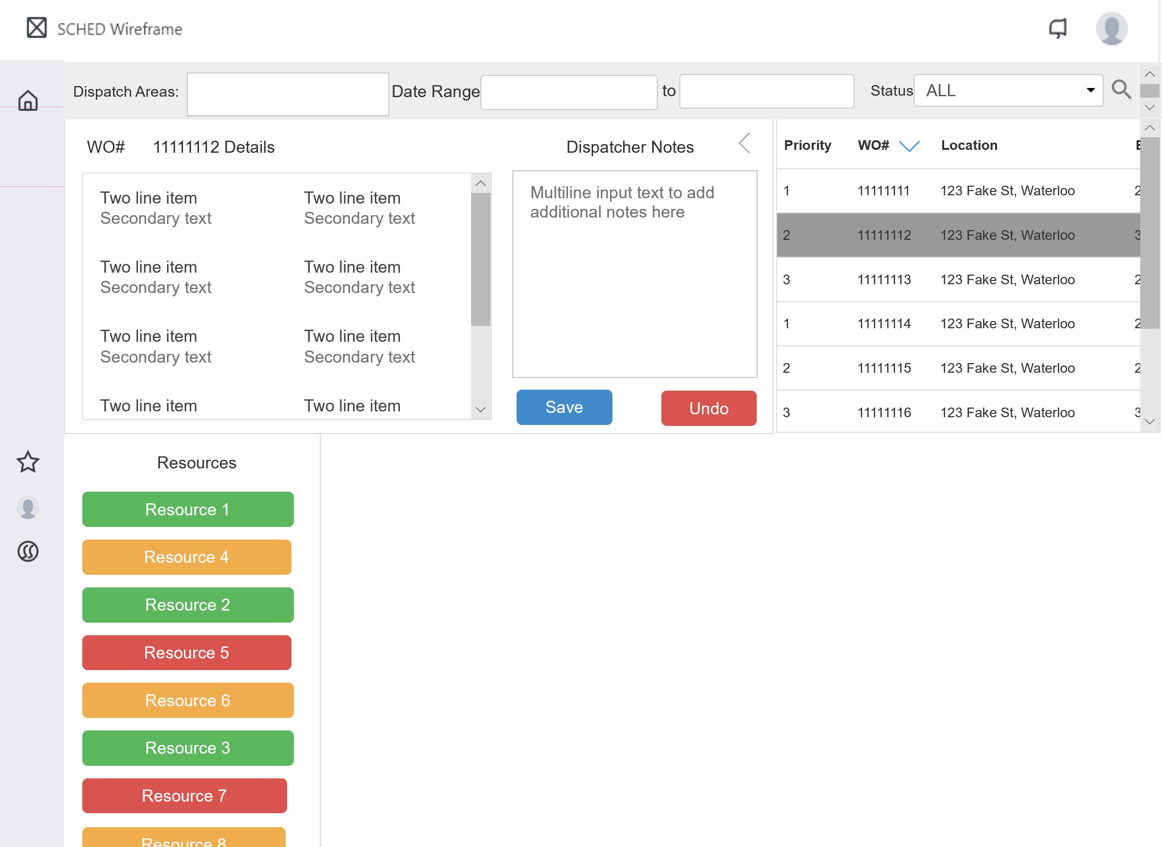

## **25.0 Entity Relation Diagram**

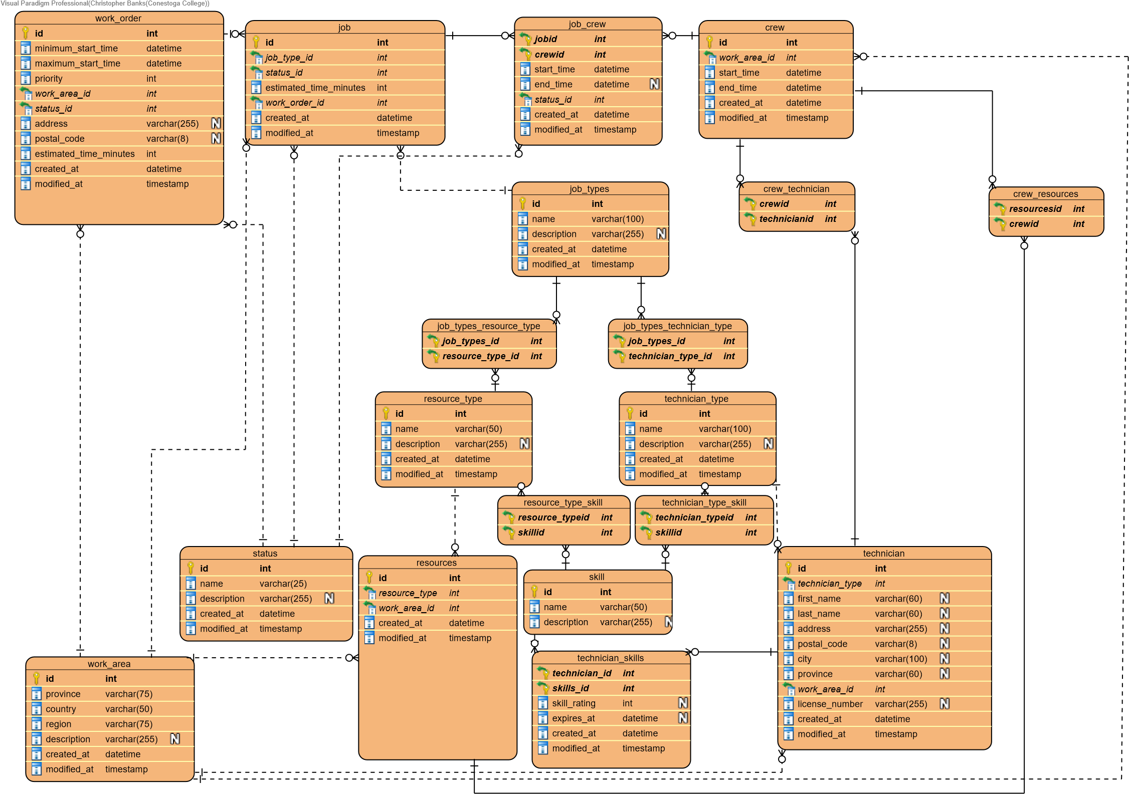

## **26.0 Data Dictionary**

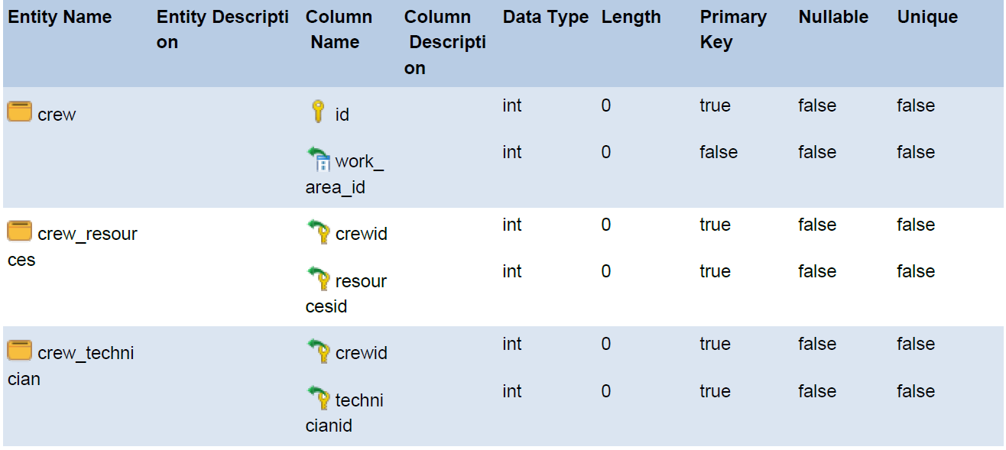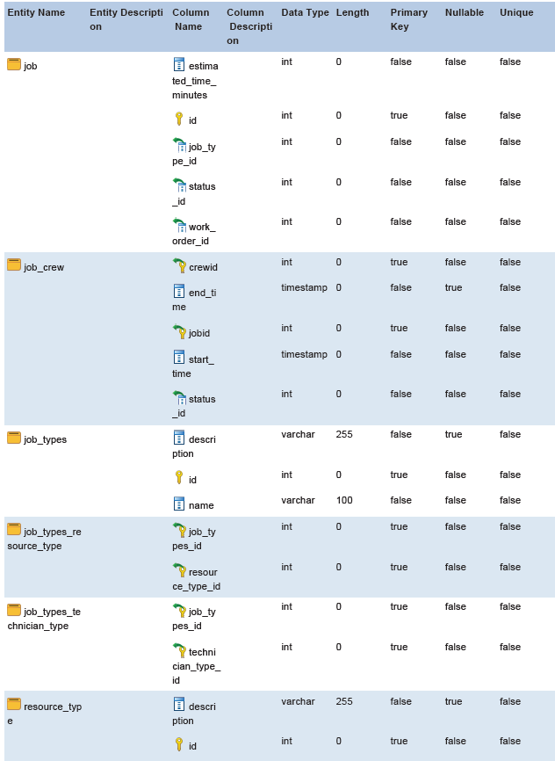

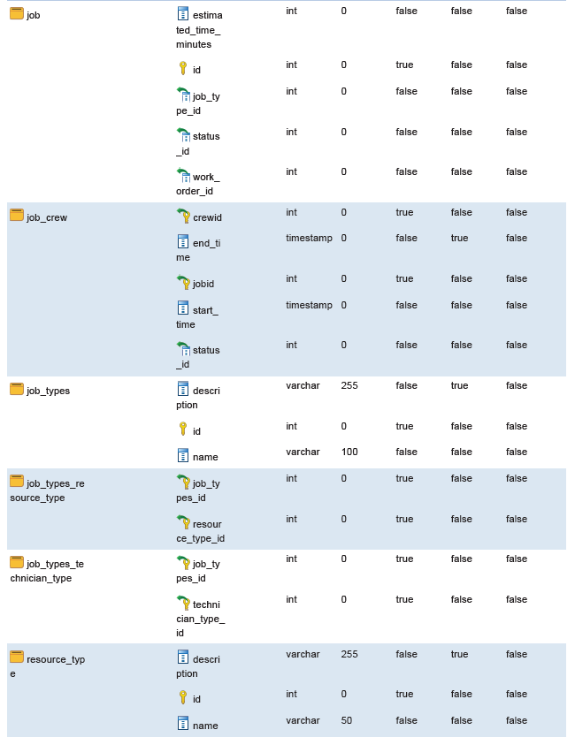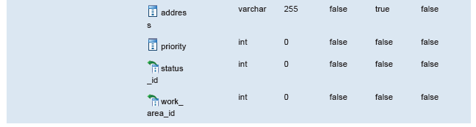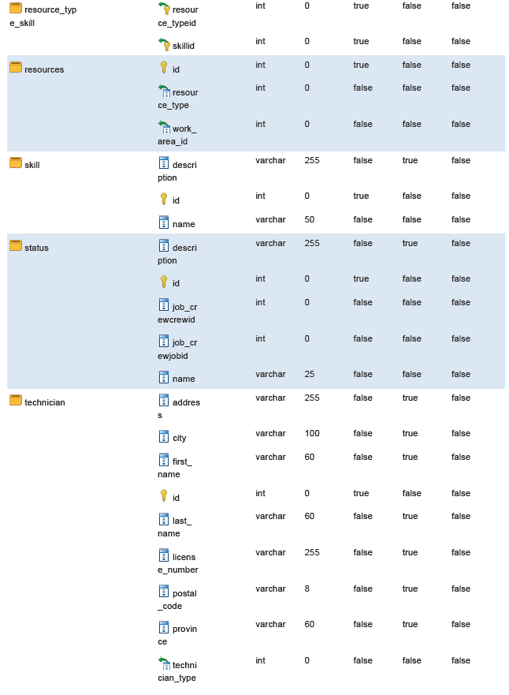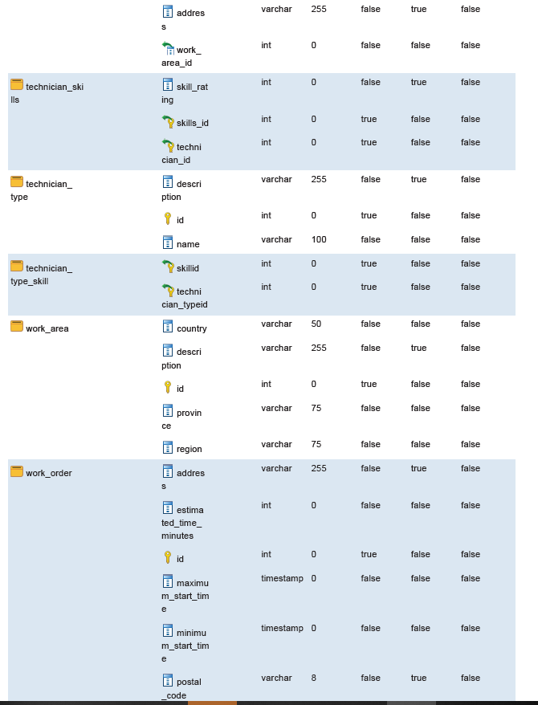

Iteration 1: Construction

## **27.0 Screen Captures**

### 27.1 Dashboard

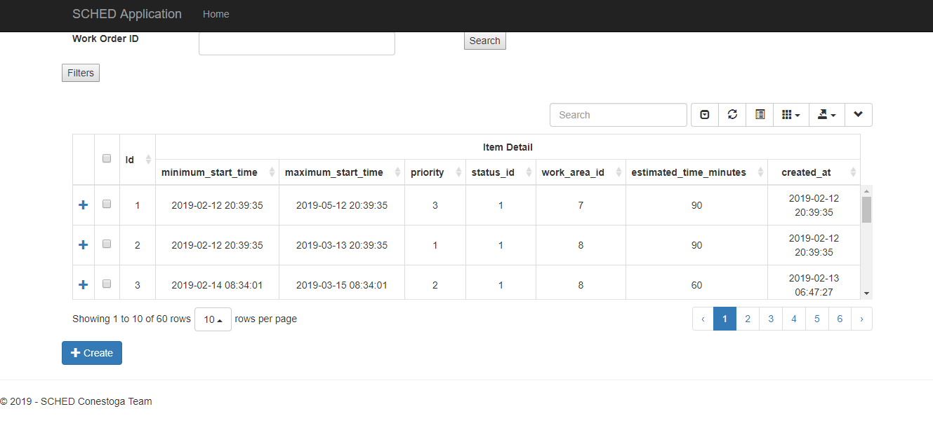

### 27.2 Filters and Search

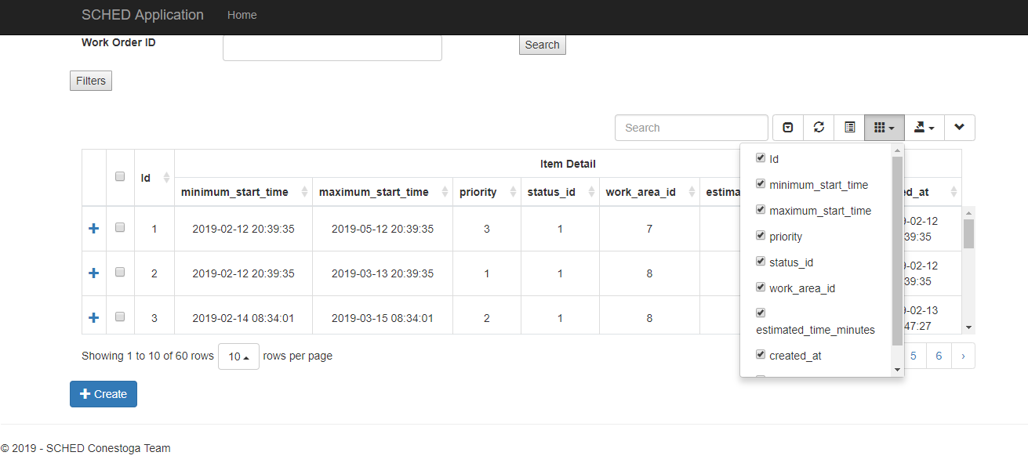

### 27.3 Advanced Search

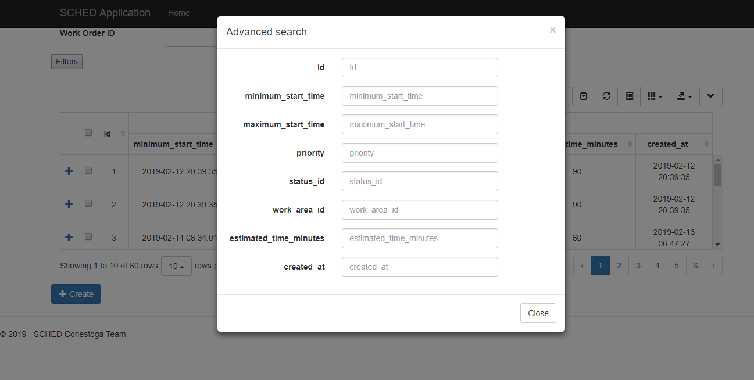

### 27.4 Select a Work Order in Work Order List

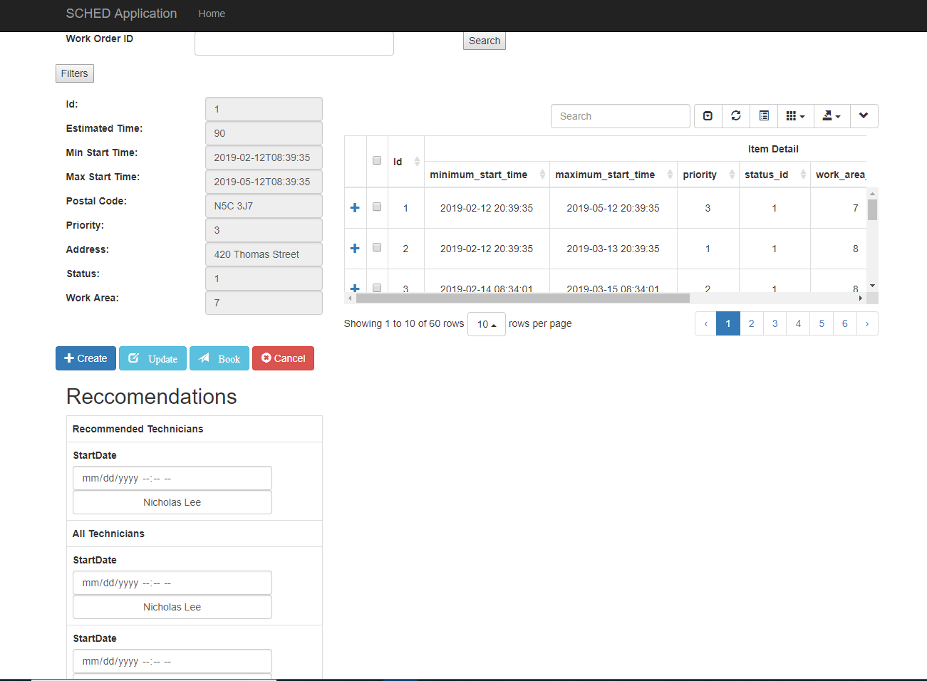

## **28.0 Unit Tests**

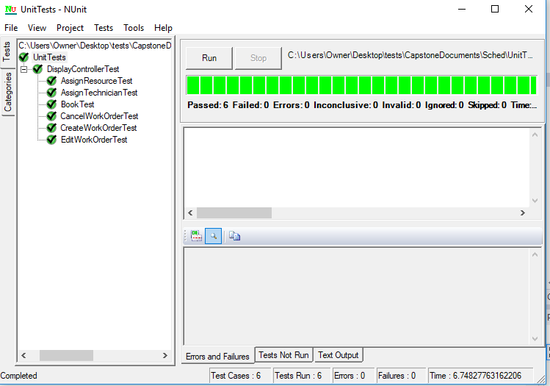

## **29.0 Agile Backlog**

## **30.0 Client Sign-off**



Iteration 2: Analysis

## **31.0 Use Case Diagram**

## **32.0 Use Case Descriptions**

### **32.1 Schedule a Resource for Work Order UC#08**

|  |  |  |
| --- | --- | --- |
| Use Case # | **UC08** | |
| Use Case Name | **Schedule Resource for Work Order (Gantt Chart)** | |
| Scenario | Dispatcher wants to scheduler a resource for a work order | |
| Triggering Event | Dispatcher drags work order onto resource schedule in the Gantt schedule | |
| Brief Description | Dispatcher schedules resource using Gantt UI | |
| Actors | Dispatcher | |
| Related Use Cases | UC22, UC21, UC09 | |
| Stakeholders | Dispatcher | |
| Pre-conditions | Resource matches work order requirements, work area and availability | |
| Post-conditions | Resource is scheduled and its availability is updated | |
| Flow of Events | **Actor** | **System** |
| 1 Dispatcher drags a work order from work order list into a resource’s schedule onto the gantt chart  2. Dispatcher clicks Save Changes button | * 1. System validates if time slot is valid with work order resource requirements, work order desired date and time range, and resource availability   1.3 System updates gantt chart to add work order to resource  1.4 System refreshes gantt ui to display added work order    2.1 System validates changes to gantt chart matching resource availability and work order requirements  2.2 System updates database with changes  2.3 System displays refreshes gantt ui to reflect updates |
| Exception  Conditions |  | * 1. If 1.1 not valid or System is not available, System will display an error to that resource can’t be booked   2.2 If 2.1 not valid or System is down, System will display an error it is unable to save changes |

### **32.2 Schedule a Technician for Work Order UC#09**

|  |  |  |
| --- | --- | --- |
| Use Case # | **UC09** | |
| Use Case Name | **Schedule Technician for Work Order (Gantt Chart)** | |
| Scenario | Dispatcher Wants to Schedule a Technician for a Work Order | |
| Triggering Event | Dispatcher selects Work Order from Work Order list | |
| Brief Description | Dispatcher schedules technician | |
| Actors | Dispatcher | |
| Related Use Cases | UC08 UC21 , UC22 | |
| Stakeholders | Dispatcher | |
| Pre-conditions | Technician matches work order requirements, work area and availability | |
| Post-conditions | Technician scheduled | |
| Flow of Events | **Actor** | **System** |
| 1 Dispatcher drags a work order from work order list into a technician's schedule in the gantt chart  2. Dispatcher clicks Save Changes | 1.1 System validates if time slot is valid with work order, technician requirements, work order desired date and time range, and technician availability  1.3 System updates gantt chart to add work order to technician  1.4 System refreshes gantt ui to display added work order  2.1 System validates changes to the gantt chart matching technician's availability and work order requirements  2.3 System updates database with changes  2.4 System displays refreshed gantt ui to reflect updates |
| Exception  Conditions |  | 1.2 If 1.1 not valid, System displays an error to the user that technician can’t be booked  2.2 If 2.1 not valid or System is down, System will display an error it is unable to save changes |

### **32.3 Cancel Work Order Assignment of Resource UC#10**

|  |  |  |
| --- | --- | --- |
| Use Case # | **UC10** | |
| Use Case Name | **Cancel Work Order Assignment of Resource (Gantt Chart)** | |
| Scenario | Dispatcher wants to cancel work order assignment of resource | |
| Triggering Event | Dispatcher clicks Cancel link in Work Order Task Info hover in Gantt Chart on a Resource row | |
| Brief Description | Resource assignment is cancelled | |
| Actors | Dispatcher | |
| Related Use Cases | UC22, UC21, UC09, UC08, UC11 | |
| Stakeholders | Dispatcher | |
| Pre-conditions | Resource must be scheduled to the Work Order | |
| Post-conditions | Resource is no longer assigned to Work Order | |
| Flow of Events | **Actor** | **System** |
| 1 Dispatcher clicks cancel on a work order in a resource's schedule’s on hover task information in the gantt chart   * 1. Dispatcher rejects confirmation   2 Dispatcher accepts confirmation | 1.1 System validates if work can be cancelled  1.3 System prompts Dispatcher to confirm cancellation   * 1. System displays Work Order still in resource's schedule   2.1 System unschedules resource from work order  2.2 System displays schedule with work order no longer scheduled to resource |
| Exception  Conditions |  | * 1. If 1.1 not valid or System is not available System displays an error that work order can’t be cancelled   2.2 If System is not available System displays an error that work order can’t be cancelled |

### **32.4 Cancel Work Order Assignment of Technician UC#11**

|  |  |  |
| --- | --- | --- |
| Use Case # | **UC11** | |
| Use Case Name | **Cancel Work Order Assignment of Technician (Gantt Chart)** | |
| Scenario | Dispatcher wants to cancel work order assignment of technician | |
| Triggering Event | Dispatcher clicks Cancel link in Work Order Task Info hover in Gantt Chart on a Technician row | |
| Brief Description | Technician assignment is cancelled | |
| Actors | Dispatcher | |
| Related Use Cases | UC22, UC21, UC09, UC08, UC10 | |
| Stakeholders | Dispatcher | |
| Pre-conditions | Technician must be scheduled to the Work Order | |
| Post-conditions | Technician is no longer assigned to work Order | |
| Flow of Events | **Actor** | **System** |
| 1 Dispatcher clicks cancel on a work order in a technician's schedule’s on hover task information in the gantt chart  1.4 Dispatcher rejects confirmation  2 Dispatcher accepts confirmation | 1.1 System validates if work can be cancelled  1.3 System prompts Dispatcher to confirm cancellation  1.5 System displays Work Order still in technician's schedule  2.1 System un-schedules technician's from work order  2.3 System displays schedule with work order no longer scheduled to technician |
| Exception  Conditions |  | * 1. If 1.1 not valid or System is not available System displays an error that work order can’t be cancelled   2.2 If System is not available System displays an error that work order can’t be cancelled |

### **32.5 Work Order Timeslot is Updated UC#12**

|  |  |  |
| --- | --- | --- |
| Use Case # | **UC12** | |
| Use Case Name | **Work Order Timeslot is Updated (Gantt Chart)** | |
| Scenario | Dispatcher wants to update a work order’s scheduled time | |
| Triggering Event | Dispatcher drags appointment tile in gantt chart to a new time | |
| Brief Description | Work Order Timeslot is updated | |
| Actors | Dispatcher | |
| Related Use Cases |  | |
| Stakeholders | Dispatcher | |
| Pre-conditions | Work order booked | |
| Post-conditions | Work Order updated | |
| Flow of Events | **Actor** | **System** |
| 1 Dispatcher drags and drops a work order on the gantt chart left or right (earlier or later) | 1.1 System validates if time slot is valid with work order techncian/resource requirements, work order desired date and time range, and technician/resource availability  1.3 System updates work scheduled time slot  1.4 System displays schedule with work order in updated time slot |
| Exception  Conditions |  | 1.2 If 1.1 is not valid or System is not available System displays an error to the user that technician/resource can't be updated and doesn't apply change to gantt ui |

### **32.6 View a single date in Gantt Chart UC#13**

|  |  |  |
| --- | --- | --- |
| Use Case # | **UC13** | |
| Use Case Name | **View a single date in Gantt Chart** | |
| Scenario | Dispatcher wants to view a single date’s schedule | |
| Triggering Event | Dispatcher inputs date into filter | |
| Brief Description | Dispatcher views a single day in the gantt ui | |
| Actors | Dispatcher | |
| Related Use Cases | UC14, UC15 | |
| Stakeholders | Dispatcher | |
| Pre-conditions | Work Order Selected | |
| Post-conditions | Gantt UI displays single day and displays schedules for recommended technicians / resources for that day | |
| Flow of Events | **Actor** | **System** |
| 1 Dispatcher specifies a single date to schedule technicians and resources | 1.1 System validates date  1.3 System filters schedule and creates gantt chart based on input date  1.4 System displays technician and resource schedules for the selected date in gantt chart |
| Exception  Conditions | 1 Dispatcher inputs invalid date | 1.2 If date is not valid or System is not available display an error |

### **32.7 View Multiple Dates in Gantt Chart UC#14**

|  |  |  |
| --- | --- | --- |
| Use Case # | **UC14** | |
| Use Case Name | **View multiple dates in Gantt Chart** | |
| Scenario | Dispatcher wants to view multiple dates for scheduling | |
| Triggering Event | Dispatcher inputs date range into date filter | |
| Brief Description | Dispatcher views multiple dates | |
| Actors | Dispatcher | |
| Related Use Cases | UC13, UC15 | |
| Stakeholders | Dispatcher | |
| Pre-conditions | Work Order Selected | |
| Post-conditions | Gantt UI displays multiple days and displays schedules for recommended technicians / resources for that date range | |
| Flow of Events | **Actor** | **System** |
| 1 Dispatcher specifies a range of dates to schedule technicians and resources in filter | 1.1 System validates dates   * 1. System updates work scheduled time slot   2. System displays schedule with work order in updated time slot |
| Exception  Conditions | 1 Dispatcher inputs invalid date | 1.2 If dates are not valid or System is not available, System displays an error that date is invalid or system not available |

### **32.8 View Assigned Work Order Information UC#16**

|  |  |  |
| --- | --- | --- |
|  |  | |
| Use Case # | **UC16** | |
| Use Case Name | **View Assigned Work Order Information (Gantt Chart)** | |
| Scenario | Dispatcher wants to see the scheduled work order information of a work order in the gantt chart | |
| Triggering Event | Dispatcher hovers over the scheduled work order in the gantt chart | |
| Brief Description | Dispatcher can view work order information when hovering over a work order in the gantt chart | |
| Actors | Dispatcher | |
| Related Use Cases |  | |
| Stakeholders | Dispatcher | |
| Pre-conditions | Dispatcher is logged in and gantt chart is filtered to hours | |
| Post-conditions | Work order information is displayed on hover | |
| Flow of Events | **Actor** | **System** |
| 1 Dispatcher hovers over a work order in the gantt chart | 1.1 System displays associated work order details |
| Exception  Conditions |  |  |

## **33.0 Activity Diagrams**

### **33.1 Schedule Resource UC#08**

### **33.2 Schedule Technician UC#09**

**Dispatcher Selects Resource Booking in**

**Gantt Chart**

**Dispatcher**

**Clicks Cancel**

**Booking of Resource**

**Cancelled**

### **33.3 Cancel Work Order Assignment of Resource UC#10**

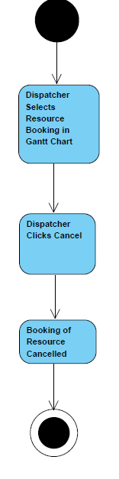

### **33.4 Cancel Work Order Assignment of Technician UC#11**

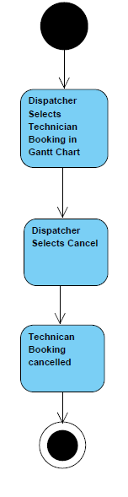

### **33.5 Work Order Timeslot is updated UC#12**

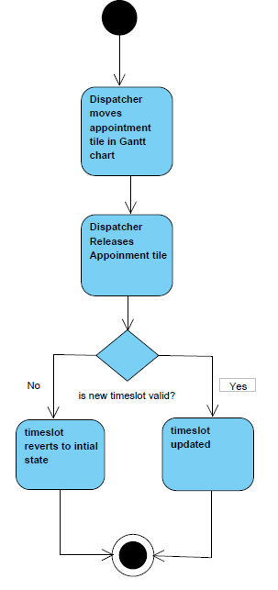

### **33.6 View Single Date in Gantt Chart UC#13**

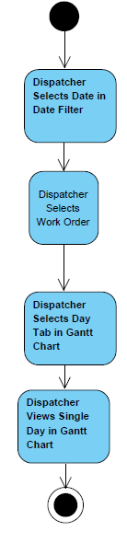

### **33.7 View Multiple Dates in Gantt Chart UC#14**

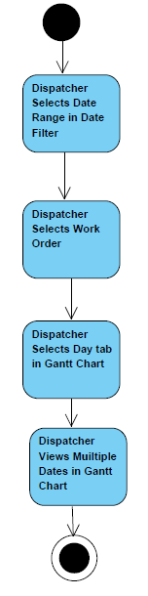

### **33.8 View Assigned Work Order Information UC#15**

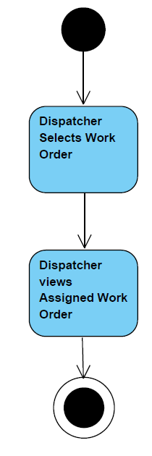

## **34.0 Analysis Class diagram**

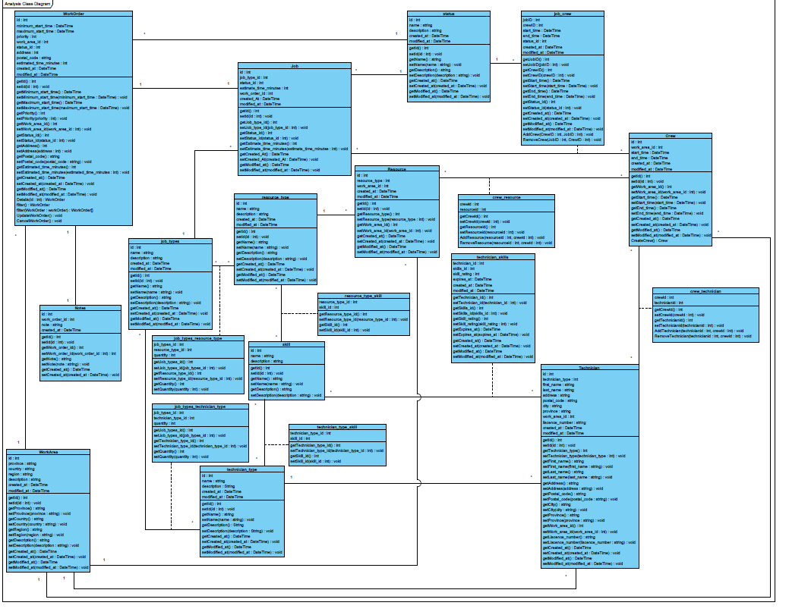

## **35.0 System Sequence Diagrams**

### **35.1 Schedule Resource for Work Order UC#08**

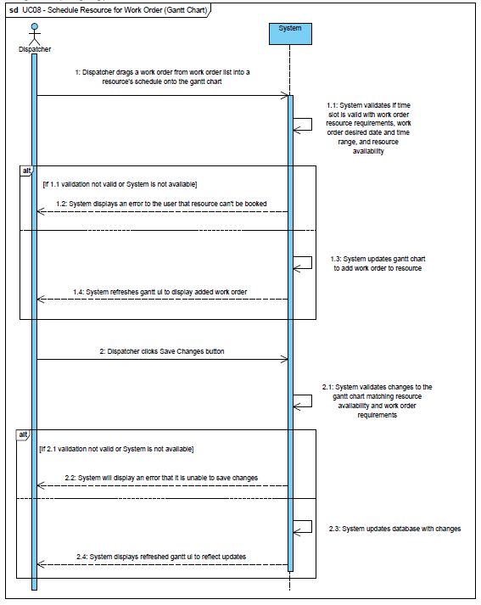

### **35.2 Schedule Technician for Work Order (Gantt Chart) UC#09**

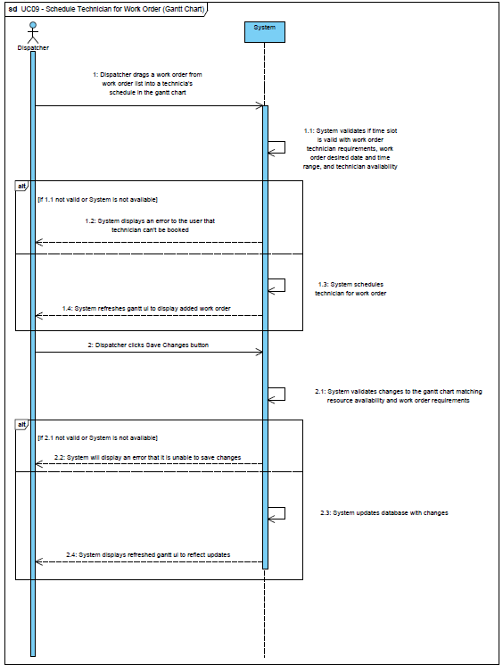

### **35.3 Cancel Work Order Assignment of Resource (Gantt Chart) UC#10**

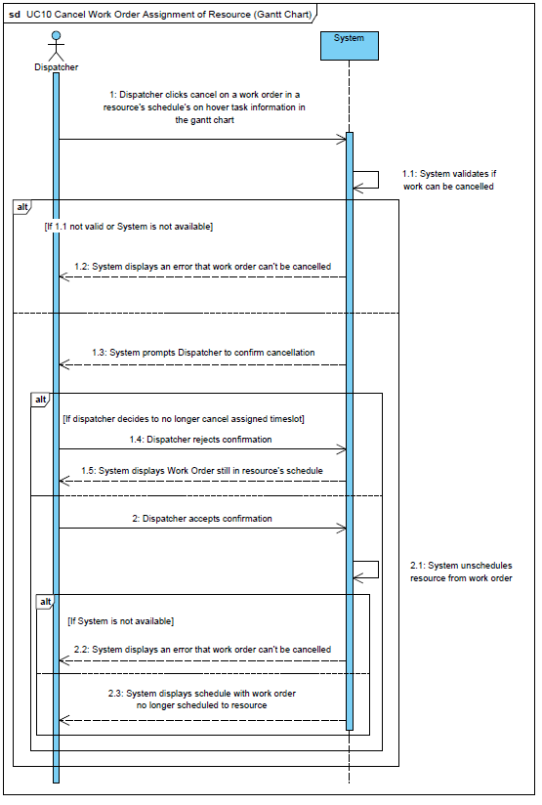

### **35.4 Cancel Work Order Assignment of Technician (Gantt Chart) UC#11**

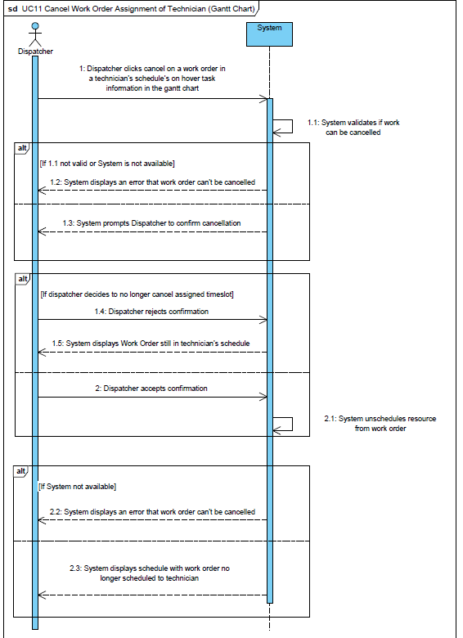

### **35.5 Work Order Time Slot is Updated (Gantt Chart) UC#12**

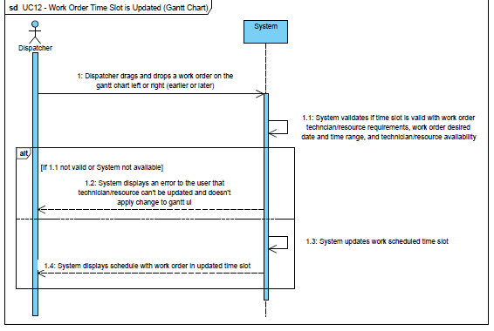

### **35.6 View a Single Date in Gantt Chart UC#13**

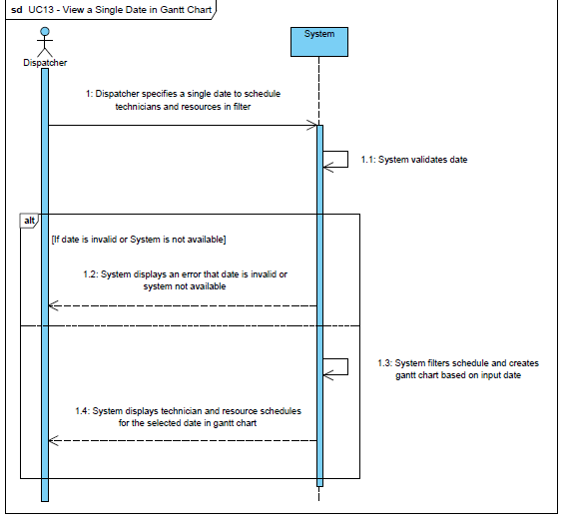

### **35.7 View Multiple Dates In Gantt Chart UC#14**

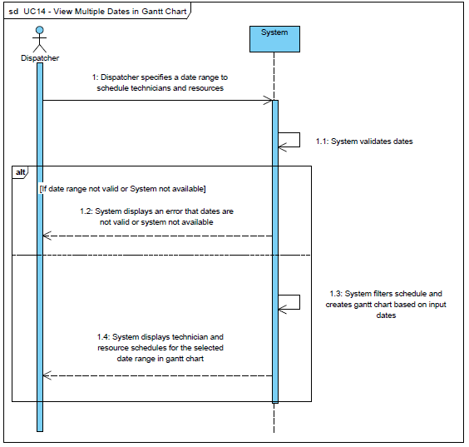

### **35.8 View Assigned Work Order Information in Gantt Chart UC#16**

## **36.0 State Chart Diagrams**

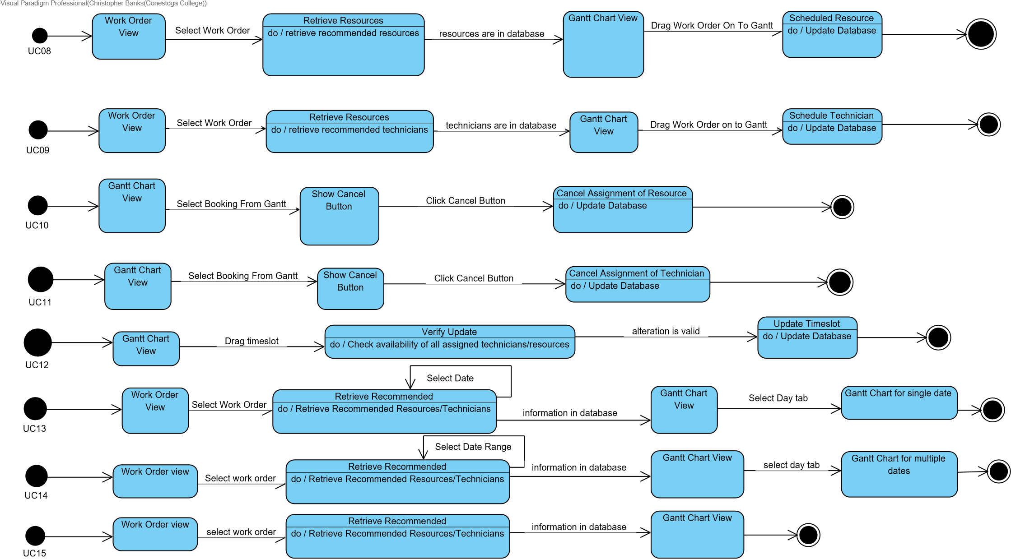

## **37.0 Meeting Agenda / Minutes**

### **2019/02/19**

#### Time:

**12:30**

#### Location:

**Remote via Join.Me**

#### Attendance

|  |  |  |
| --- | --- | --- |
| **Present** | **Regrets** | **Status**  **Report?** |
| Nick Lee |  |  |
| Cynthia Cheng |  |  |
| Thomas Craig |  |  |
| Chris Banks |  |  |
| Daniel Heidt |  |  |
| Ted Byers |  |  |
|  | **Team Status Report?** |  |

#### Agenda

|  |  |
| --- | --- |
| Discussed Iteration 1 | Complete |
| Discussed how to identify priority/status in front end | Complete |
| Discuss Multiple Dispatchers in the same area | Delayed |

#### Deliverables

|  |  |
| --- | --- |
| Iteration 1 Documents for Client Sign Off | Complete |
| Color possibilities | Delayed |

Action Items

|  |  |  |  |
| --- | --- | --- | --- |
| **What** | **Who** | **When** | **Complete?** |
| Provide Circumference ERD to review | Chris | 2019.02.11 | Complete |
| Send Iteration 1 to Circumference | Cynthia | 2019.02.19 |  |

#### Minutes / Notes

|  |
| --- |
| Reviewed the Iteration 1 documents |
| Discussed how to identify priority/status/hot calls front end (identifying priority to status (priority will |
| be icons, status the color of the work order) |
| Circumference to get back to us about final decision on multiple dispatchers in a single area |

### **2019/02/20**

#### Time:

**17:00**

#### Location:

**Doon Collaboration Room 1**

#### Attendance

|  |  |  |
| --- | --- | --- |
| **Present** | **Regrets** | **Status**  **Report?** |
| Nick Lee |  |  |
| Cynthia Cheng |  |  |
| Thomas Craig |  |  |
| Chris Banks |  |  |
| Barbara Pridham |  |  |
|  | **Team Status Report?** |  |

#### Agenda

|  |  |
| --- | --- |
| Hand in Iteration 1 | Delayed |
| Discuss what to do moving forward | Complete |

#### Deliverables

|  |  |
| --- | --- |
| Hand in Iteration 1 and sign off | Delayed |

#### Action Items

|  |  |  |  |
| --- | --- | --- | --- |
| **What** | **Who** | **When** | **Complete?** |
| Submit Iteration 1 | Cynthia | 2019.02.19 |  |

#### Minutes / Notes

|  |
| --- |
| Review Iteration 1 submission and discuss problem areas and how to move into iteration 2 |

### **2019/02/25**

#### Time:

**12:30**

#### Location:

**Remote via Join.Me**

#### Attendance

|  |  |  |
| --- | --- | --- |
| **Present** | **Regrets** | **Status**  **Report?** |
| Nick Lee |  |  |
| Cynthia Cheng | No Audio |  |
| Thomas Craig |  |  |
| Chris Banks |  |  |
| Daniel Heidt |  |  |
| Ted Byers |  |  |
|  | **Team Status Report?** |  |

#### Agenda

|  |  |
| --- | --- |
| Demonstrated Iteration 1 | Complete |
| Discuss Multiple Dispatchers in the same area | Complete |

#### Deliverables

|  |  |
| --- | --- |
| Iteration 1 Client Sign Off | Delayed |
| Color possibilities | Complete |

#### Action Items

|  |  |  |  |
| --- | --- | --- | --- |
| **What** | **Who** | **When** | **Complete?** |
| Send Iteration 1 to Circumference | Cynthia | 2019.02.19 | Complete |
| Start Coding Iteration 2 | Cynthia, Nick, Thomas, Chris | 2019.02.27 |  |

#### Minutes / Notes

|  |
| --- |
| Demonstrated Iteration 1 |
| More discussion about multiple dispatchers in a single area |
| UI improvements: Priority and status columns will display text instead of numbers |
| Will add job code description to WO browse |
| Team will abbreviate column name descriptions |

### **2019/03/04**

#### Time:

**12:30**

#### Location:

**Collaboration Room 2**

#### Attendance

|  |  |  |
| --- | --- | --- |
| **Present** | **Regrets** | **Status**  **Report?** |
| Nick Lee |  |  |
| Cynthia Cheng |  |  |
| Thomas Craig |  |  |
| Chris Banks |  |  |
| Daniel Heidt |  |  |
| Ted Byers |  |  |
|  | **Team Status Report?** |  |

#### Agenda

|  |  |
| --- | --- |
| Discuss Multiple Dispatchers in the same area | Complete |
| Discuss Gantt Chart formating | Complete |

#### Deliverables

|  |  |
| --- | --- |
| Initial Gantt chart | Complete |

#### Action Items

|  |  |  |  |
| --- | --- | --- | --- |
| **What** | **Who** | **When** | **Complete?** |
| Start Coding Iteration 2 | Cynthia, Nick, Thomas, Chris | 2019.02.27 | Complete |

#### Minutes / Notes

|  |
| --- |
| All Work Order for a tech/resource will show up on one bar, hover will display all information |
| (Circumference will trim fields next iteration) |
| All WOs will stay with their current booking status, appointment times etc… in the DB until they are |
| dispatched. |
| Notes will not be editable, but new notes can be added |
| Additional people (ex. cops) will be handled as Boolean fields with prompts for dispatchers |
| – they are not bookable the same way as a cherry picker |

### **2019/03/06**

#### Time:

**17:00**

#### Location:

**Doon Collaboration Room 1**

#### Attendance

|  |  |  |
| --- | --- | --- |
| **Present** | **Regrets** | **Status**  **Report?** |
| Nick Lee |  |  |
| Cynthia Cheng |  |  |
| Thomas Craig |  |  |
| Chris Banks |  |  |
| Barbara Pridham |  |  |
|  | **Team Status Report?** |  |

#### Agenda

|  |  |
| --- | --- |
| Discuss issues with conflicting libraries | Complete |

#### Deliverables

|  |  |
| --- | --- |
|  |  |

#### Action Items

|  |  |  |  |
| --- | --- | --- | --- |
| **What** | **Who** | **When** | **Complete?** |
| Submit Iteration 1 | Cynthia | 2019.02.19 | Complete |
| Submit Iteration 2 | Cynthia | 2019.03.08 |  |

#### Minutes / Notes

|  |
| --- |
| Review Iteration 2 Coding progress and discuss the conflicts between jsgantt and bootstrap-table |
| Internet went out |

### **2019/03/08**

#### Time:

**11:45**

#### Location:

**Remote via Join.Me**

#### Attendance

|  |  |  |
| --- | --- | --- |
| **Present** | **Regrets** | **Status**  **Report?** |
| Nick Lee | Chris Banks |  |
| Cynthia Cheng |  |  |
| Thomas Craig |  |  |
| Daniel Heidt |  |  |
| Ted Byers |  |  |
|  | **Team Status Report?** |  |

#### Agenda

|  |  |
| --- | --- |
| Iteration 2 Demonstration | Complete |
| Discuss conditional client sign off | Complete |

#### Deliverables

|  |  |
| --- | --- |
| Iteration 2 Demonstration | Complete |

#### Action Items

|  |  |  |  |
| --- | --- | --- | --- |
| **What** | **Who** | **When** | **Complete?** |
| Send Iteration 2 Documents | Nick | 2019.03.08 |  |
| Send Conditional Client Sign-off | Nick | 2019.03.08 |  |

#### Minutes / Notes

|  |
| --- |
| Discussed issues encountered in Iteration 2 and asked for a conditional client sign-off |

## **38.0 Team Member Status Reports**

### **Cynthia Cheng**

#### Date:

**2019/03/08**

#### Team Member Activities

|  |  |  |
| --- | --- | --- |
| **Category** | **Activity** | **Hours**  **(.25 increments)** |
| WEBPR, PM | Finalized Iteration 1 | 2 |
| DOD, DCR | Started designing logic to handle use cases for Iteration 2 | 4 |
| WEBPR | Working on Implementation of JSGantt | 3 |
| WEBPR | Fixing JSGantt Implementation to work with schedule data | 4 |
| WEBPR | Refactoring of original model to interact with JSGantt library easier | 3 |
| DOD | Updating of documentation for changes over the Iteration | 4 |

#### Team Activty

|  |  |  |
| --- | --- | --- |
| **Location** | **Activity** | **Hours**  **(.25 increments)** |
| Remote via Join.me | Client Meeting | 1 |
| Collab Room 1 | Facilitator Meeting | 1 |
| 2A409 & 2A140 | Team Activity – Fixing Iteration 1 and Discussed Iteration 2 | 3 |
| Remote via Discord | Fixing Iteration 1 & Creating colour palette AP request from Daniel | 3 |
| Remote via Join.Me | Client Meeting | 1 |
| 2A411 | Team Activity – Iteration 2 Documentation and Logic | 6 |
| Remote via Discord | Team Activity - Iteration 2 Database Setup and Documentation | 6 |
| Remote via Discord | Team Activity – Construction & Implementation of JSGantt | 6 |
| 2A409 | Team Activity – Construction | 8 |
| 2A411 | Team Activity – Construction | 2 |
| 2A116 | Facilitator Meeting | 1 |
| 2A206 | Team Activity – Construction | 5 |
| Remote via Discord | Team Activity – Construction | 7 |
| Remote via Join.me & 2A114 | Client Meeting | 1 |
| 2A409 | Team Activity – Construction and Finalized Documentation for Iteration 2 | 9 |
| **Issues/Obstacles/Dependencies/Problems** | | |
| Issues with Visual Paradigm crashing on home computer | | |
| Issue with no audio during one of the remote meetings | | |

#### Categories:

|  |  |
| --- | --- |
| PM Project Management | WEBPR WEB PRogramming |
| IWC Interacting With Clients | ITEST Interactive TESTing |
| DCR Diagramming and Documenting Client Requirements | ENTPR ENTity class design and PRogramming |
| DOD Diagramming and Documenting Overall Design | ITEST Interactive TESTing |
| TDOC Technical DOCumentation | TPR Technical / lower-level PRogramming |
| CDOC Client DOCumentation | UTEST Unit and integration TESTing |
| GUID GUI Design | DBD DataBase Design |
| WINPR WINdows PRogramming | SQL SQL development |
| WSD Web Site Design | RPT Report Development |
| WPD Web Page Design | INST Installer development |

### **Thomas Craig**

#### Date:

**2019/02/16**

#### Team Member Activities

|  |  |  |
| --- | --- | --- |
| **Category** | **Activity** | **Hours**  **(.25 increments)** |
| DOD | Class diagrams | 2 |
| WEBPR | Drag and Drop Coding | 2 |

#### Team Activty

|  |  |  |
| --- | --- | --- |
| **Location** | **Activity** | **Hours**  **(.25 increments)** |
| Remote via Join.me | Client Meeting | 1 |
| 2A409 & 2A140 | Team Activity – Fixing Iteration 1 and Discussed Iteration 2 | 3 |
| 2A206 | Team Activity – Fixing Iteration 1 | 1 |
| Collab Room 1 | Facilitator Meeting | 1 |
| Remote via Discord & 2A206 | Team Activity – Fixing Iteration 1 | 3 |
| Remote via Join.Me | Client Meeting | 1 |
| 2A411 | Team Activity – Iteration 2 Documentation | 2 |
| Remote via Discord | Team Activity – Iteration 2 Database Setup and Documentation | 6 |
| Remote via Discord | Team Activity – Logic for Drag and Drop | 1.25 |
| Collab Room 2 | Client Meeting | 1 |
| 2A409 | Team Activity – Construction | 6 |
| 2A411 | Team Activity – Construction | 2 |
| 2A116 | Facilitator Meeting | 1 |
| 2A206 | Team Activity – Construction | 5 |
| Remote via Discord | Team Activity – Construction | 3 |
| Remote via Join.me & 2A114 | Client Meeting | 1 |
| 2A409 | Team Activity – Construction and Finalized Documentation for Iteration 2 | 9 |
| **Issues/Obstacles/Dependencies/Problems** | | |
| Front end difficulties due to clashing libraries | | |
| Difficulties gantt partial view | | |

#### Categories:

|  |  |
| --- | --- |
| PM Project Management | WEBPR WEB PRogramming |
| IWC Interacting With Clients | ITEST Interactive TESTing |
| DCR Diagramming and Documenting Client Requirements | ENTPR ENTity class design and PRogramming |
| DOD Diagramming and Documenting Overall Design | ITEST Interactive TESTing |
| TDOC Technical DOCumentation | TPR Technical / lower-level PRogramming |
| CDOC Client DOCumentation | UTEST Unit and integration TESTing |
| GUID GUI Design | DBD DataBase Design |
| WINPR WINdows PRogramming | SQL SQL development |
| WSD Web Site Design | RPT Report Development |
| WPD Web Page Design | INST Installer development |

### **Chris Banks**

#### Date:

**2019/02/16**

#### Team Member Activities

|  |  |  |
| --- | --- | --- |
| **Category** | **Activity** | **Hours**  **(.25 increments)** |
| DOD | Use Case Descriptions with Activity Diagrams | 2.5 |
| DOD | User Interface Prototype | 2 |
| WEBPR | Gantt chart | 2 |

#### Team Activty

|  |  |  |
| --- | --- | --- |
| **Location** | **Activity** | **Hours**  **(.25 increments)** |
| Remote via Join.me | Client Meeting | 1 |
| 2A409 & 2A140 | Team Activity – Fixing Iteration 1 and Discussed Iteration 2 | 3 |
| Collab Room 1 | Facilitator Meeting | 1 |
| Remote via Join.Me | Client Meeting | 1 |
| Collab Room 2 | Client Meeting | 1 |
| 2A409 | Team Activity – Construction | 2 |
| **Issues/Obstacles/Dependencies/Problems** | | |
| Misunderstanding Due date | | |
| Work/Job | | |

#### Categories:

|  |  |
| --- | --- |
| PM Project Management | WEBPR WEB PRogramming |
| IWC Interacting With Clients | ITEST Interactive TESTing |
| DCR Diagramming and Documenting Client Requirements | ENTPR ENTity class design and PRogramming |
| DOD Diagramming and Documenting Overall Design | ITEST Interactive TESTing |
| TDOC Technical DOCumentation | TPR Technical / lower-level PRogramming |
| CDOC Client DOCumentation | UTEST Unit and integration TESTing |
| GUID GUI Design | DBD DataBase Design |
| WINPR WINdows PRogramming | SQL SQL development |
| WSD Web Site Design | RPT Report Development |
| WPD Web Page Design | INST Installer development |

### **Nicholas Lee**

#### Date:

**2019/02/16**

#### Team Member Activities

|  |  |  |
| --- | --- | --- |
| **Category** | **Activity** | **Hours**  **(.25 increments)** |
| DBD | ERD | 1 |
| DBD | Data Dictionary | 0.5 |
| DBD | Set Up database | 0.5 |
| PM | Email Client | 0.25 |
| WEBPR | Programming Crud | 4 |
| WEBPR | Programming Crud | 4 |
| WEBPR | Programming Crud | 4 |
| WEBPR | Gantt Programming | 4 |
| WEBPR | Gantt Programming | 4 |
| WEBPR | Gantt Programming | 5 |
| DBD | Fix Database | 0.25 |
| WEBPR | Gantt Programming | 10 |

#### Team Activty

|  |  |  |
| --- | --- | --- |
| **Location** | **Activity** | **Hours**  **(.25 increments)** |
| Remote via Join.me | Client Meeting | 1 |
| 2A409 & 2A140 | Team Activity – Fixing Iteration 1 and Discussed Iteration 2 | 3 |
| 2A206 | Team Activity – Fixing Iteration 1 | 1 |
| Collab Room 1 | Facilitator Meeting | 1 |
| Remote via Discord & 2A206 | Team Activity – Fixing Iteration 1 | 3 |
| Remote via Join.Me | Client Meeting | 1 |
| 2A411 | Team Activity – Iteration 2 Documentation and Logic | 4 |
| 2A411 | Team Activity – Iteration 2 Documentation | 2 |
| Remote via Discord | Team Activity – Iteration 2 Database Setup and Documentation | 6 |
| Remote via Discord | Team Activity – Logic for Drag and Drop | 1.25 |
| Remote via Discord | Team Activity – Construction & Implementation of JSGantt | 6 |
| Collab Room 2 | Client Meeting | 1 |
| 2A409 | Team Activity – Construction | 2 |
| 2A409 | Team Activity – Construction | 6 |
| 2A411 | Team Activity – Construction | 2 |
| 2A116 | Facilitator Meeting | 1 |
| 2A206 | Team Activity – Construction | 5 |
| Remote via Discord | Team Activity – Construction | 4 |
| Remote via Discord | Team Activity – Construction | 3 |
| Remote via Join.me & 2A114 | Client Meeting | 1 |
| 2A409 | Team Activity – Construction and Finalized Documentation for Iteration 2 | 9 |
| **Issues/Obstacles/Dependencies/Problems** | | |
| Front end difficulties due to clashing libraries | | |
| Difficulties gantt partial view | | |
| Azure database account ran out of free credits | | |

#### Categories:

|  |  |
| --- | --- |
| PM Project Management | WEBPR WEB PRogramming |
| IWC Interacting With Clients | ITEST Interactive TESTing |
| DCR Diagramming and Documenting Client Requirements | ENTPR ENTity class design and PRogramming |
| DOD Diagramming and Documenting Overall Design | ITEST Interactive TESTing |
| TDOC Technical DOCumentation | TPR Technical / lower-level PRogramming |
| CDOC Client DOCumentation | UTEST Unit and integration TESTing |
| GUID GUI Design | DBD DataBase Design |
| WINPR WINdows PRogramming | SQL SQL development |
| WSD Web Site Design | RPT Report Development |
| WPD Web Page Design | INST Installer development |

## **39.0 Team Status Report**

### Date:

**2019/03/08**

### Team Meetings and Activities

|  |  |  |  |  |
| --- | --- | --- | --- | --- |
| **Location** | **Team Meeting / Team Activity** | **Present**  (list of initials) | **Date**  YYYY.MM.DD | **Duration**  (nearest .25 hr) |
| Remote via Join.me | Client Meeting | NL, CC, TC, CB | 2019.02.19 | 1 |
| 2A409 & 2A140 | Team Activity – Fixing Iteration 1 and Discussed Iteration 2 | NL, CC, TC, CB | 2019.02.19 | 3 |
| 2A206 | Team Activity – Fixing Iteration 1 | NL, TC | 2019.02.20 | 1 |
| Collab Room 1 | Facilitator Meeting | NL, CC, TC, CB | 2019.02.20 | 1 |
| Remote via Discord & 2A206 | Team Activity – Fixing Iteration 1 | NL, CC, TC | 2019.02.20 | 3 |
| Remote via Join.Me | Client Meeting | NL, CC, TC,CB | 2019.02.24 | 1 |
| 2A411 | Team Activity – Iteration 2 Documentation and Logic | NL, CC | 2019.02.26 | 4 |
| 2A411 | Team Activity – Iteration 2 Documentation | NL, CC, TC | 2019.02.26 | 2 |
| Remote via Discord | Team Activity – Iteration 2 Database Setup and Documentation | NL, CC, TC | 2019.02.27 | 6 |
| Remote via Discord | Team Activity – Logic for Drag and Drop | NL, TC | 2019.03.01 | 1.25 |
| Remote via Discord | Team Activity – Construction & Implementation of JSGantt | NL, CC | 2019.03.02 | 6 |
| Collab Room 2 | Client Meeting | NL, CC, TC, CB | 2019.03.04 | 1 |
| 2A409 | Team Activity – Construction | NL, CC, CB | 2019.03.05 | 2 |
| 2A409 | Team Activity – Construction | NL, CC, TC | 2019.03.05 | 6 |
| 2A411 | Team Activity – Construction | NL, CC, TC | 2019.03.06 | 2 |
| 2A116 | Facilitator Meeting | NL, CC, TC | 2019.03.06 | 1 |
| 2A206 | Team Activity – Construction | NL, CC, TC | 2019.03.06 | 5 |
| Remote via Discord | Team Activity – Construction | NL, CC | 2019.03.07 | 4 |
| Remote via Discord | Team Activity – Construction | NL, CC, TC | 2019.03.07 | 3 |
| Remote via Join.me & 2A114 | Client Meeting | NL, CC, TC | 2019.03.08 | 1 |
| 2A409 | Team Activity – Construction and Finalized Documentation for Iteration 2 | NL, CC, TC | 2019.03.08 | 9 |
| **Issues/Obstacles/Dependencies/Problems** | | | | |
| Remote meeting on the 24th Cynthia was connected but was unable to hear the meeting | | | | |
| Issue with Azure trial running out  Issue with Gantt and Bootstrap libraries interacting  Issue with updating Gantt table with drag and drop implementation | | | | |

Iteration 2: Design

## **40.0 Design Class Diagram**

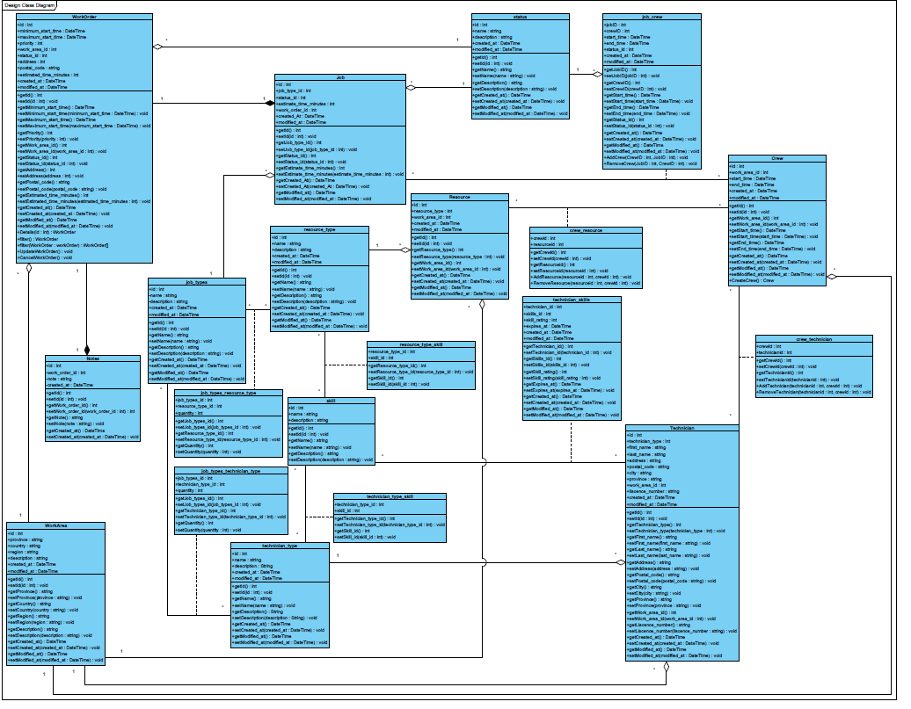

## **41.0 System Sequence Diagrams**

### **41.1 Schedule Resource for Work Order (Gantt Chart) UC#08**

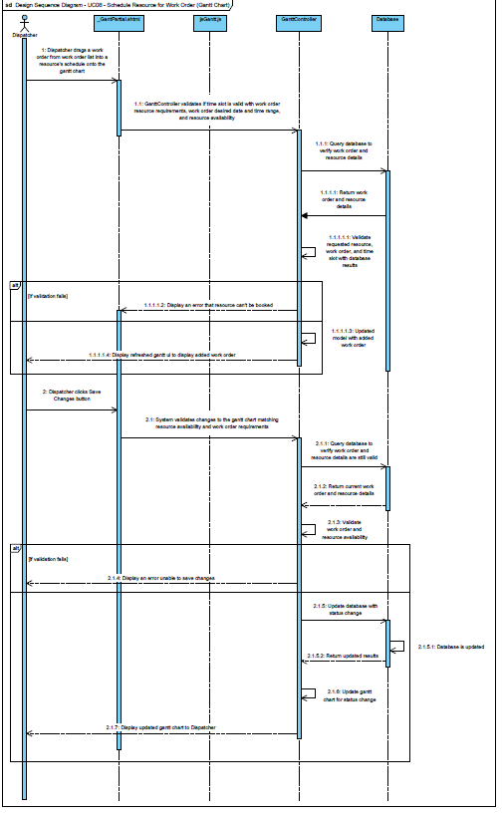

### **41.2 Schedule Technician for Work Order (gantt Chart) UC#09**

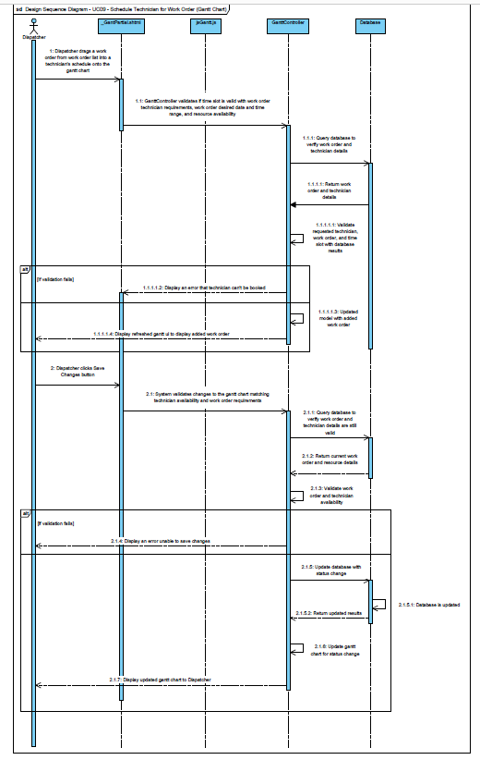

### **41.3 Cancel Work Order Assignment of Resource (Gantt) UC#10**

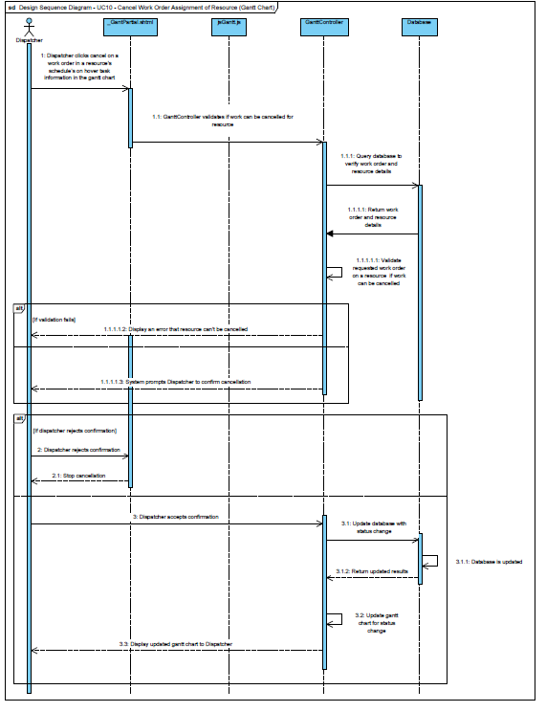

### **41.4 Cancel Work Order Assignment of Technician (Gantt) UC#11**

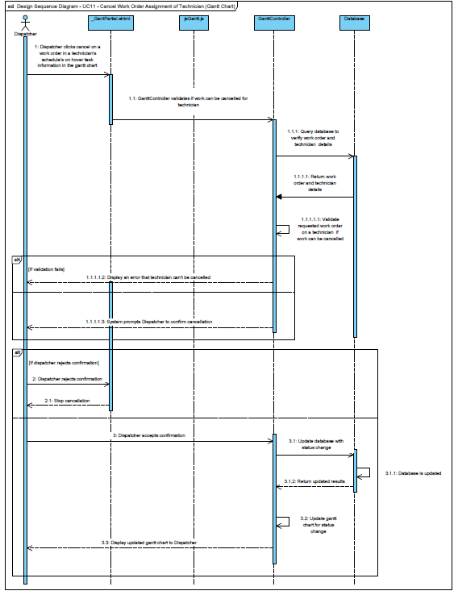

### **41.5 Work Order Timeslot is Updated (Gantt) UC#12**

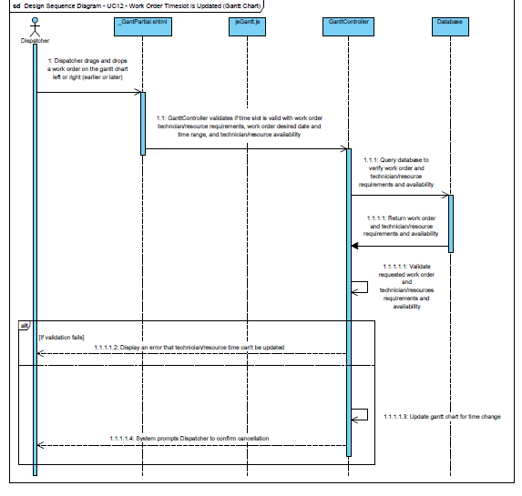

### **41.6 View a Single Date in Gantt Chart UC#13**

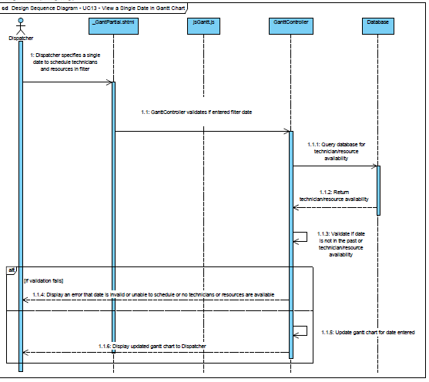

### **41.7 View Multiple Dates in Gantt Chart UC#14**

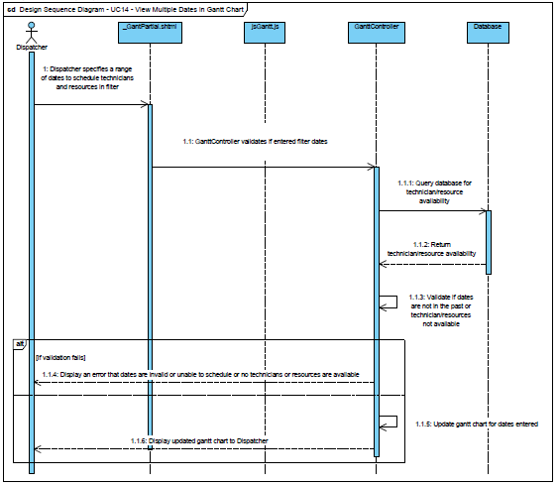

### **41.8 View Assigned Work Order Information in Gantt Chart UC#16**

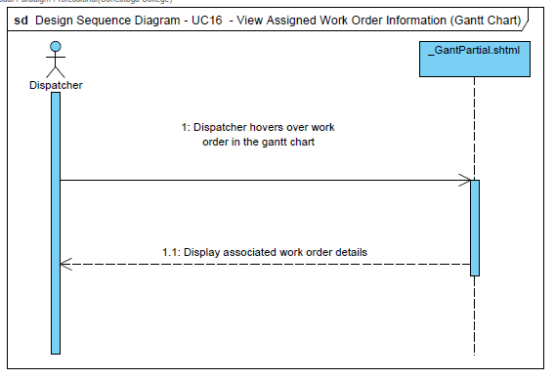

## **42.0 Navigation Diagram**

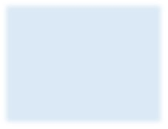

Dashboard

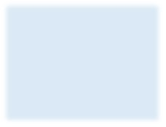

Work Order

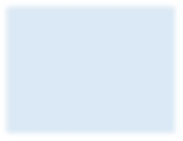

Technicians and

Resources

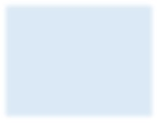

Gantt

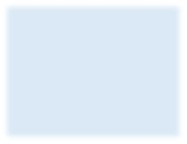

Add Work Order

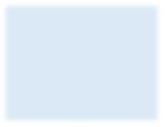

Work Order List

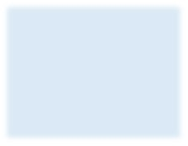

Work Order Details

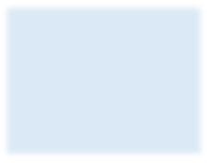

Edit Work Order

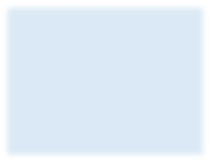

Dispatch Work

Order

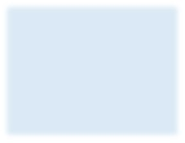

Cancel Work Order

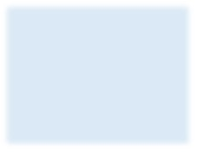

Add Workorders to

resources/

technicians

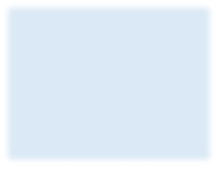

Update work orders

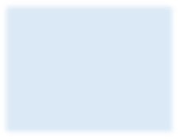

Recommended List

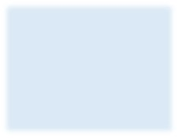

Technician List

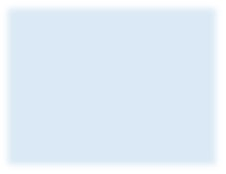

Resources List

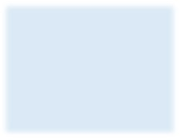

Cancel Workorder

asisgnment to

resource/technician

## **43.0 Prototype Screen Captures**

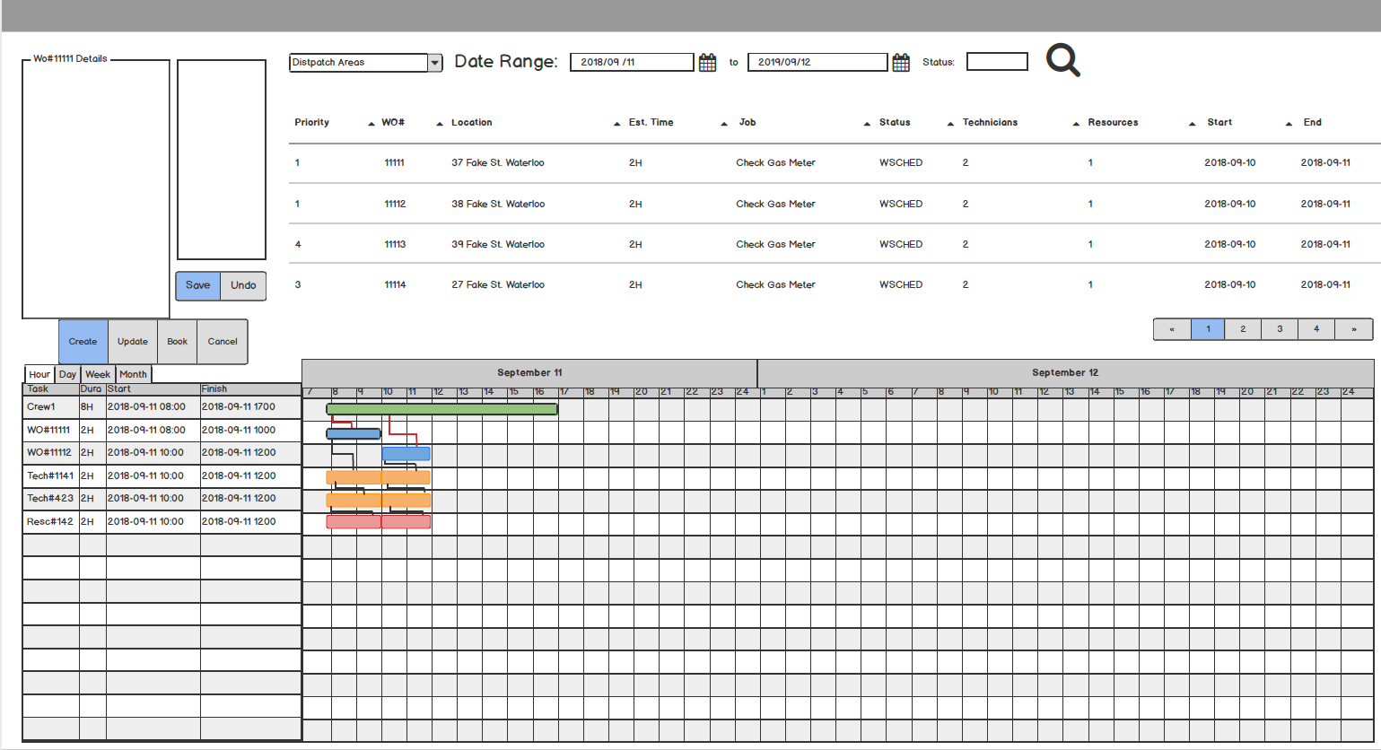

## **44.0 Entity Relation Diagram**

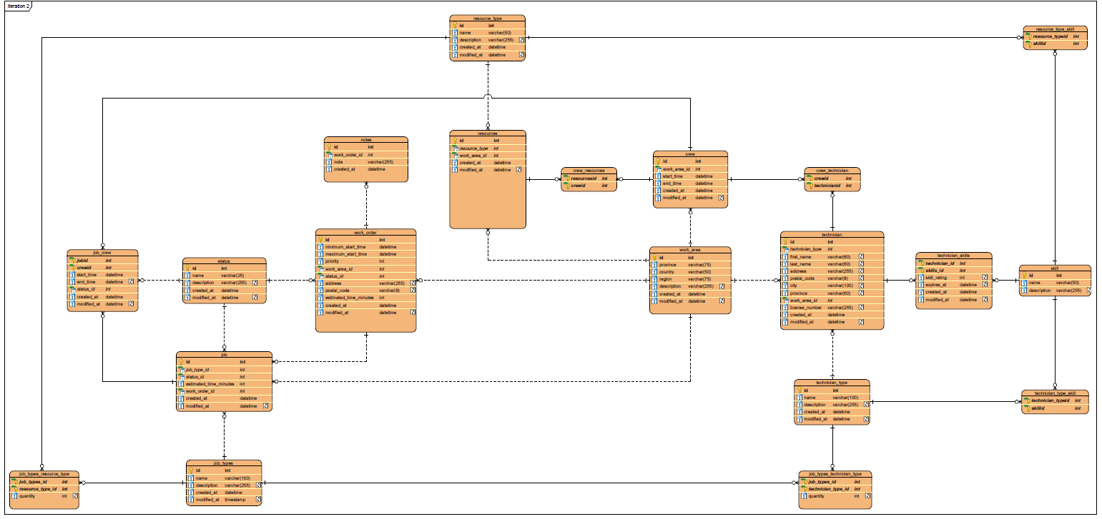

## **45.0 Data Dictionary**

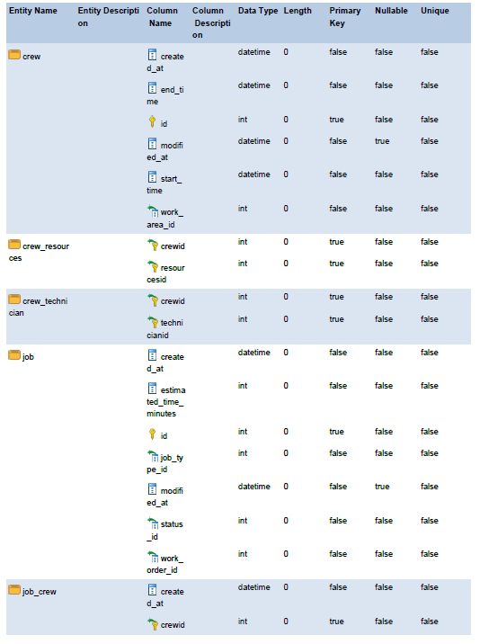

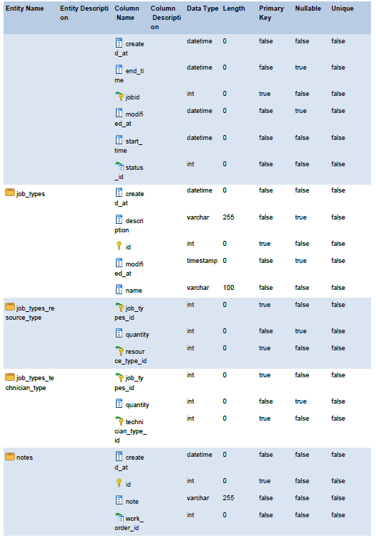

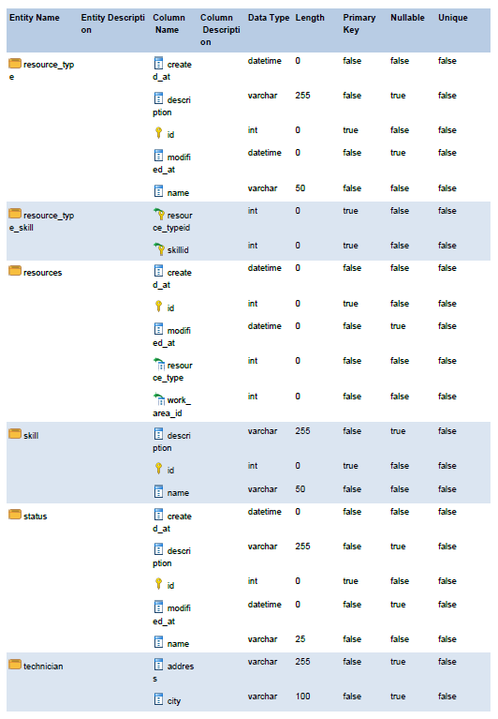

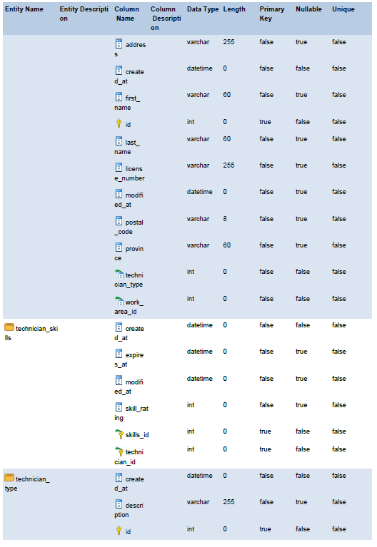

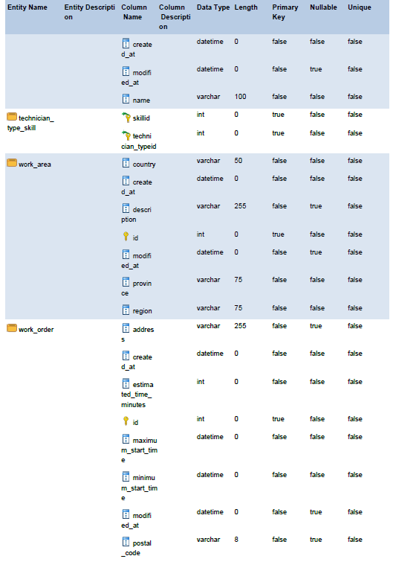

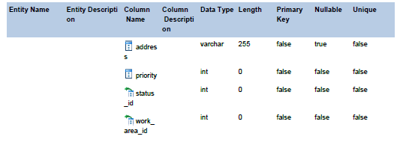

Iteration 2: Construction

## **46.0 Agile Release Summary**



## **47.0 Agile Backlog**



## **48.0 Client Sign Off**

Iteration 3: Analysis

## **49.0 Use Case Diagram**

## **50.0 Use Case Descriptions**

### **50.1 View Technician or Resource ETA UC#19**

|  |  |  |
| --- | --- | --- |
| Use Case # | **UC19** | |
| Use Case Name | **View Technician or Resource ETA** | |
| Scenario | Dispatcher wants to view technician or resource ETA | |
| Triggering Event | Dispatcher drags work order onto resource schedule in the Gantt schedule | |
| Brief Description | Dispatcher sees technician or resource ETA using Gantt UI | |
| Actors | Dispatcher | |
| Related Use Cases | UC108, UC109 | |
| Stakeholders | Dispatcher | |
| Pre-conditions | User Dropped Task Item | |
| Post-conditions | Resource is scheduled and its availability is updated | |
| Flow of Events | **Actor** | **System** |
|  | 1 Job is added to Gantt Chart   * 1. Calculates time to travel from one Work Order to another   1.2 Calculated time is added to job time |
| Exception  Conditions |  | 1.1b If there are no jobs within 2 hours of the newly added job travel time is not calculated |

## **51.0 Activity Diagrams**

### **51.1 View Technician or Resource ETA UC#19**

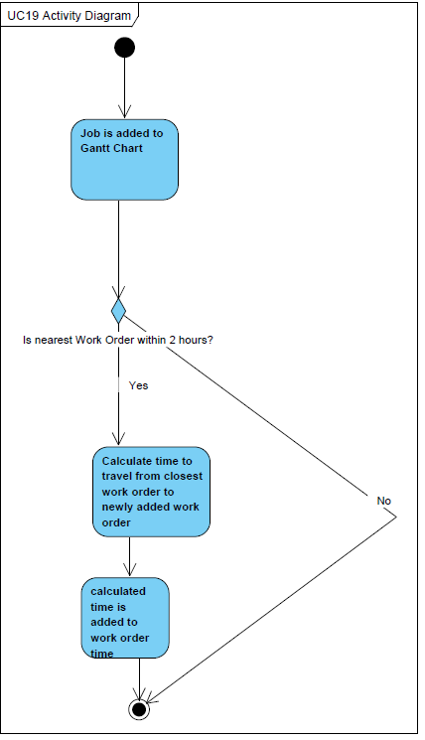

## **52.0 Analysis Class Diagram**

## **53.0 System Sequence Diagram**

### **53.1 View Technician Or Resource ETA UC#19**



Iteration 3: Design

## **54.0 System Sequence Diagrams**

### **54.1 View Technician or Resource ETA UC#19**

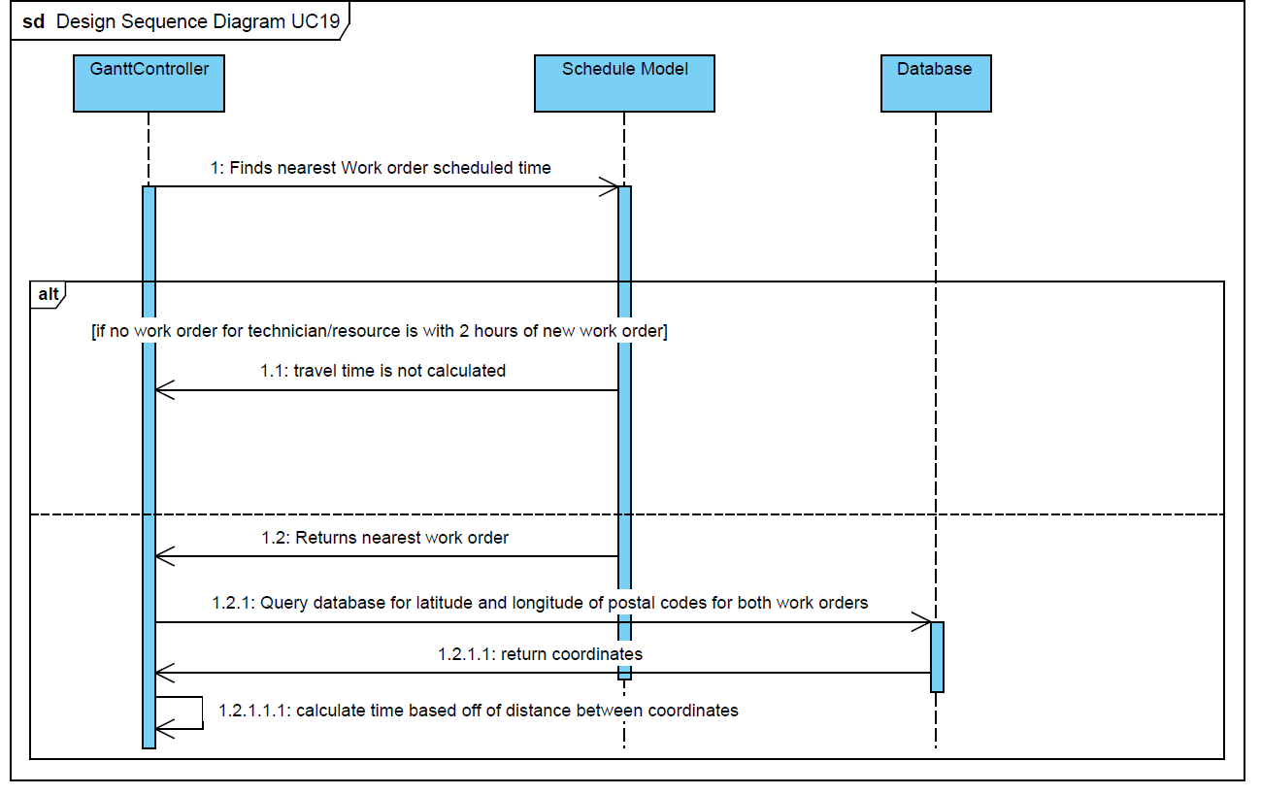

## **55.0 Design Class Diagram**

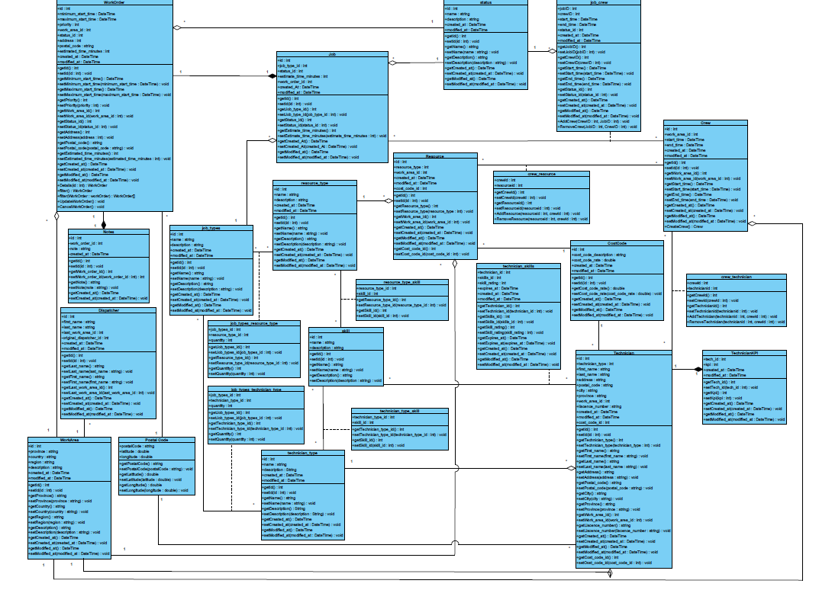

## **56.0 Navigation Diagram**

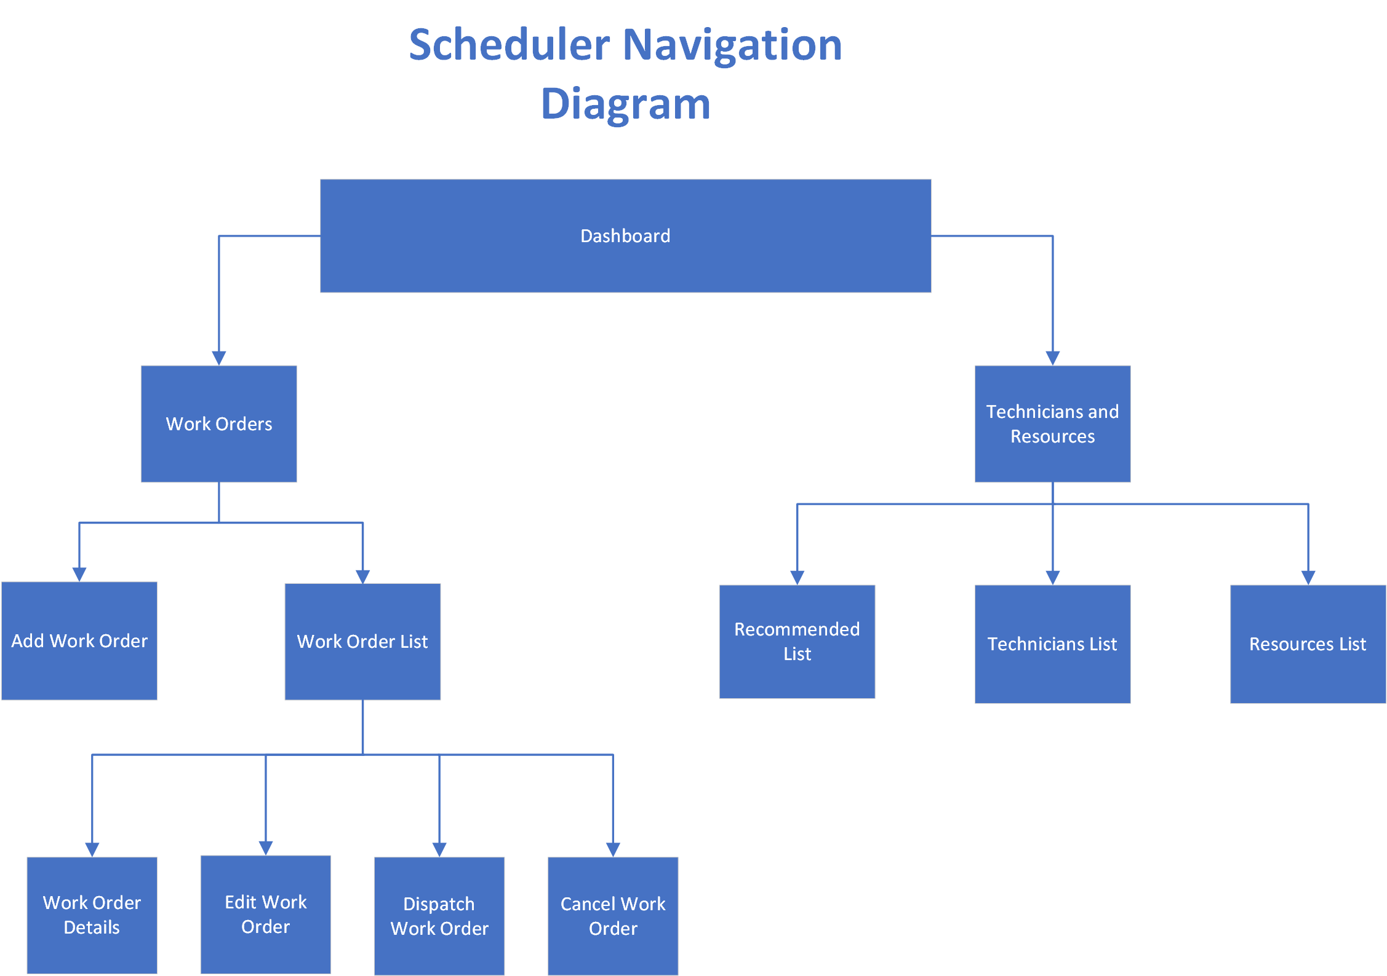

## **57.0 Screen Captures**

### **Dashboard**

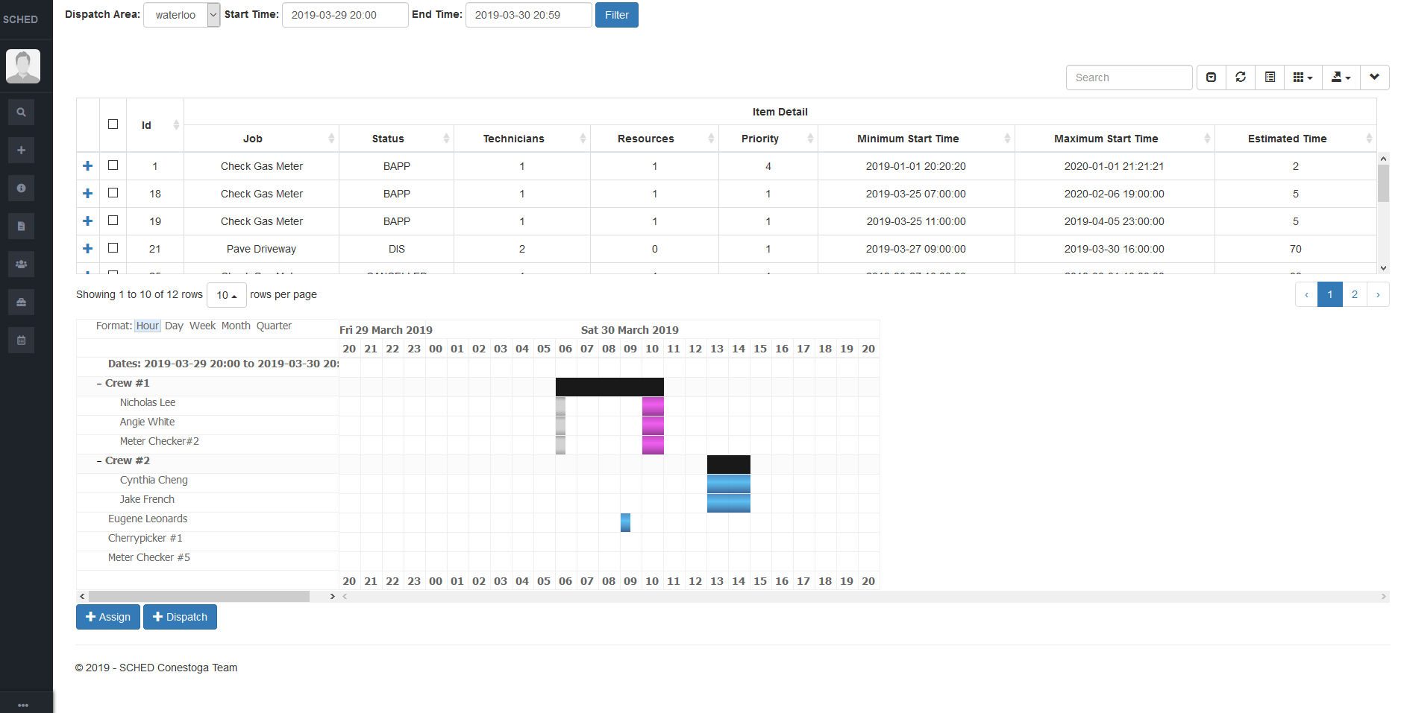

### **Sidebar**

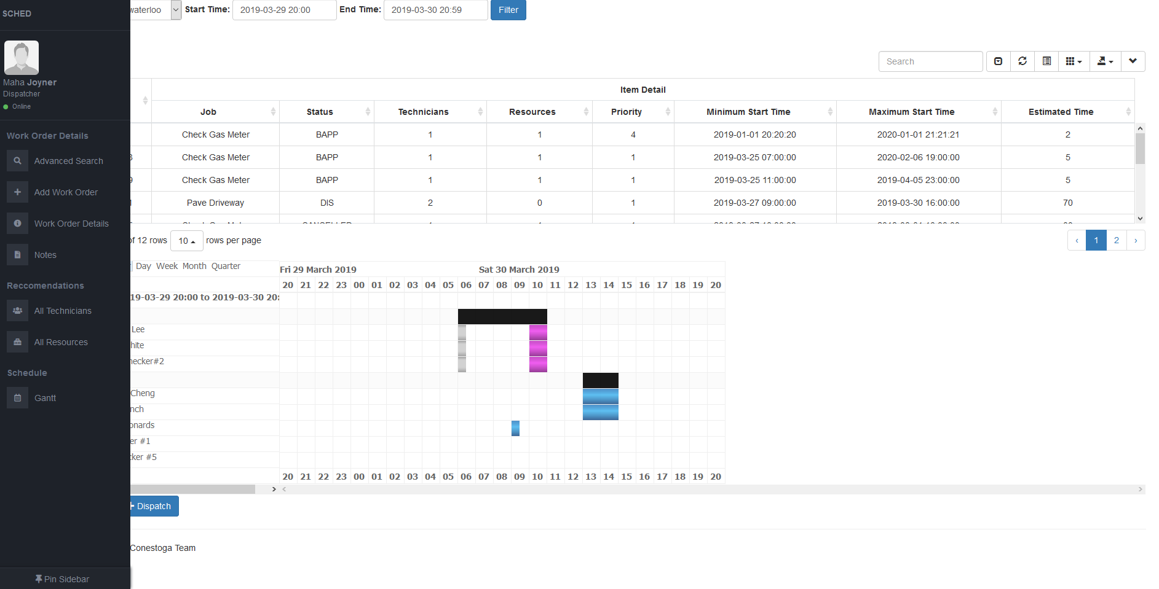

### **Selected Work Order**

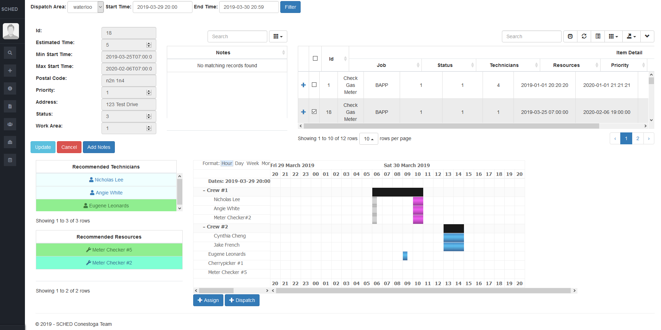

## **58.0 Entity Relation Diagram**

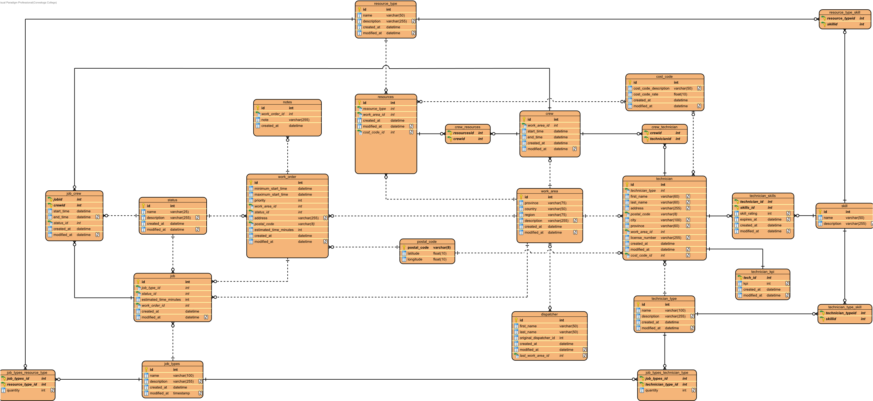

## **59.0 Data Dictionary**

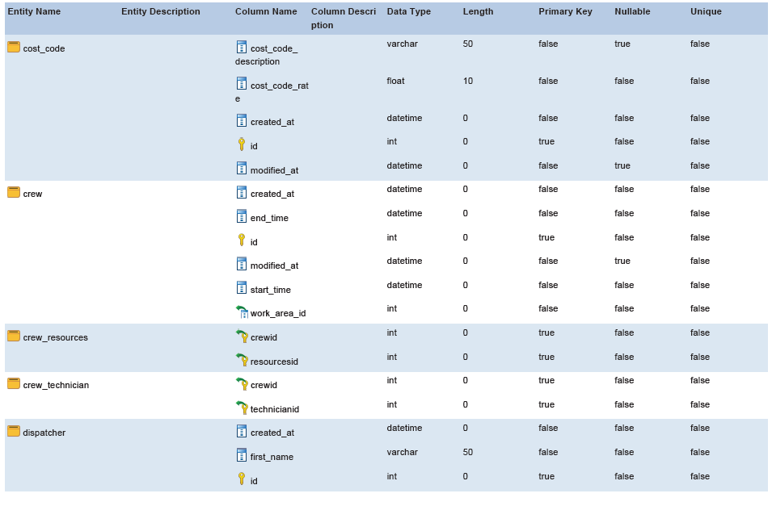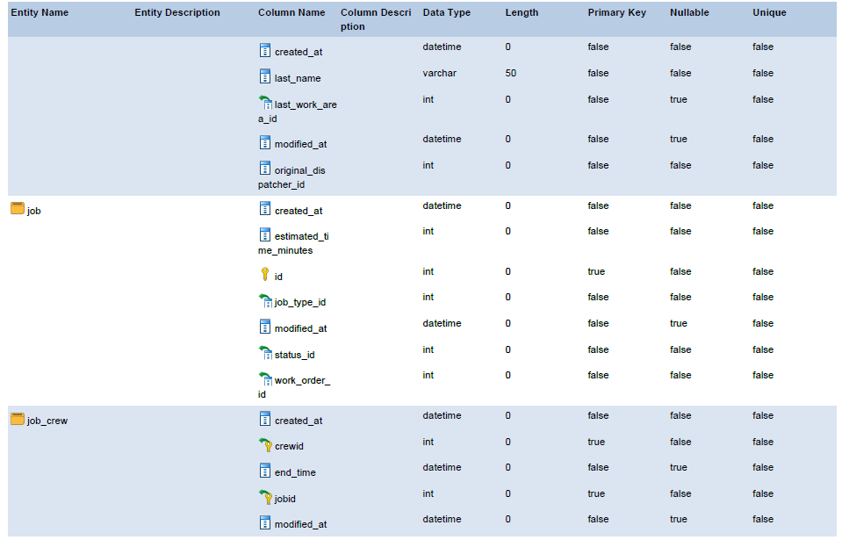

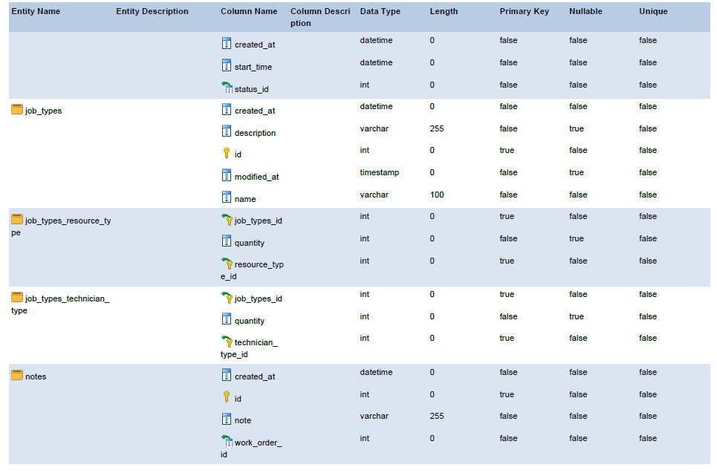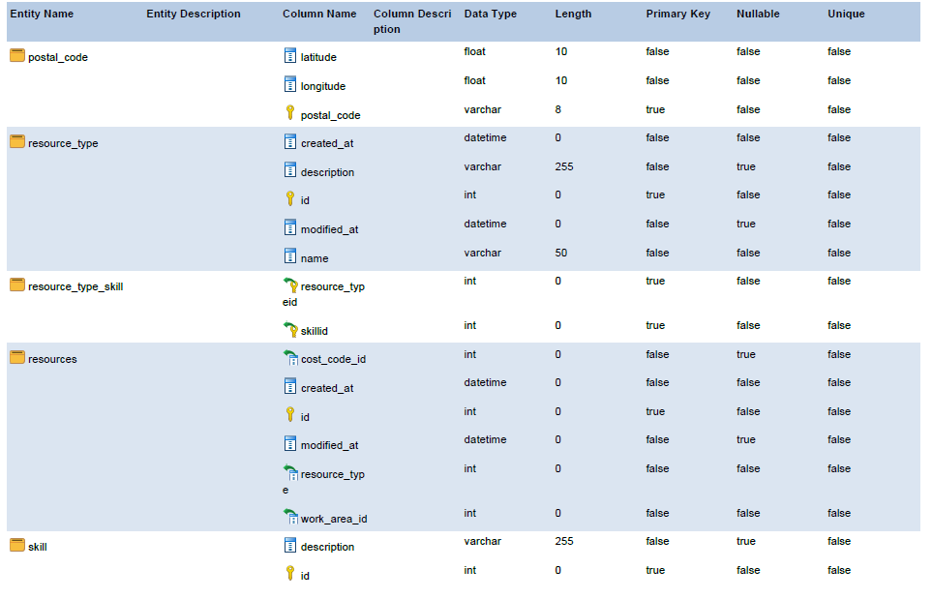

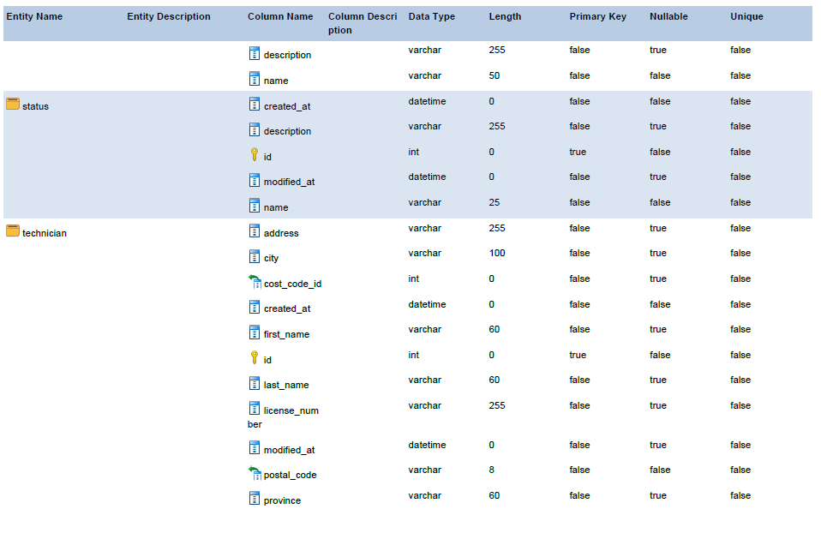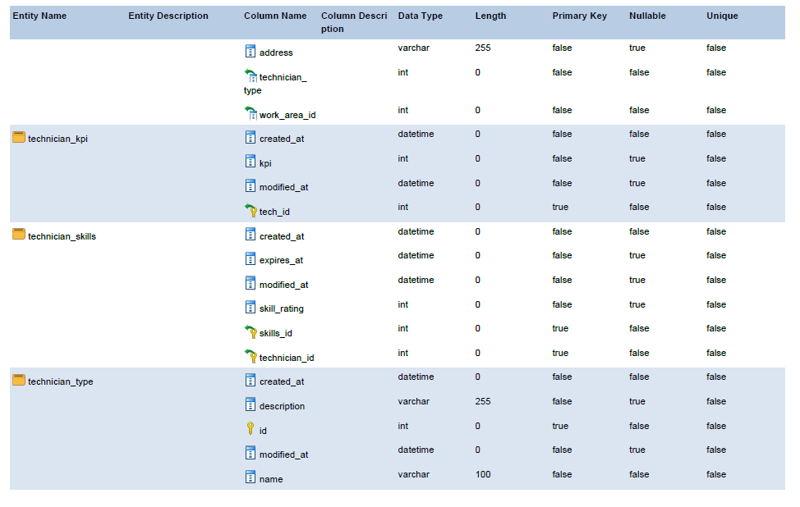

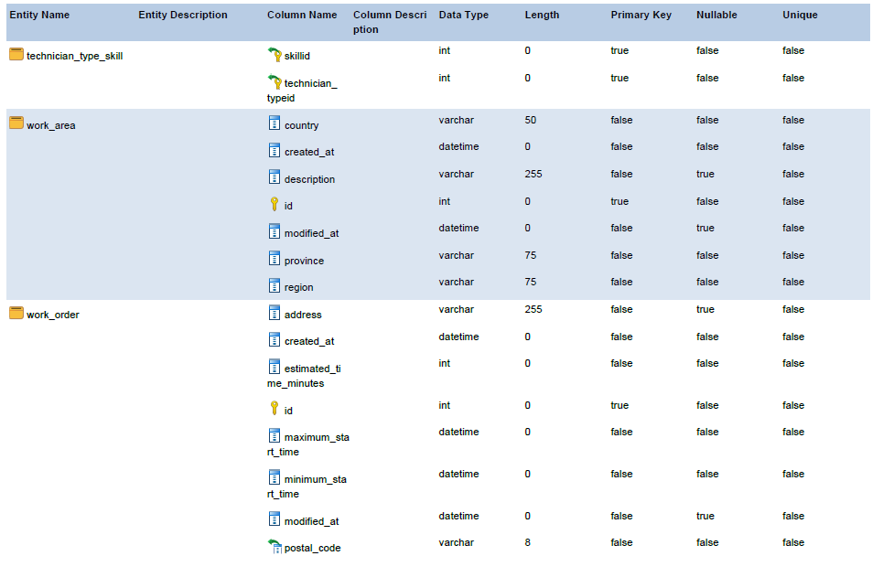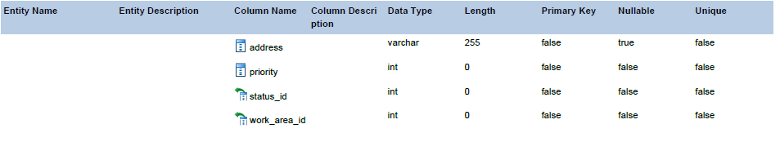

## **60.0 Meeting Agenda / Minutes**

### **2019/03/11**

#### Time:

**12:30**

#### Location:

**Collab 3**

#### Attendance

|  |  |  |
| --- | --- | --- |
| **Present** | **Regrets** | **Status**  **Report?** |
| Nick Lee |  |  |
| Cynthia Cheng |  |  |
| Thomas Craig |  |  |
| Chris Banks |  |  |
| Daniel Heidt |  |  |
| Ted Byers |  |  |
|  | **Team Status Report?** |  |

#### Agenda

|  |  |
| --- | --- |
| Discussed Iteration 2 | Complete |

#### Deliverables

|  |  |
| --- | --- |
| Iteration 2 | Delayed |

#### Action Items

|  |  |  |  |
| --- | --- | --- | --- |
| **What** | **Who** | **When** | **Complete?** |
| Finish Iteration 2 | Everyone | 2019.03.29 |  |
| Give postal codes | Dan | 2019.3.18 |  |

#### Minutes / Notes

|  |
| --- |
| Reviewed the Iteration 2 documents |
| Discussed finishing iteration 2 instead of completing iteration 3 use cases |
| Discussed postal codes will be |
| Postal codes will be in a zip file given to team |

### **2019/03/13**

#### Time:

**17:00**

#### Location:

**Collab room 2**

#### Attendance

|  |  |  |
| --- | --- | --- |
| **Present** | **Regrets** | **Status**  **Report?** |
| Nick Lee |  |  |
| Cynthia Cheng |  |  |
| Thomas Craig |  |  |
|  | Chris Banks | Sick |
| Barbara Pridham |  |  |
|  | **Team Status Report?** |  |

#### Agenda

|  |  |
| --- | --- |
| Hand in Iteration 1 | Delayed |

#### Deliverables

|  |  |
| --- | --- |
|  |  |

Action Items

|  |  |  |  |
| --- | --- | --- | --- |
| **What** | **Who** | **When** | **Complete?** |
| Give Barb iteration 2 code | Nick | 2019.02.19 |  |

#### Minutes / Notes

|  |
| --- |
| Barb had trouble getting iteration 2 files |
| Discussed decision to move on with iteration 3, but focus on UI |

### **2019/03/18**

#### Time:

**12:30**

#### Location:

**Remote via Join.Me**

#### Attendance

|  |  |  |
| --- | --- | --- |
| **Present** | **Regrets** | **Status**  **Report?** |
| Nick Lee |  |  |
| Cynthia Cheng |  |  |
| Thomas Craig |  |  |
| Chris Banks |  |  |
| Ted Byer |  |  |
| Dan Heidt |  |  |
|  | **Team Status Report?** |  |

#### Agenda

|  |  |
| --- | --- |
| Demoed Fixes for iteration 2 | Complete |

#### Deliverables

|  |  |
| --- | --- |
|  |  |

#### Action Items

|  |  |  |  |
| --- | --- | --- | --- |
| **What** | **Who** | **When** | **Complete?** |

#### Minutes / Notes

|  |
| --- |
| Demonstrated Fixes for iteration 2 |
| Discussed Postal Codes |

### **2019/03/20**

#### Time:

**5:00**

#### Location:

**Work room 1**

#### Attendance

|  |  |  |
| --- | --- | --- |
| **Present** | **Regrets** | **Status**  **Report?** |
| Nick Lee |  |  |
| Cynthia Cheng |  |  |
| Thomas Craig |  |  |
| Chris Banks |  |  |
| Barb Pridham |  |  |
|  |  |  |
|  | **Team Status Report?** |  |

#### Agenda

|  |  |
| --- | --- |
| Discussed what circumference would need for transition phase | Complete |

#### Deliverables

|  |  |
| --- | --- |
|  |  |

#### Action Items

|  |  |  |  |
| --- | --- | --- | --- |
| **What** | **Who** | **When** | **Complete?** |
| Complete power point | everyone | 3/27/2019 |  |

#### Minutes / Notes

|  |
| --- |
| Discussed Presentation for capstone |
| Discussed transition phase |

### **2019/03/25**

#### Time:

**5:00**

#### Location:

**Collaboration room 2**

#### Attendance

|  |  |  |
| --- | --- | --- |
| **Present** | **Regrets** | **Status**  **Report?** |
| Nick Lee |  |  |
| Cynthia Cheng |  |  |
| Thomas Craig |  |  |
| Chris Banks |  |  |
| Ted Byers |  |  |
| Dan Heidt |  |  |
|  | **Team Status Report?** |  |

#### Agenda

|  |  |
| --- | --- |
| Informed client about future responsibilities | Complete |
| Showed client current functionlity | Complete |
| Discussed colour scheme | Complete |
| Showed Side Bar | complete |

#### Deliverables

|  |  |
| --- | --- |
|  |  |

#### Action Items

|  |  |  |  |
| --- | --- | --- | --- |
| **What** | **Who** | **When** | **Complete?** |

#### Minutes / Notes

|  |
| --- |
| Client asked to make gantt chart day cells smaller |
| Client discussed UI options |

## **61.0 Team Member Status Reports**

### **Chris Banks**

#### Date:

**2019/03/29**

#### Team Member Activities

|  |  |  |
| --- | --- | --- |
| **Category** | **Activity** | **Hours**  **(.25 increments)** |
| WEBPR | Worked On UI | 20 |

#### Team Activty

|  |  |  |
| --- | --- | --- |
| **Location** | **Activity** | **Hours**  **(.25 increments)** |
| Doon Collaboration Room 3 | Facilitator Meeting | 1 |
| 2A409 | Collaborated with Group | 10.75 |
| Online Meeting with Circumference | Meeting with Client | 3 |
| **Issues/Obstacles/Dependencies/Problems** | | |
|  | | |

#### Categories:

|  |  |
| --- | --- |
| PM Project Management | WEBPR WEB PRogramming |
| IWC Interacting With Clients | ITEST Interactive TESTing |
| DCR Diagramming and Documenting Client Requirements | ENTPR ENTity class design and PRogramming |
| DOD Diagramming and Documenting Overall Design | ITEST Interactive TESTing |
| TDOC Technical DOCumentation | TPR Technical / lower-level PRogramming |
| CDOC Client DOCumentation | UTEST Unit and integration TESTing |
| GUID GUI Design | DBD DataBase Design |
| WINPR WINdows PRogramming | SQL SQL development |
| WSD Web Site Design | RPT Report Development |
| WPD Web Page Design | INST Installer development |

### **Cynthia Cheng**

#### Date:

**2019/03/29**

#### Team Member Activities

|  |  |  |
| --- | --- | --- |
| **Category** | **Activity** | **Hours**  **(.25 increments)** |
| WEBPR, PM | Fixing Iteration 2, Updating Recommendations Logic to meet client requirements, coded validations and related modals, filter modals, and adjustments to Gantt functionality | 10 |
| PM | Created Powerpoint for presentation | 2 |

#### Team Activty

|  |  |  |
| --- | --- | --- |
| **Location** | **Activity** | **Hours**  **(.25 increments)** |
| Collab 3 | Client Meeting | 1 |
| Collab 2 | Facilitator Meeting | 1 |
| 2A409 / Remote | Team Activity – Fixing iteration 2 bugs | 8 |
| 2A409 | Team Activity – Fixing Iteration 2 | 8 |
| Remote via Join.Me | Client Meeting | 1 |
| Work Room 1 / Remote | Facilitator Meeting | 1 |
| 2A409 | Team Activity - Group work | 10 |
| Remote via Discord | Team Activity – Remote Work | 7 |
| Remote via Discord | Team Activity – Remote Work | 7 |
| Collab Room 2 | Client Meeting | 1 |
| 2A411 | Team Activity – Construction | 7 |
| 2A411 | Team Activity – Construction | 7 |
| 2A209 | Team Activity – Construction and Finalized Documentation for Iteration 3 | 9 |
| **Issues/Obstacles/Dependencies/Problems** | | |
| Multiple family/home issues -> Water heater breaking, car leaking gas twice, and more. Approximately | | |
| 4 days of work lost. | | |
| Major merge conflicts preventing progress for several days, coded back end during these times | | |
| However was unable to fully test until front end conflicts were resolved, losing time | | |

#### Categories:

|  |  |
| --- | --- |
| PM Project Management | WEBPR WEB PRogramming |
| IWC Interacting With Clients | ITEST Interactive TESTing |
| DCR Diagramming and Documenting Client Requirements | ENTPR ENTity class design and PRogramming |
| DOD Diagramming and Documenting Overall Design | ITEST Interactive TESTing |
| TDOC Technical DOCumentation | TPR Technical / lower-level PRogramming |
| CDOC Client DOCumentation | UTEST Unit and integration TESTing |
| GUID GUI Design | DBD DataBase Design |
| WINPR WINdows PRogramming | SQL SQL development |
| WSD Web Site Design | RPT Report Development |
| WPD Web Page Design | INST Installer development |

### **Thomas craig**

#### Date:

**2019/03/29**

#### Team Member Activities

|  |  |  |
| --- | --- | --- |
| **Category** | **Activity** | **Hours**  **(.25 increments)** |
| WEBPR | Code front end | 6 |

#### Team Activty

|  |  |  |
| --- | --- | --- |
| **Location** | **Activity** | **Hours**  **(.25 increments)** |
| Collab 3 | Client Meeting | 1 |
| Collab 2 | Facilitator Meeting | 1 |
| 2A409 / Remote | Team Activity – Fixing iteration 2 bugs | 8 |
| 2A409 | Team Activity – Fixing iteration 2 bugs | 8 |
| Remote via join me | Client meeting | 1 |
| 2A409 | Team Activity -Group work | 6 |
| Work room 1 | Facilitator Meeting | 1 |
| 2A409 | Team Activity –Group Work | 10 |
| 2A409 | Team Activity –Group Work | 8 |
| Remote via Discord | Team Activity –Remote work | 7 |
| Remote via Discord | Team Activity –Remote work | 7 |
| Collab Room 2 | Client meeting | 1 |
| 2A409 | Team Activity – Construction | 10 |
| 2A411 | Team Activity – Construction | 7 |
| 2A411 | Team Activity – Construction | 7 |
| 2A4091 | Team Activity – Construction and Finalized Documentation for Iteration 3 | 9 |
| **Issues/Obstacles/Dependencies/Problems** | | |

#### Categories:

|  |  |
| --- | --- |
| PM Project Management | WEBPR WEB PRogramming |
| IWC Interacting With Clients | ITEST Interactive TESTing |
| DCR Diagramming and Documenting Client Requirements | ENTPR ENTity class design and PRogramming |
| DOD Diagramming and Documenting Overall Design | ITEST Interactive TESTing |
| TDOC Technical DOCumentation | TPR Technical / lower-level PRogramming |
| CDOC Client DOCumentation | UTEST Unit and integration TESTing |
| GUID GUI Design | DBD DataBase Design |
| WINPR WINdows PRogramming | SQL SQL development |
| WSD Web Site Design | RPT Report Development |
| WPD Web Page Design | INST Installer development |

### **Nicholas Lee**

#### Date:

**2019/03/29**

#### Team Member Activities

|  |  |  |
| --- | --- | --- |
| **Category** | **Activity** | **Hours**  **(.25 increments)** |
| DOD | Analysis Sequence Diagram, Activity Diagram, Use case Diagram, Use case Description | 2 |
| WEBPR | Code assign technician/resource to work order validation | 4 |
| WEBPR | Consolidate Code | 4 |
| WEBPR | Code assign/dispatch technician/resource to work order validation | 5 |
| WEBPR | Code front end | 4 |
| WEBPR | Code ETA | 4 |
| WEBPR | Code ETA | 4 |
| WEBPR | Bug hunt | 5 |

#### Team Activty

|  |  |  |
| --- | --- | --- |
| **Location** | **Activity** | **Hours**  **(.25 increments)** |
| Remote via Join.me | Client Meeting | 1 |
| 2A409 & 2A140 | Team Activity – Fixing Iteration 1 and Discussed Iteration 2 | 3 |
| 2A206 | Team Activity – Fixing Iteration 1 | 1 |
| Collab Room 1 | Facilitator Meeting | 1 |
| Remote via Discord & 2A206 | Team Activity – Fixing Iteration 1 | 3 |
| Remote via Join.Me | Client Meeting | 1 |
| 2A411 | Team Activity – Iteration 2 Documentation and Logic | 4 |
| 2A411 | Team Activity – Iteration 2 Documentation | 2 |
| Remote via Discord | Team Activity – Iteration 2 Database Setup and Documentation | 6 |
| Remote via Discord | Team Activity – Logic for Drag and Drop | 1.25 |
| Remote via Discord | Team Activity – Construction & Implementation of JSGantt | 6 |
| Collab Room 2 | Client Meeting | 1 |
| 2A409 | Team Activity – Construction | 2 |
| 2A409 | Team Activity – Construction | 6 |
| 2A411 | Team Activity – Construction | 2 |
| 2A116 | Facilitator Meeting | 1 |
| 2A206 | Team Activity – Construction | 5 |
| Remote via Discord | Team Activity – Construction | 4 |
| Remote via Discord | Team Activity – Construction | 3 |
| Remote via Join.me & 2A114 | Client Meeting | 1 |
| 2A409 | Team Activity – Construction and Finalized Documentation for Iteration 2 | 9 |
| **Issues/Obstacles/Dependencies/Problems** | | |
| Browser compatability with datetime | | |
| Chrome on personal computer seems buggy | | |
| Azure database account ran out of free credits | | |

#### Categories:

|  |  |
| --- | --- |
| PM Project Management | WEBPR WEB PRogramming |
| IWC Interacting With Clients | ITEST Interactive TESTing |
| DCR Diagramming and Documenting Client Requirements | ENTPR ENTity class design and PRogramming |
| DOD Diagramming and Documenting Overall Design | ITEST Interactive TESTing |
| TDOC Technical DOCumentation | TPR Technical / lower-level PRogramming |
| CDOC Client DOCumentation | UTEST Unit and integration TESTing |
| GUID GUI Design | DBD DataBase Design |
| WINPR WINdows PRogramming | SQL SQL development |
| WSD Web Site Design | RPT Report Development |
| WPD Web Page Design | INST Installer development |

## **62.0 Team Status Report**

### **Date:**

**2019.03.29**

### **Team Meetings and Activities**

|  |  |  |  |  |
| --- | --- | --- | --- | --- |
| **Location** | **Team Meeting / Team Activity** | **Present**  (list of initials) | **Date**  YYYY.MM.DD | **Duration**  (nearest .25 hr) |
| Collab 3 | Client Meeting | NL, CC, TC, CB | 2019.03.11 | 1 |
| Collab 2 | Facilitator Meeting | NL, CC, TC, CB | 2019.03.13 | 1 |
| 2A409 / Remote | Team Activity – Fixing iteration 2 bugs | NL, TC, CC | 2019.03.14 | 8 |
| 2A409 | Team Activity – Fixing Iteration 2 | NL, CC, TC | 2019.03.15 | 8 |
| Remote via join me | Client meeting | NL, CC, TC, CB | 2019.03.18 | 1 |
| 2A409 | Team Activity -Group work | NL, CC, CB | 2019.03.19 | 4 |
| 2A409 | Team Activity -Group work | NL, CC, TC | 2019.03.19 | 6 |
| Work room 1 | Facilitator Meeting | NL, CC, TC, CB | 2019.03.20 | 1 |
| 2A409 | Team Activity Group Work | NL, CC, TC | 2019.03.21 | 10 |
| 2A409 | Team Activity –Group Work | NL, TC | 2019.03.22 | 8 |
| Remote via Discord | Team Activity – Remote Work | NL, CC, TC, CB | 2019.03.23 | 7 |
| Remote via Discord | Team Activity –Remote work | NL, CC, TC, CB | 2019.03.24 | 7 |
| Collab Room 2 | Client Meeting | NL, CC, CB, TC | 2019.03.25 | 1 |
| 2A409 | Team Activity – Construction | NL, TC | 2019.03.26 | 10 |
| 2A411 | Team Activity – Construction | NL, CC, TC,CB | 2019.03.27 | 7 |
| 2A411 | Team Activity – Construction | NL, CC, TC | 2019.03.27 | 7 |
| 2A209 | Team Activity – Construction and Finalized Documentation for Iteration 3 | NL, CC, TC | 2019.03.29 | 9 |
| **Issues/Obstacles/Dependencies/Problems** | | | | |
| Issue with DateTime Local not being cross browser compatible, resolved using a custom date time picker – 4 hours | | | | |
| Cynthia experienced many family/home issues which prevented her from being able to work on the project for a total of 4 days | | | | |
| Issues with several branch merge conflicts, approximately 2 days to resolve | | | | |

Iteration 3: Construction

## **63.0 Client Sign-off**

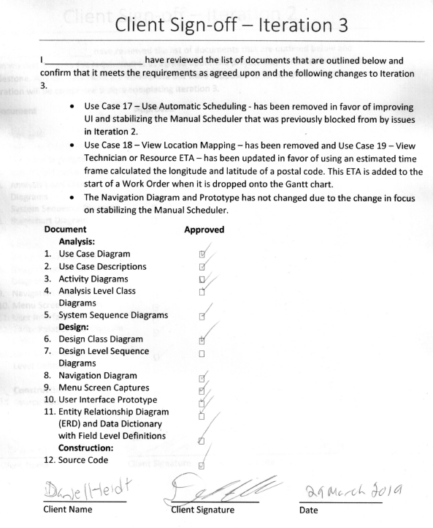

# Transition

## **64.0 Test Plan / Results**

## **65.0 Help System / User Doc**

## **66.0 Deployment Guide**

## **67.0 Web Search and Rationale Report**

## **68.0 Final presentation slides**

## **69.0 Team Member Status Reports**

## **70.0 Team Status Report**

## **71.0 Client Sign Off**